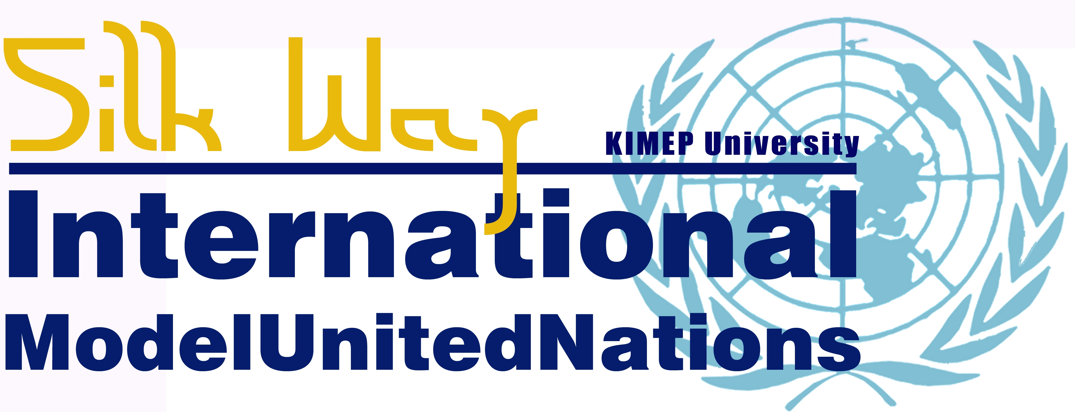
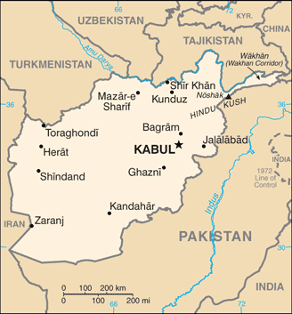
18-20 APRIL 2012

SECURITY COUNCIL
Topic: The Situation in Afghanistan

Study Guide
- Introduction
Afghanistan is a landlocked country situated in Central and South Asia, neighboring China, Iran, Pakistan, Tajikistan, Turkmenistan and Uzbekistan.
With a population of 30 million and 652,230 sq. km, Afghanistan is the 42nd most populous and 41st largest nation in the world. Afghanistan has an important geostrategic location connecting the Middle East with Central Asia and the Indian subcontinent.
In 1747, Ahmad Shah Durrani set the basis for a monarchy ruled by ethnic Pashtuns. In the late 19th century, Afghanistan served as a buffer state in the "Great Game" between the British and Russian empires until King Amanullah Khan won its independence from the British Empire in 1919. He was considered a secular modernizer presiding over a government in which all ethnic minorities participated. He was succeeded by King Mohammad Nadir Shah (1929-1933), and then by King Mohammad Zahir Shah (1933-1973). Zahir Shah was overthrown by his cousin, Mohammad Daoud, a military leader who established a dictatorship.
During the Cold War, Afghanistan became a key battleground after the Soviet invasion in 1979. The Soviets sent troops to Afghanistan in order to prevent further gains by the mujahedin. Soviet occupation forces never seized control over the entirety of Afghanistan. They had control over the major cities, but the mountainous regions remained largely under mujahedin control.
On April 14, 1988, the Soviet Union agreed to redraw according to the Geneva Accords brokered by the UN. The Soviet Union completed the withdrawal on February 15, 1989, leaving behind a weak government led by Najibullah. After the collapse of the Soviet Union, Moscow agreed with Washington on September 13, 1991, to a joint cutoff of military aid to the Afghan combatants.
After the fall of Najibullah, Rabbani became president in June 1992 and had agreed to step down in December 1994 but refused to do so when the time came. Four years (1992-1996) of civil war among the mujahedin followed, destroying much of Kabul and creating popular support for the Taliban movement. Finally in 1996, Kabul fell to the Taliban.

- The war of 2001
Following the 11 September 2001 terrorist attacks, a coalition led by the US intervened in Afghanistan after the government in Kabul refused to extradite Osama Bin Laden, the founder of Al-Qaeda, in order to prevent military action. The US military campaign against the Taliban, Operation Enduring Freedom, began on October 2001.
The Taliban was overwhelmingly defeated, but small Taliban and Al Qaeda groups reportedly continue to operate throughout Afghanistan. In May 2003, the US and the government of Afghanistan declared major US-led combat to have ended.

- The situation after the war
Afghanistan is a fragile state attempting to stabilize. A resurgent Taliban and continuing provincial instability - particularly in the south and the east - remain serious challenges for the Afghan Government.
After the war a process of state-building began in Afghanistan. The UN-sponsored Bonn Conference in 2001 established a process for political reconstruction. In December 2004, Hamid Karzai became the first democratically elected president of Afghanistan and
re-elected in August 2009 for a second term.
- ISAF
The International Security Assistance Force (ISAF) was established by the United Nations Security Council in December 2001 by Resolution 1386, according to the Bonn Agreement, in order to “assist the Afghan Interim Authority in the maintenance of security in Kabul and its
surrounding areas”. In 2003, NATO took control of ISAF which includes troops from 42 countries. In 2012, the 11th year of the conflict, NATO announced plans to hand over combat duties to Afghan forces by mid-2013. Some 130,000 NATO-led combat troops will leave Afghanistan by December 2014.
It is considered that the best chance of Afghanistan to avoid anarchy after the withdrawal of the NATO forces is the effectiveness Afghan National Security Forces.

- UNAMA
The United Nations is involved in Afghan governance and national building. In 2002, the Security Council established The United Nations Assistance Mission in Afghanistan (UNAMA) at the request of the government to assist it and the people of Afghanistan in laying the foundations for sustainable peace and development in the country.
The role of UNAMA is to promote peace and stability in Afghanistan by leading the efforts by the international community, regional cooperation and the work of all United Nations agencies, funds and programs.
To help further development, the UN has lifted most of the sanction imposed on Afghanistan since the Soviet invasion.
Afghanistan is one of the world's poorest countries as a result of the continuous state of conflict. Its unemployment rate is 35% and about 42% of the population lives on less than $1 a day, according to CIA World Factbook. Its economy depends on the drug trade, as Afghanistan is the world's largest producer of opium and the drug trade funds the Taliban insurgency.

Source: https://www.cia.gov/library/publications/the-world-factbook/maps/maptemplate_af.html
Louis Dupree, Nancy Hatch Dupree and others,” Last Afghan empire". Encyclopedia Britannica Online.
Kenneth Katzman (2012), Afghanistan: Post-Taliban Governance, Security, and U.S. Policy, CRS Report for Congress, p. 2
Kenneth Katzman (2012), Afghanistan: Post-Taliban Governance, Security, and U.S. Policy, CRS Report for Congress, p. 3
Ibidem, p . 4
Kenneth Katzman (2012), Afghanistan: Post-Taliban Governance, Security, and U.S. Policy, CRS Report for Congress, p. 9
https://www.cia.gov/library/publications/the-world-factbook/geos/af.html
Resolution 1386 http://daccess-dds-ny.un.org/doc/UNDOC/GEN/N01/708/55/PDF/N0170855.pdf?OpenElement
http://www.bbc.co.uk/news/world-south-asia-12011352
Barbara J Stapleton, (2012): Beating a retreat. Prospects for the transition process in Afghanistan, Afghanistan Analyst Network, p. 2
http://unama.unmissions.org/Default.aspx?tabid=12255&language=en-US
http://unama.unmissions.org/Default.aspx?tabid=12255&language=en-US

