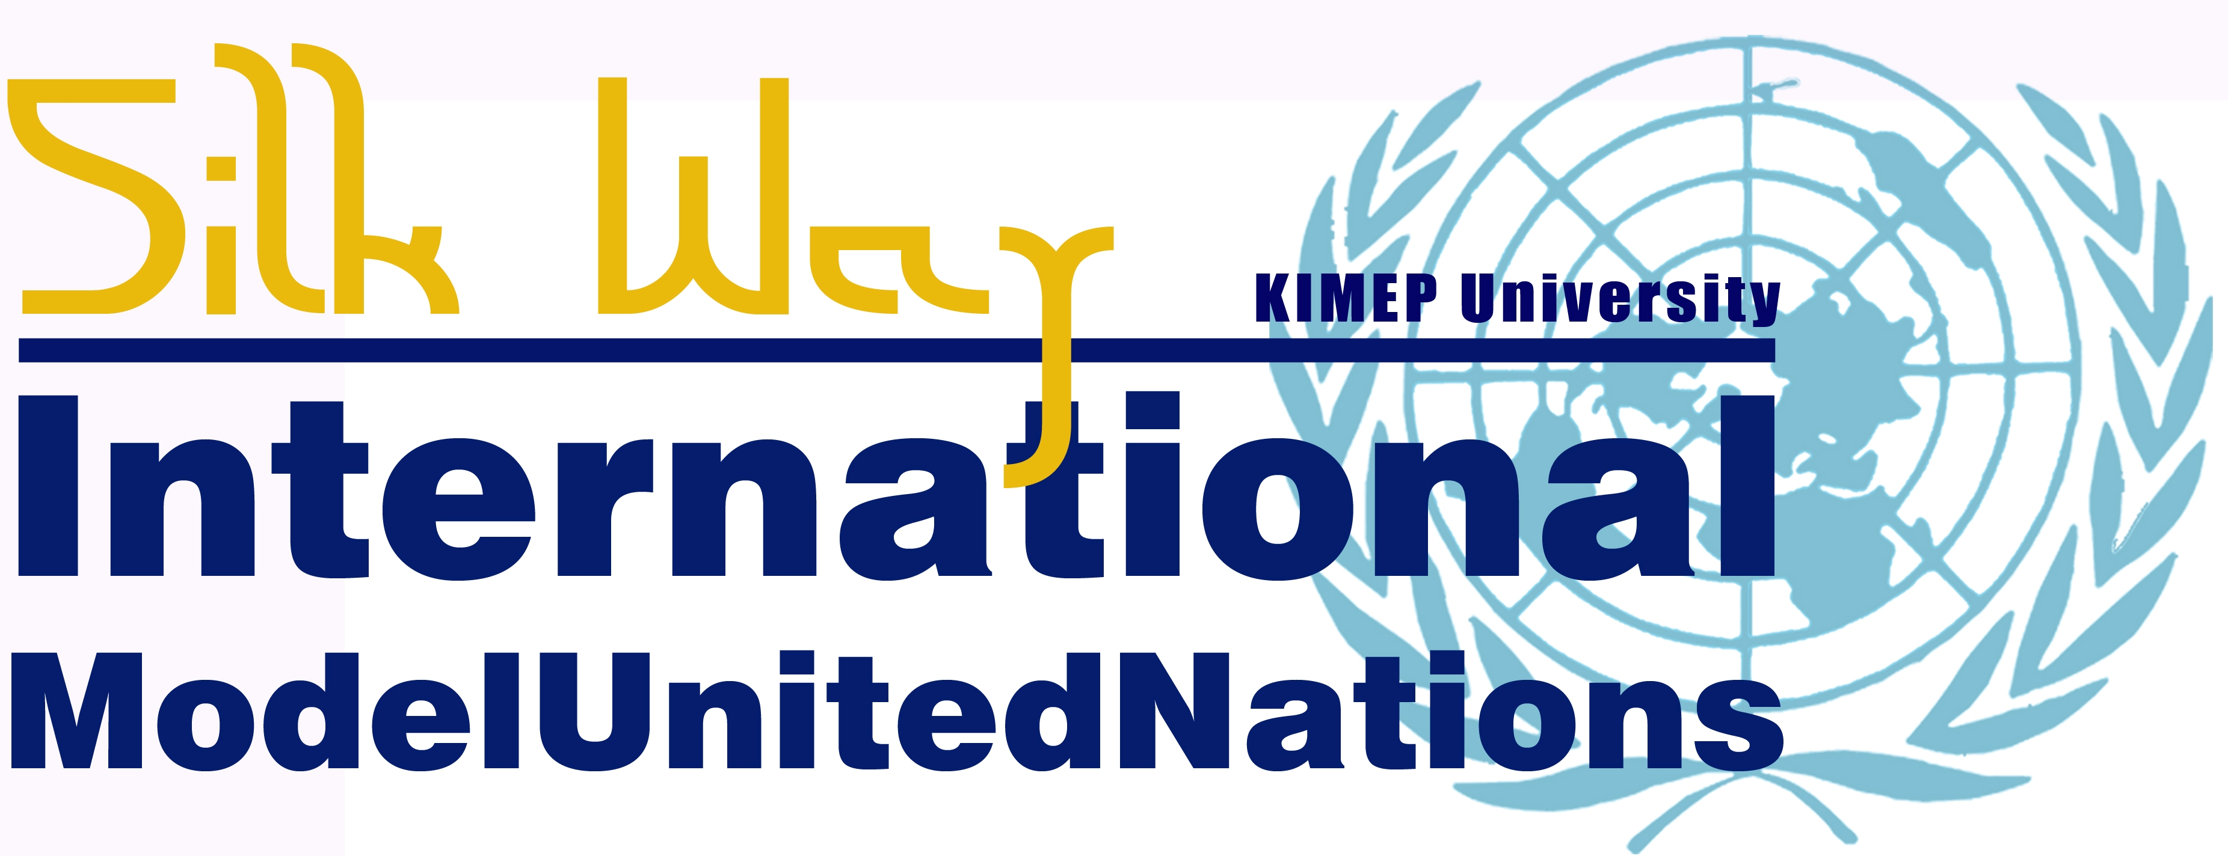
18-20 APRIL 2013

UN HUMAN RIGHTS COUNCIL (UNHRC): ON THE FREEDOM OF SPEECH AND FREEDOM OF RELIGION
Study Guide

The UN Human Rights Council

The United Nations General Assembly created the Human Rights Council (UNHRC) on March 15, 2006 by resolution 60/251. The council was created as an inter-governmental organization that promotes and protects human rights throughout the world by addressing human rights violations and providing recommendations on how to solve these problems. The council’s first session was held in June of 2006.

The Human Rights Council is made up of 47 United Nation country governments. The council has 13 African countries, 13 Asian countries, 8 Latin American countries, 7 Western countries and 6 Eastern European countries on the council currently. The council meets three times every year in March, June and September and has had 19 special meetings for serious human rights violations.

It is the job of the Human Rights Council to evaluate and recommendation United Nation action to the General Assembly and Security Council on human rights’ studies conducted by UNHRC experts. These experts come from all over the world and are specialists in different areas of human rights. These experts are chosen by the council and give presentations and reports on different issues that the council then votes on.

On Human Rights
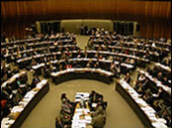
Human rights are considered innate and unalterable rights that each and every human being has that cannot be taken away from them because they are a human being. These rights are universal (everyone has them) and egalitarian (the same for everyone) and are considered natural rights for all people. These rights may or may not be supported by some governments or countries but are still considered natural for all people.

The idea of human rights can be found in the writing of many 17th and 18th century European philosophers and has ethical and moral ties to western religious ideals. After World War II and the creation of the United Nations, it was agreed upon by the founding members of the UN that the protection and promotion of human rights around the world through international law over the past 70 years. The Universal Declaration of Human Rights is considering the founding law that guides human rights today.

Human rights is a very broad topic that includes many issues like freedom of speech, expression, religion, freedom from torture, freedom from slavery, a fair and just trial, freedom from discrimination because of race, gender or sexuality, the right to work, and the right to food and water to name a few of the topics.
Today there are many non-profit and non-governmental organizations (NGOs) that promote and protect certain human rights issues for people all around the world. These NGOs as well as individual governments work together all with international organizations like the UN, African Union, the EU and the Arab League to protect people’s human rights and stop violations of human rights.

Examples of NGOs are the Red Cross/Red Crescent, Amnesty International, Human Rights Watch and Freedom House. These organizations help raise money and awareness for human rights problems all over the world and create projects and programs to help people whose human rights have been violated.

On Freedom of Speech

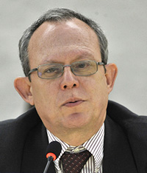
The United Nations Commission on Human Rights, the organization UNHRC replaced created a mandate or command on the promotion and protection of freedom of opinion and expression in 1993. The freedom to speak what you believe or think is considered part of the freedom of having an opinion and being able to express this opinion.

The mandate was extended by resolution 7/36 by UNHRC in March of 2008. The mandate reads:

“(a) To gather all relevant information, wherever it may occur, relating to violations of the right to freedom of opinion and expression, discrimination against, threats or use of violence, harassment, persecution or intimidation directed at persons seeking to exercise or to promote the exercise of the right to freedom of opinion and expression, including, as a matter of high priority, against journalists or other professionals in the field of information;
(b) To seek, receive and respond to credible and reliable information from Governments, non-governmental organizations and any other parties who have knowledge of these cases;
(c) To make recommendations and provide suggestions on ways and means to better promote and protect the right to freedom of opinion and expression in all its manifestations; and
(d) To contribute to the provision of technical assistance or advisory services by the Office of the United Nations High Commissioner for Human Rights to better promote and protect the right to freedom of opinion and expression.”
This mandate was created to protect people like journalists and reporters who are harassed, imprisoned, tortured and harmed because they ask questions and search for information.
This mandate was created to protect political groups, parties and trade unions from being attacked or harmed by governments or the police. The right to have an opinion and be able to express a different idea or thought in a peaceful way is consider a founding principle of the Freedom of Speech mandate from the UNHRC.
Publishers of books, magazines, articles and blogs as well as human rights defenders and media organizations are considered targets for harassment, violence and imprisonment and protected under this mandate.
The idea of censorship and limiting individuals from gathering information and promoting different ideas is seen as an obstacle to promoting freedom of opinion and expression.
This year the UNHRC Special Rapporteur or expert, Frank La Rue of Guatemala investigated human rights violation of journalists in war zones like Pakistan and Afghanistan as well as in country governments that have harassed and imprisoned news and media organizations.
On Freedom of Religion
The UNHRC as followed the previous mandate from the UN Commission on Human Rights in regards to freedom of religion. It is the mission and goal of the UNHRC to promote and protect individuals the right to worship and believe in any religion or belief system they wish without being persecuted or harmed.

The UNHRC mandate is called the Special Rapporteur on freedom of religion or belief and was adopted in Resolution 14/11. The mandate reads as:

“- to promote the adoption of measures at the national, regional and international levels to ensure the promotion and protection of the right to freedom of religion or belief;
- to identify existing and emerging obstacles to the enjoyment of the right to freedom of religion or belief and present recommendations on ways and means to overcome such obstacles;
- to continue her/his efforts to examine incidents and governmental actions that are incompatible with the provisions of the Declaration on the Elimination of All Forms of Intolerance and of Discrimination Based on Religion or Belief and to recommend remedial measures as appropriate;
- to continue to apply a gender perspective, inter alia, through the identification of gender-specific abuses, in the reporting process, including in information collection and in recommendations.”
It is the goal of the mandate to protect to the human rights of women and children as well as those individuals who are stateless or migrant. The mandate is also set out to guarantee country governments protect all of their citizens regardless of religious beliefs – that certain minorities are not discriminated against. The idea of education is fundamental in this mandate as well – children should be taught tolerance and respect for all creeds or religions without bias.
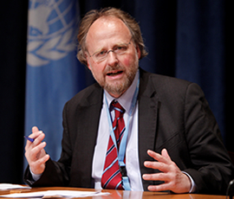
Discrimination is work and communities due to religious belief are considered violations of the mandate. The idea of using religion or promoting hatred or intolerance for others because of their religion is considered an extreme rejection of the mandate.
Dr. Heiner Bielefeldt, the Special Rapporteur on Freedom of Religion visited Paraguay and Moldova this year to discuss issues involving the freedom of religion and belief. He reinforced the idea of women having a role in promoting freedom of religion as well as condemned the idea of using religion to incite xenophobic, nationalist, and racial violence amongst citizens of the same country or neighboring countries.
He also promoted the idea of using mass-media (television, internet, and modern technologies) in better informing and educating people in religious tolerance and acceptance. He also spoke about the idea of recognizing and accepting different religions and beliefs in different societies.
Conclusion
The UNHRC serves as United Nations organization that promotes the human rights of all people regardless of nationality, race, gender, ethnicity, sexual orientation, creed or belief and covers a wide range of issues and topics that relate to human rights.
The protection and promotion of human rights is considering one of the founding and most important issues for the United Nations and all the organizations that support the UN. The UN Human Rights Council serves as a policy-making organization that evaluates and reviews the activity of governments, businesses and organizations around the world that may or may not be violating these rights.
Freedom of Speech and Religion are considered two of the key fundamental human rights that still come into conflict today. These topics are considered sensitive yet extremely important for all people around the world. It is the mission of the UNHRC to make sure that all human beings have a right and access to these freedoms.

Questions to Consider
Does the UNHRC have the right to dictate or tell governments and organizations around the world what freedoms or rights they must give to their citizens?
Do individual governments have the rights to decide what opinions, expression, speech and religions are practiced in their country?
Do the goals and missions of the UNHRC meet the cultural, social and economic standards of all countries?
Are human rights universal and egalitarian (for everyone)? Does everyone naturally have access to these rights or are they just created by man?
Why do you think there are human rights violations around the world? What kind of examples can you think of that may or may not be accepted in your country?
Additional Sources for Information
United Nations Human Rights Council (UNHRC) website:
http://www.ohchr.org/EN/Pages/WelcomePage.aspx
Nickel, James.Aug. 2010, “Human Rights”, The Stanford Encyclopedia of Philosophy
http://plato.stanford.edu/entries/rights-human/
The Universal Declaration of Human Rights (UDHR)
http://www.un.org/en/documents/udhr/index.shtml

http://www.ohchr.org/EN/HRBodies/HRC/Pages/AboutCouncil.aspx
http://www.ohchr.org/EN/HRBodies/HRC/Pages/MembersByGroup.aspx
http://www.ohchr.org/EN/HRBodies/HRC/Pages/Sessions.aspx
http://www2.ohchr.org/english/bodies/subcom/index.htm
http://en.wikipedia.org/wiki/Human_rights
http://en.wikipedia.org/wiki/Human_rights
http://www.ohchr.org/EN/Issues/FreedomOpinion/Pages/OpinionIndex.aspx
http://www.ohchr.org/EN/Issues/FreedomOpinion/Pages/Complaints.aspx
http://daccess-dds-ny.un.org/doc/UNDOC/GEN/G12/137/87/PDF/G1213787.pdf?OpenElement
http://www.ohchr.org/EN/Issues/FreedomReligion/Pages/FreedomReligionIndex.aspx
http://www.ohchr.org/EN/Issues/FreedomReligion/Pages/Complaints.aspx
http://daccess-dds-ny.un.org/doc/UNDOC/GEN/G11/175/41/PDF/G1117541.pdf?OpenElement

