Instructions for KIMEP English Placement Test (KEPT) on-line testing on the PROCTOREDU professional platform

Dear Applicant,

Thank you for your interest in our university! KIMEP University strives to provide its applicants with the utmost comfort in meeting the admission requirements for our bachelor's, master's and doctoral programs. Following this principle, our university provides its applicants with the opportunity to pass the entrance tests required for admission online using the professional PROCTOREDU platform, which allows you to take KIMEP tests anywhere and anytime through the management system of our university.

ProctorEdu is a proctoring system for online monitoring, recording, and evaluating user behavior throughout online assessments. Proctoring functions are integrated with LMS of our university, which allows to control remote exams in live or automated modes. Please be informed that all internal exams are synchronically proctored, meaning that besides auto proctoring there is a live proctor observing your behavior during the whole exam.

More detailed information about functional opportunities of this monitoring system can be found here .

We hope that the experience of participating in our tests will be simple and comfortable for you.

If you have any questions, we will be happy to help.

Yours faithfully,

KIMEP University Admissions Team

The following steps will help you to successfully take the KIMEP English Placement Test (КЕРТ)

Check the technical requirements of your PC

Prior to the test please ensure that the technical characteristics of your PC meet the parameters presented in the table below.
PC user requirements

Parameter | Minimum requirements
Web browser | Chrome 72, Opera 59, Firefox 66, Edge 79
Operating System | Windows 7, macOS 10.12 "Sierra", Linux
Supported mobile version | Android 4.4+ Chrome, iOS 12+ Safari
Webcam | 640x480, 15 fps
Headset | Any
Speakers | Optionally (for communication with proctor)
Web (Internet) | 256 Kbit/s

Before the event, you should check the compatibility of the computer with the proctoring system on the page https://proctoredu.com/check.
Additionally, you can check the webcam, microphone and network here:
- Webcam test
- Microphone test
- WebRTC Troubleshooter
- Access the testing page
In your browser type in the following address https://el2019.kimep.kz/course/index.php?categoryid=23 and
Access the testing page
- Test choice
In the opened window click on the test you need to take:
• BAJ Entrance exam KIMEP or
• Graduate Entrance Test (KGET) or
• KIMEP English Placement Test (KEPT)
Then press СONTINUE button
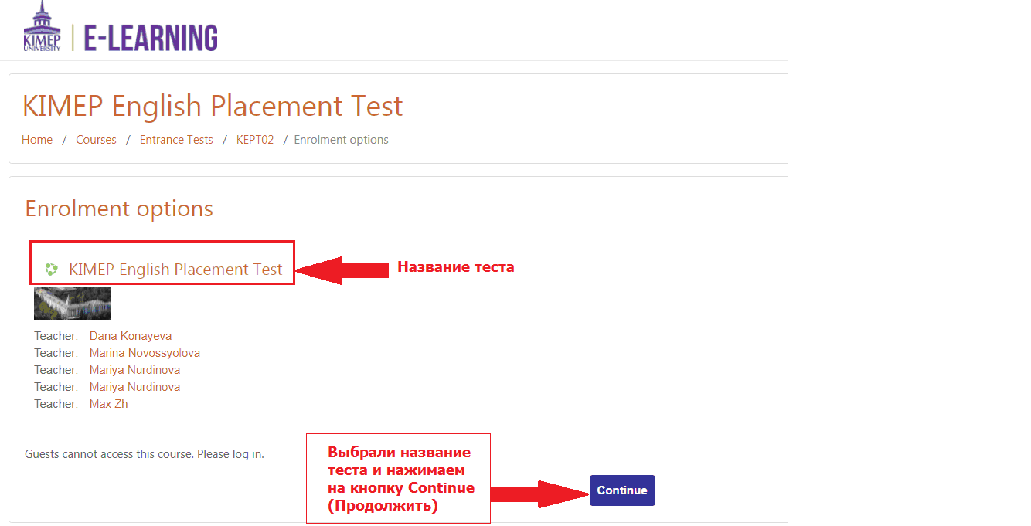
- Authorization in the Moodle system
Type in your login and password which are indicated in your exam ticket
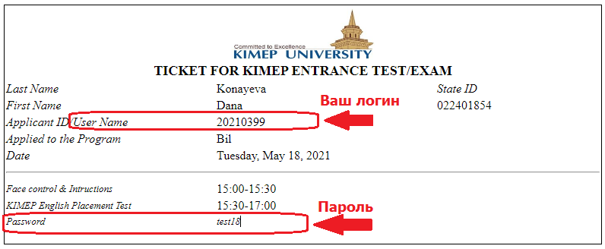
Then press Log In button
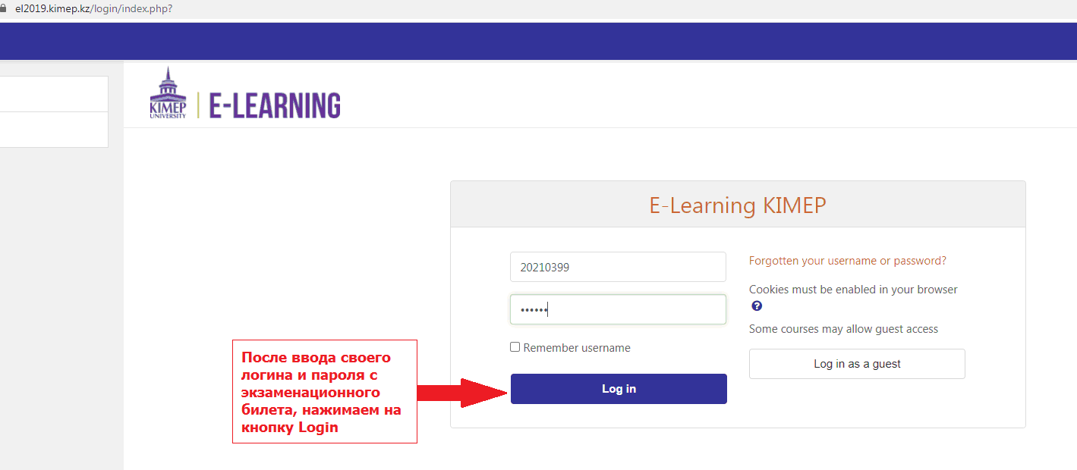
- Getting familiar with the test instructions
In the opened window you will see the KEPT test instructions, scroll them down as you are reading it
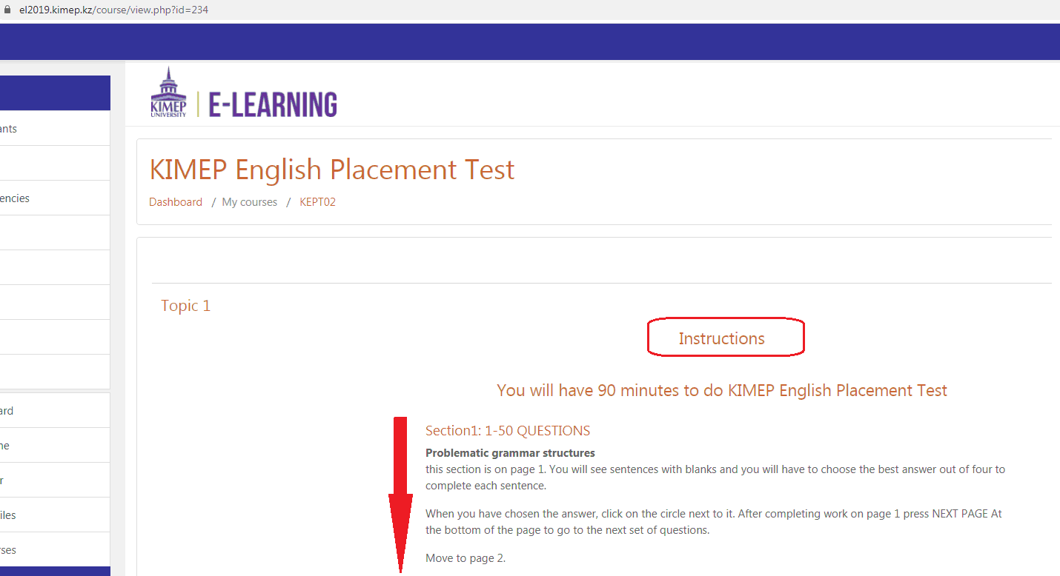

At the bottom of instructions you will see Topic 5 Proctored KEPT, click on it for further actions
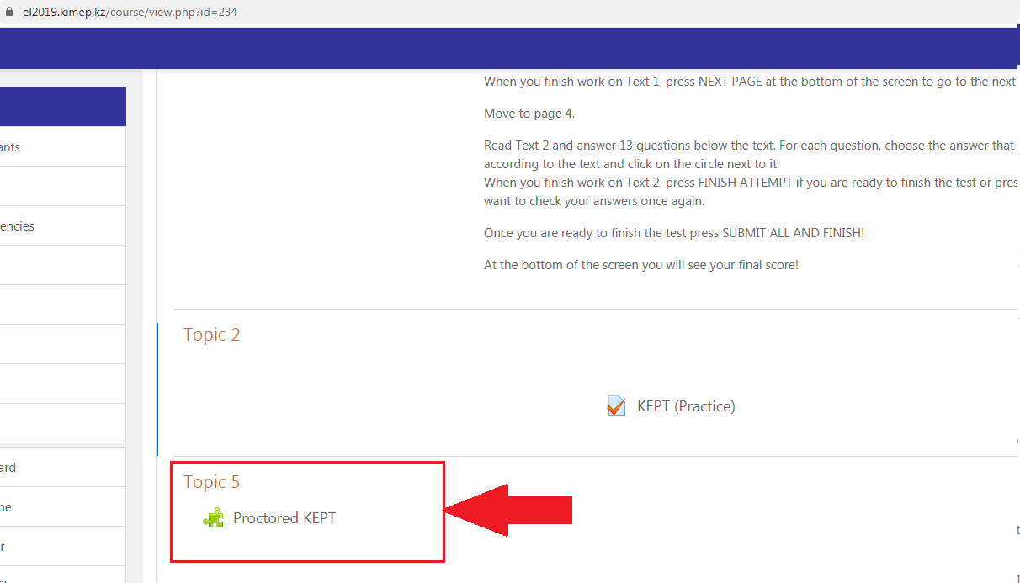

- Equipment check
After that you will see the video with instructions relating to the behavior during exam, watch it before moving further.

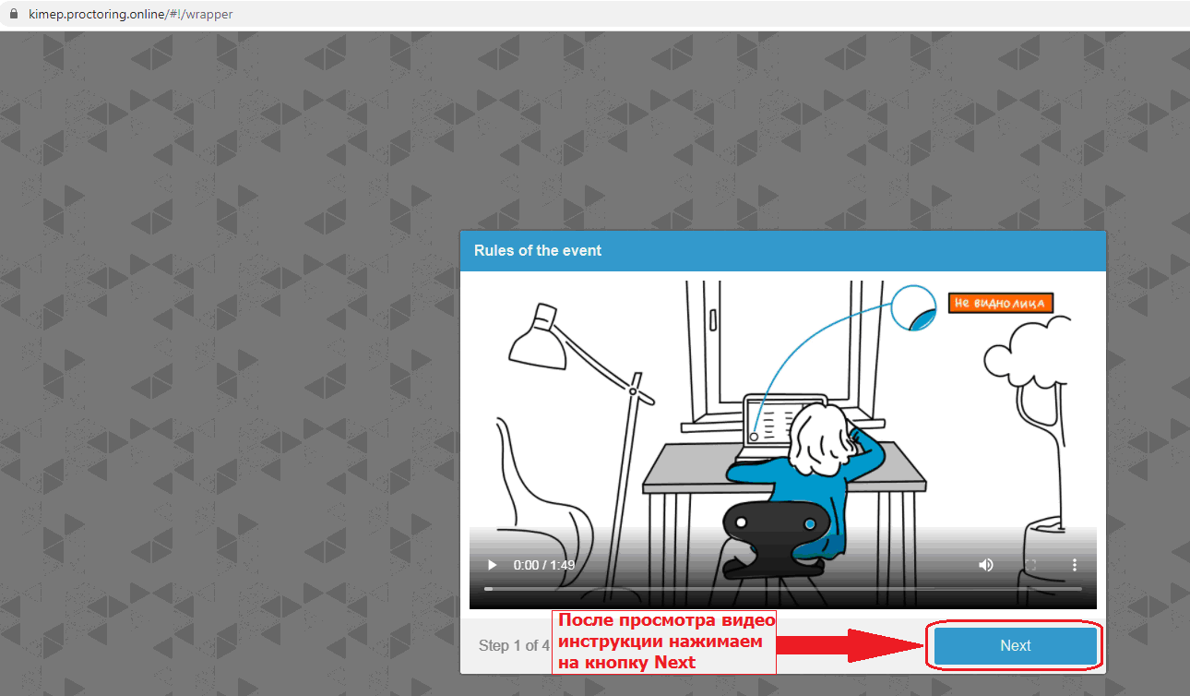
After watching the video press the NEXT button and you will be redirected to the Equipment check stage. The system will be checking your browser, webcam, mic, screen and WebRTC. During the course of check across each parameter there will be a green point lightened if the check is successful.
Equipment check stages are the following:
- At the browser compliance check stage, the system checks whether your browser complies with the minimum requirements of the proctoring system; browser window should be switched to full-screen mode.
- At the webcam check stage, you should enable camera access in the browser, if such a request is made. If the camera works correctly, then you will pass the webcam check.
- At the microphone check stage, you should enable microphone access in the browser, if such a request is made. If the volume of your microphone is enough, then you will pass the microphone check.
- At the screen check stage, you should give access to the entire screen. If access is given only to a part of the screen, or an additional monitor is installed, then the check will result in an error. Press on the picture itself located under the ENTIRE SCREEN signature and press SHARE button.
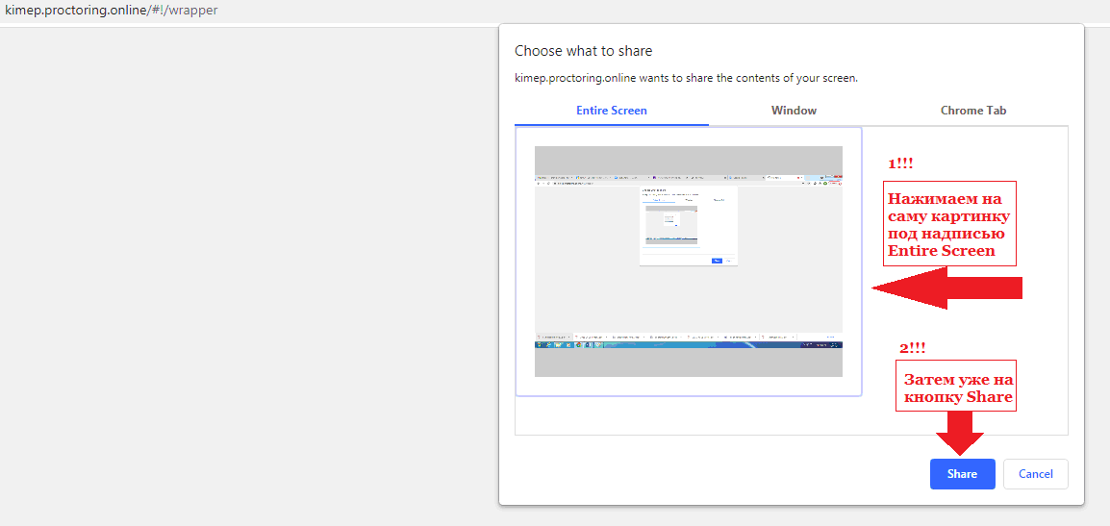

- At the network check stage, the system checks the capacity of your web to transmit video traffic on WebRTC technology. If traffic is not blocked, you will successfully pass the check.

Potential Issues and their Solutions are indicated in the table # 2. After your parameters are successfully checked press the NEXT button and go to the next stage.

Your identity check

Please ensure that the scan copy of the passport (for international students) or state ID (for KZ citizens) is available for downloading on your PC
- the webcam must be installed strictly in front of the face, and it is not allowed to install the camera from the side;
- the head should be fully framed, and no partial or complete exit from the camera's field of view is permitted;
- the face should be in the center of the webcam's field of view and occupy at least 10% of the space captured by the camera during the entire session;
- the face should be evenly lit, the light source should not be directed at the camera or only one half of the face;
- hair, clothing, hands or anything else should not cover the face area;
- it is not permitted to wear sunglasses, glasses with transparent lenses are only allowed to be used.

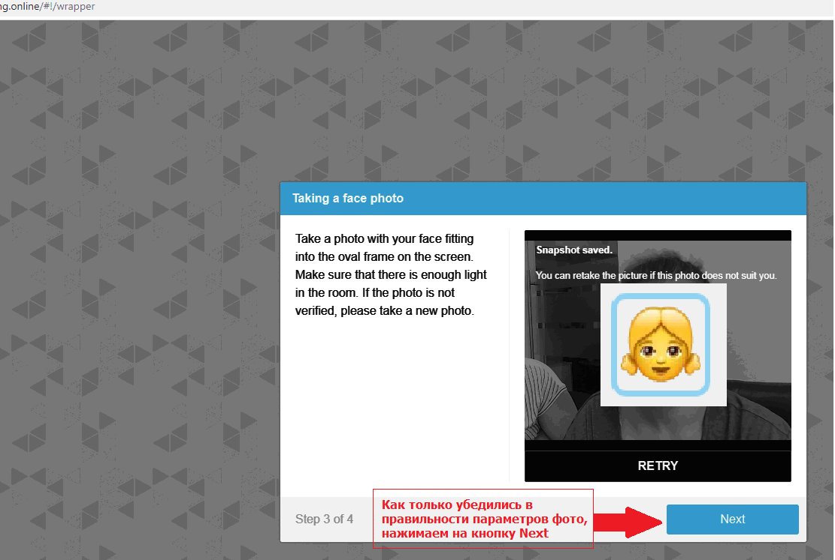

If you are satisfied with your photo settings press TAKE A PICTURE button.
Then there will your passport/state ID verification stage follow. Please UPLOAD you scan copy of the passport/state ID and press NEXT
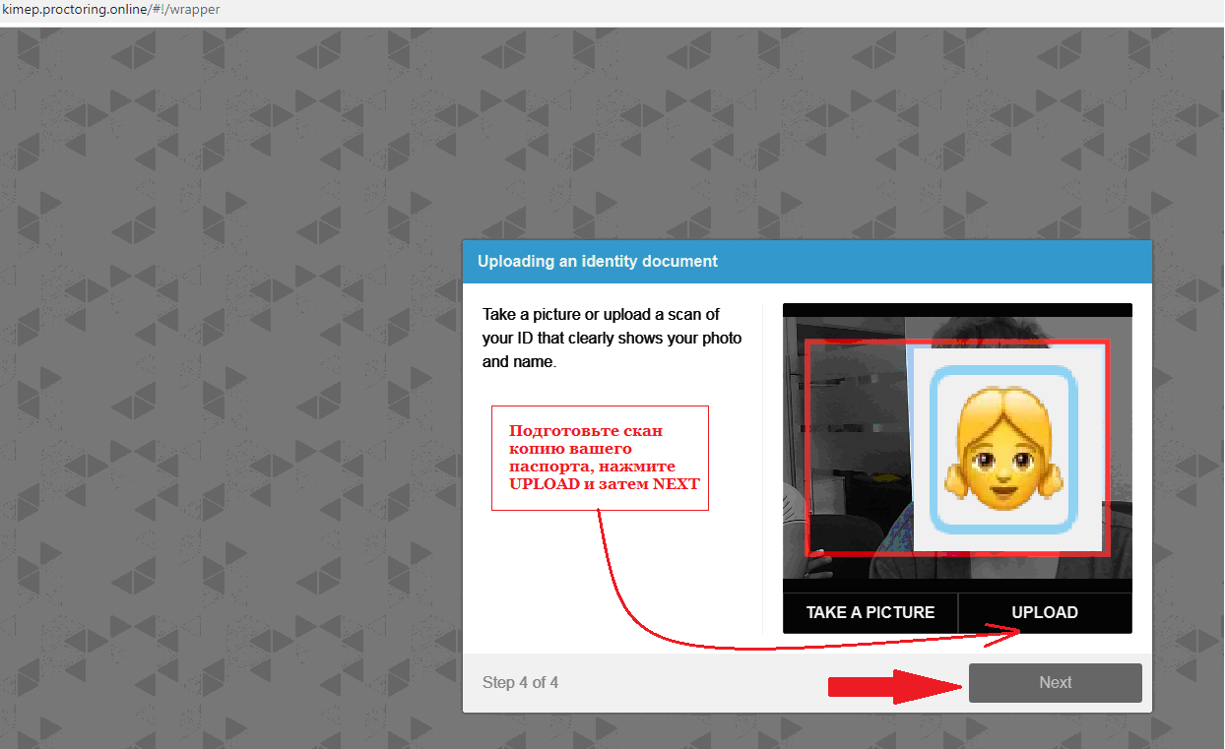
Then the system will ask you to share your screen. Press on the picture itself located under the ENTIRE SCREEN signature and press SHARE button.
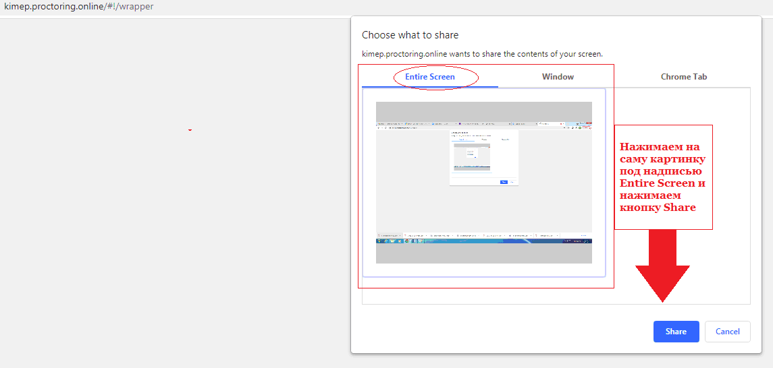
- Start of the KEPT test

In the opened window you will see KEPT Instructions that you will have to carefully read scrolling them down to the end.
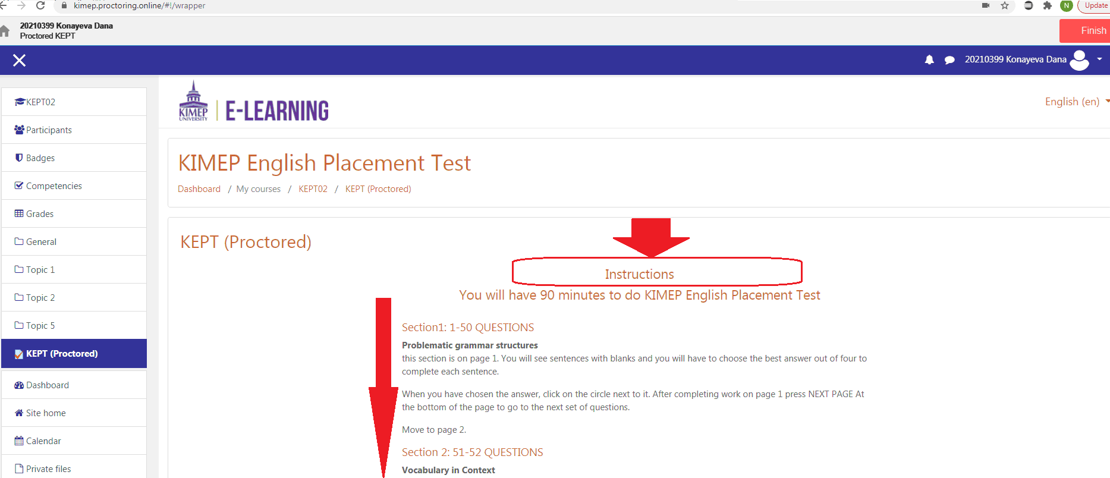

as soon as you are ready press the ATTEMPT QUIZ NOW button at the bottom of the screen.
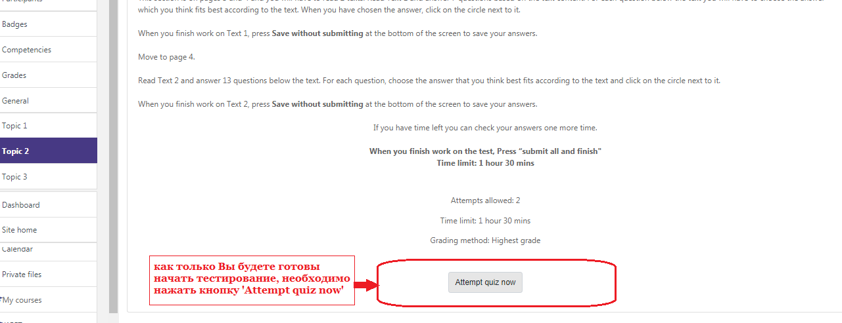

Further, in the opening secondary window you will have to confirm your intent to start the test by pressing START ATTEMPT button.

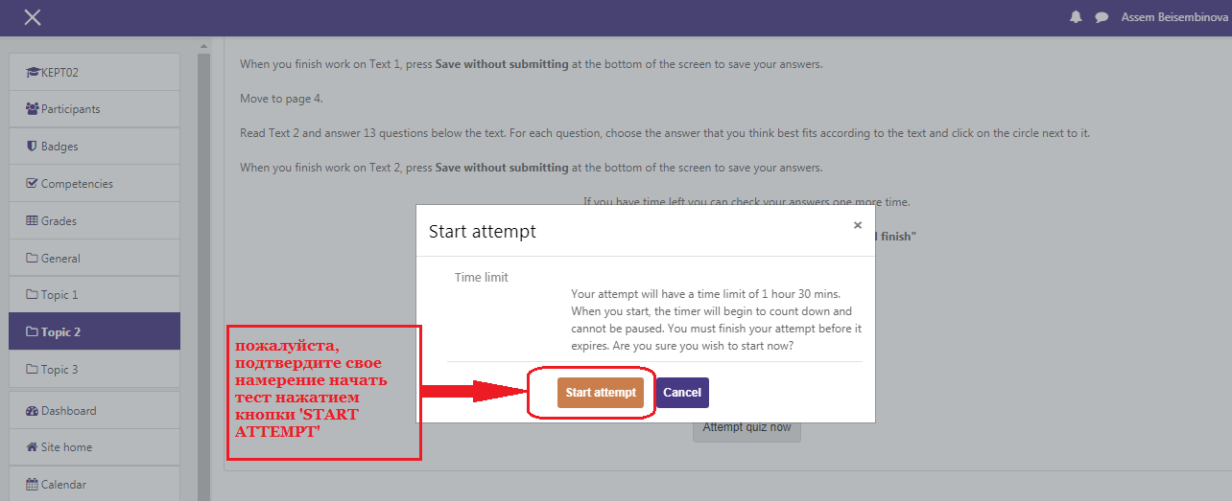
You should necessarily pay attention to the timer that shows time remaining till the end of the test..
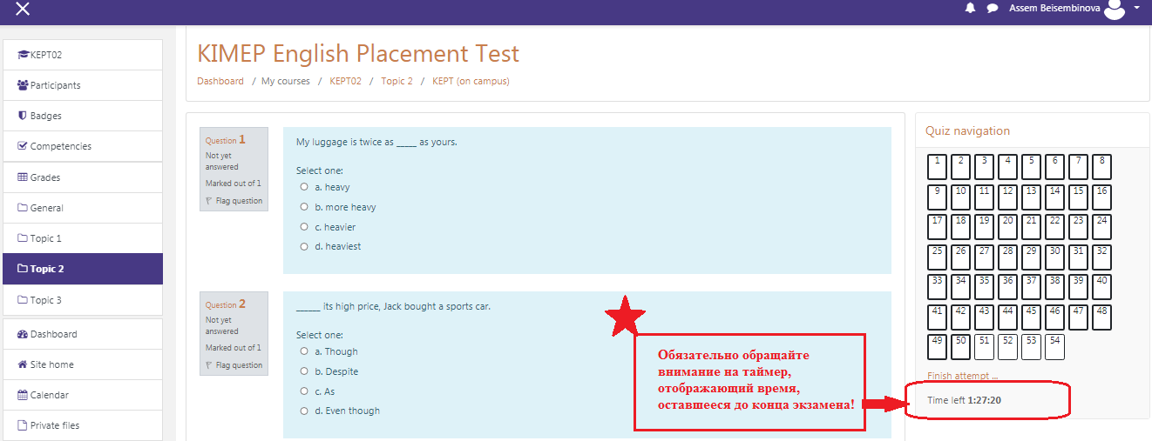

During the test - follow the instructions stated in the beginning. At the right side of your screen there is a grid of questions – 1 to 54. By pressing a corresponding box with a question number you will be able to switch to the needed question. You may go from one page to another and return to the previous page to check your answers with the help of NEXT or PREVIOUS buttons.

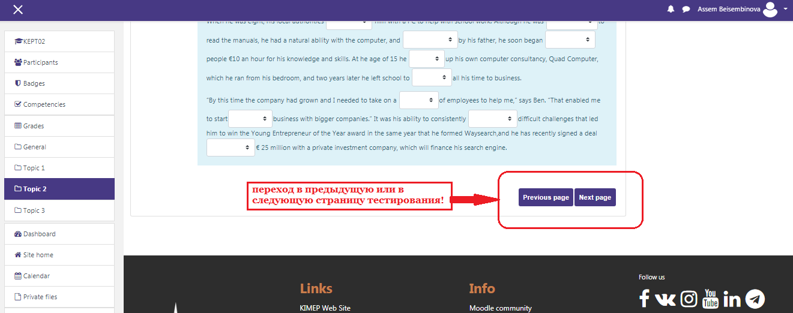

- Test finish
After you have answered all questions, if you are sure in your answers and are ready to submit them, press FINISH ATTEMPT button and further - SUBMIT ALL AND FINISH.

You will be able to see your score in the lower part of the screen.

Once you finished your test please finish your session by putting the tick in the box and press YES button.

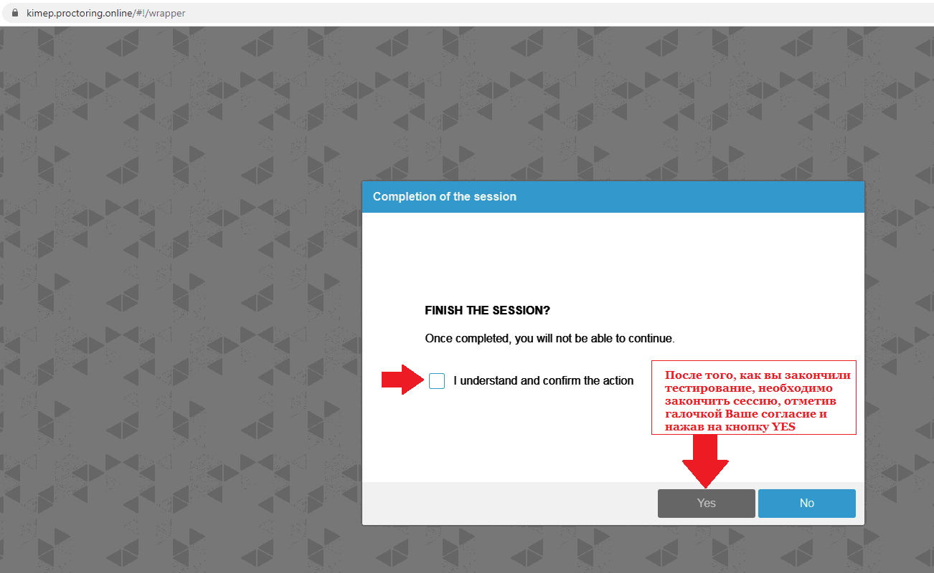

Table # 2.
Problems and solutions
Issues | Solution
1) Browser check stage error | Your browser does not comply with the minimum requirements of the proctoring system. Install the latest version of Google Chrome and try again.
2) Webcam check stage error | Your webcam is not working or is being blocked by other computer applications. Check whether your webcam is working properly in the browser; close other applications that might be using your webcam;
disable antivirus; if there are several webcams on your computer, choose the correct one in the browser settings. If the webcam is working, but the error is still present, try to refresh the computer.
3) Microphone check stage error | The microphone is not working or disabled in the settings of your computer (operating system). Increase the volume of the microphone or plug another microphone and then choose it in the browser settings. Check whether your microphone is working properly in the browser.
4) Screen check stage error | Access to the screen is disabled; your browser does not support screen sharing; you gave access only to a part of the screen. If the browser requests you to enable screen sharing, do so; otherwise, refresh the browser.

