Perspectives

The new court of the Astana International Financial Centre: promoting the rule of law or giving up on the rule of law?
Nicolás Zambrana-Tévar,
School of Law, KIMEP University, Kazakhstan
n.zambrana@kimep.kz

Abstract: In 2015, Kazakhstan set up the AIFC, a new international financial center located in the country’s capital. Financial services companies that decide to establish themselves there will profit from an advantageous tax system and from modern financial regulation as well as from commercial laws that are based on English law and are different from those of the rest of this Central Asian state. AIFC law will also be applied by the center’s own English judges and arbitrators. The objective is to appeal to investors and to turn Kazakhstan into an attractive financial hub for the region. Additionally, this initiative may improve the rule of law in the country, serving as an example for local judiciary and regulators. However, for a fruitful cross-fertilization between the AIFC and local institutions and in order to contribute to the real development of the country, the AIFC and local stakeholders must make an effort to see each other as partners and not as isolated legal systems and institutions. JEL Code: O3
Keywords: International Financial Centers, Rule of Law, Institutions, International Courts and Tribunals, Applicable Law, Recognition of Foreign Decisions, Kazakhstan, Central Asia

1. Introduction
In 2015, Kazakhstan announced that it would set up a new offshore or international financial center in the country’s capital. This interesting initiative tries to follow the steps of similar financial centers in the Persian Gulf (see below). The confessed goal of the center is to attract investors, especially financial service providers that can help Kazakhstan become a reliable financial hub for Central Asia. However, the center’s own financial and commercial laws and regulations, as well as its own dispute resolution mechanisms, may also provide a good example for the rest of the country, which needs to foster the rule of law. Kazakhstan’s own banking regulators, government officials, judges, and lawyers may learn much from the experience of the judges and officials who have been hired from abroad, if the latter also make an effort to establish a dialogue and a two-side learning relationship with the country that is hosting them, instead of remaining an isolated institution.

2. Offshore Financial Centers and Offshore Courts
The International Monetary Fund broadly defines offshore financial centres as “any financial centre where offshore [financial] activity takes place.” Basically, offshore finance is “the provision of financial services by banks and other agents to nonresidents.
Such nonresidents are usually foreign businesses: entities which are either not locally incorporated or whose main activities take place elsewhere or both.
Also in accordance with the International Monetary Fund, offshore financial centers must meet the following four criteria: (i) orientation of business primarily toward nonresidents; (ii) favorable regulatory environment, including favorable employment and visa regimes; (iii) a low or zero tax rate; and (iv) offshore banking as an entrepôt business.
However, this definition of offshore finance does not differentiate between those financial markets of sovereign states―where offshore finance services may be provided―and those cases where a sovereign state creates an offshore financial center within its territory but with its own laws and dispute resolution system, which differ from those of the rest of the host country that provide offshore financial services. The latter are sometimes referred to as “financial free zones.”
Two traditional and well-known financial centers, hubs, or districts are New York’s Wall Street and the City of London, but these are territorially part of and are integrated into the constitutional and regulatory framework of their respective countries. Many offshore centers are sovereign states in their own right, such as Panama or Andorra. Other centers are in overseas territories or in jurisdictions that, for historical reasons, are part of or are under the sovereignty of another nation state, as in Gibraltar or the Cayman Islands. Even after the 1999 devolution to China, Hong Kong could also be said to belong to this latter category.
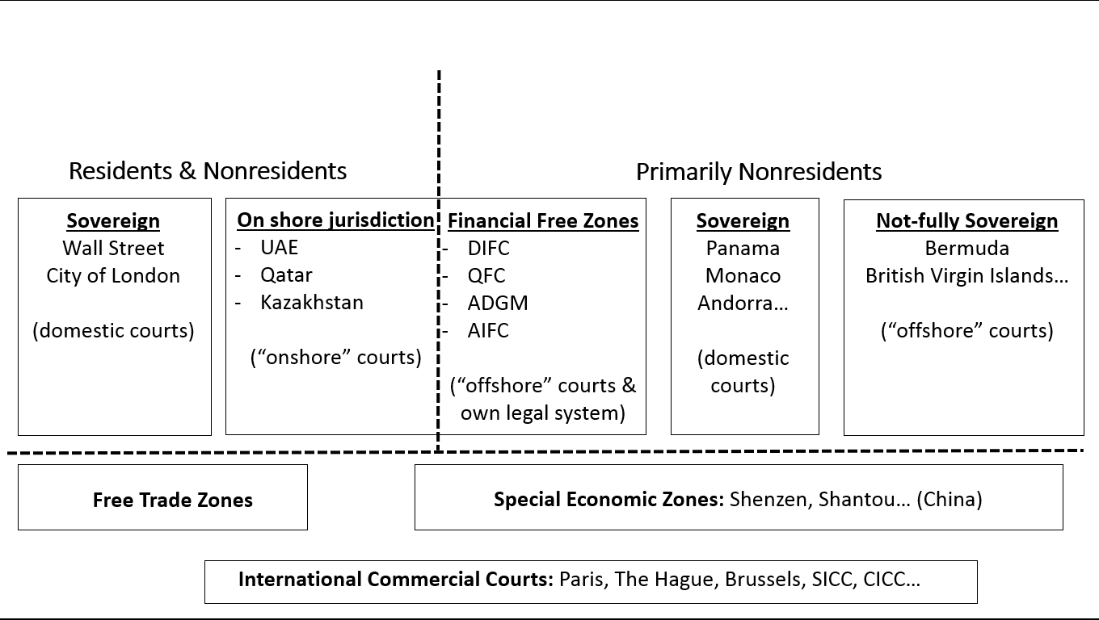
Figure 1: Anatomy of offshore finance and offshore courts.

The term “offshore courts” is sometimes used simply to refer to the domestic courts and tribunals of offshore financial centers. Thus, the courts of some Caribbean jurisdictions may commonly be referred to as “offshore courts.” In addition, the courts of financial free zones are often referred to as “offshore courts” too, in order to distinguish them from the “onshore courts,” which are the domestic courts and tribunals of the host country where the financial free zone is located.
On the other hand, special economic zones can be defined as “demarcated geographic areas contained within a country’s national boundaries, where the rules of business are different from those that prevail in the national territory.” They are small or well-sized territories such as sea ports or whole provinces, where different laws and regulations are enacted and enforced from those of the rest of the country. Nevertheless, such special legislation usually concerns commodity trade, custom duties, worker permits, VAT, etc (Figure 1).
Further to the above, there is a visible trend in Asia and the Middle East to establish financial free zones that are properly speaking hybrids between offshore financial centers and special economic zones. Some examples of these hybrids could be international financial centers such as the Dubai International Financial Centre (DIFC, established in UAE in 2004), the Qatar Financial Centre (QFC, established in Qatar in 2005), the Abu Dhabi Global Market (ADGM, established in UAE in 2013), or the Astana International Financial Centre (AIFC, established in Kazakhstan and launched in 2018).
These hybrids would share with special economic zones the feature of a special legal regime whose application is limited to a small or simply nominal territory. Therefore, from a legal perspective, they are artificially created jurisdictions within another jurisdiction. On the other hand, these kinds of international financial centers would share with offshore centers the fact that their goal is mainly the provision of offshore corporate and financial services to foreign clients, not necessarily related to the international trade of goods.
Despite their great amount of natural resources, the governments of Persian Gulf countries as well as the government of Kazakhstan may be aware, in different degrees, of the need to attract more investment and to diversify their economies, in order to avoid cyclical economic crisis each time that the price of mineral resources falls in the markets. This diversification involves attracting foreign businesses interested in economic sectors other than minerals. To this end, all kinds of foreign investors need to be reassured that their assets are duly protected. The stronger and the more familiar the legal and adjudicatory system of the host country, the more reassured those foreign investors will feel.
In some cases, these financial centers also try to capitalize on one of the intrinsic cultural features of the countries where they are located―Islam―for the purposes of attracting entities willing to use financial instruments that are compatible with Sharia law. Islamic finance is widely practiced in Persian Gulf countries and Islamic finance legislation is being introduced in some Central Asian countries.
Since foreign and sophisticated investors and other stakeholders such as legal consultants are used to political stability and to a strict understanding of the rule of law and need to be reassured that those investments are secure, the governments that sponsor these new financial centers may have calculated that it is less costly― politically or otherwise―to set up new, limited, and insulated financial institutions with their own robust financial legal system and judiciary, instead of having to undertake major legal, social, or political reforms nationwide.

3. The Rule of Law in Kazakhstan
Kazakhstan ranks low in most indexes that assess the strength of the rule of law in different countries. Thus, in the 2018 Corruption Perception Index made by Transparency International, Kazakhstan occupies the place 124 out of 180. In the 2017-2018 Judicial Independence Index of the Global Competitiveness Report (i.e. the World Economic Forum), this country ranks 79th out of 137. In the Rule of Law Index of 2019 of the World Justice Project, the place is 65 out of 126. In the 2017 Judicial Independence (WEF) Index of the World Bank, Kazakhstan receives a grade of 3.64, where 1 is “heavily influenced” and 7 is “entirely independent.” However, the Kazakhstani government is implementing several measures to improve situations such as corruption or poor professional training.
Additionally, institutions such as the OECD or the American Chamber of Commerce have repeatedly asked for solutions to the problem of corruption and disregard for the rule of law in Kazakhstan, although they also believe that progress is being made. Anti-bribery campaigns, plans to set up investment courts and to provide more training for judges and state officials, a new Arbitration Law, and now the Astana International Financial Centre may all be part of this effort. In addition, powerful or well-funded entities such as the American Bar Association, the German Federal Ministry for Economic Cooperation and Development, and the European Union have their own Rule of Law programs for Kazakhstan and for the entire Central Asian region.

4. The Court of the Astana International Financial Centre
The AIFC was launched in Nur-Sultan (formerly Astana), the newly named capital of the Republic of Kazakhstan, in July 2018. The AIFC combines features of territorial administrative subdivisions, technologically advanced business facilities, financial regulators and flexible dispute resolution mechanisms. It has regulatory and judicial jurisdiction over corporations established in it and it has been expressly modeled after similar initiatives in the Persian Gulf, such as the abovementioned DIFC. The creation of the AIFC is also in line with other world tendencies such as regulatory competition and innovative English-speaking sections of domestic courts, set up with a view to diverting legal business away from traditional litigation hubs.
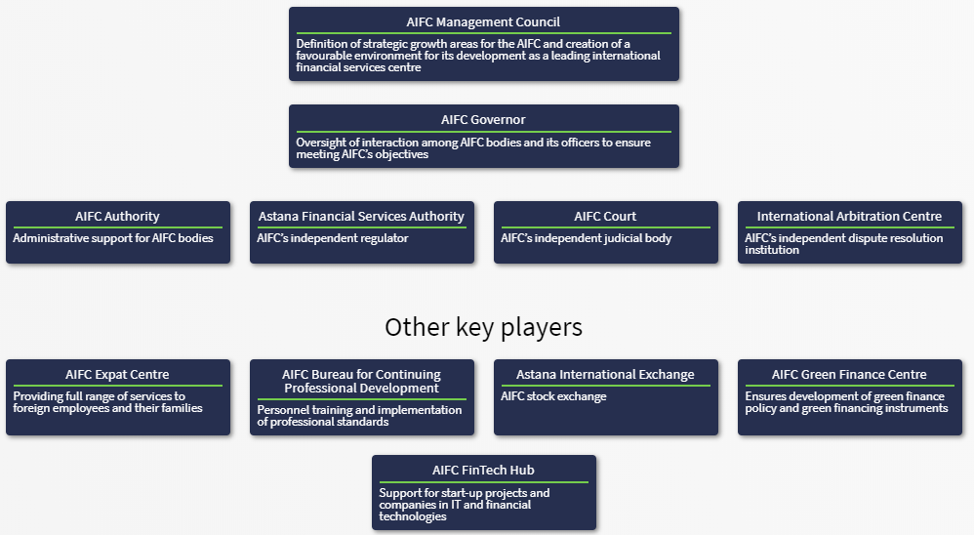
Figure 2. AIFC bodies. Source: www.aifc.kz

Kazakhstan has claimed that the AIFC will strengthen the rule of law in this Central Asian republic. This would be key, not only to attracting sophisticated investors but also to fighting corruption and improving the domestic legal system, which not only needs to develop but is probably too advanced to be fully respected or properly applied by state officials, particularly by judges. The government of Kazakhstan might hope that the AIFC, as a super-modern mini-jurisdiction of common law, might in time pull up the rest of the country behind.
As already mentioned, a peculiar added characteristic of only a group of these hybrids is the establishment of various dispute resolution mechanisms such as civil and commercial courts or regulatory tribunals and alternative dispute resolution centers. Such dispute resolution mechanisms are part of the legal structure of these hybrid financial centers and must be seen as a secondary or collateral legal service offered to their participants and to the business community in general. They also serve as enforcers of their more favorable or technically advanced legal regime.
The existence of these dispute resolution mechanisms raises other and distinct legal issues in areas such as jurisdiction, applicable law, international judicial cooperation, recognition of foreign judgments and arbitral awards within their territory, as well as the recognition and enforcement of offshore judgments and arbitral awards outside the financial hub but within the territory of the host state or abroad.
Within this set of legal issues, other interesting questions can be posed, such as the relationship between these sophisticated offshore courts and the English-speaking judges and arbitrators, trained in common law, that these centers have hired, on the one hand, and the local and potentially less sophisticated judiciary of the host country, on the other hand, when it comes to the practicalities of domestic and reciprocal recognition and enforcement of offshore judgments and awards.
Another relevant issue is how foreign courts are supposed to characterize court rulings and arbitration awards issued by the courts and arbitration tribunals of these financial centers, for the purposes of recognition and enforcement. In some of these centers, the enacted legislation expressly declares that their courts are independent from and not part of the local judicial branch (e.g. AIFC). In other cases there is an express mention of the fact that the offshore courts are part of the judiciary power of the state, including a reference, in the case of the DIFC Courts, to the fact that its judgments are issued in the name of the sovereign. In both cases the question is to what extent foreign courts are obliged―under their domestic legislation or under existing international treaties―to treat such rulings and awards as any other judicial or arbitration decision originating in that country.

5. The AIFC as a Legal Transplant
Three things may summarize the reasons for setting up the AIFC and the strategy followed by the government of Kazakhstan in establishing this new offshore financial center. They may also be key in understanding the relevance of the AIFC for the future of the rule of law in Kazakhstan. The three aspects are: a “call effect” in relation to similar international financial centers; the import of foreign and foreign-trained personnel; the import or creation of a new legal and adjudicatory system.
(a) The call effect
The “call effect” is simply an acknowledgment that Kazakhstan is trying to capitalize on the apparent success that similar initiatives have had, especially in the Persian Gulf. Former President Nazarbayev made an express reference to the DIFC when he first mentioned the future creation of the AIFC, and the DIFC has attracted more than 3,000 business entities which are already incorporated or registered within its territory in accordance with its own laws, as well as a workforce of almost 23,000 people working within its territory and in accordance with its own employment regime.
Such degree of investment and business activity in Dubai, directly or indirectly facilitated by the DIFC, probably weighed heavily in the decision to set up the AIFC, with the great economic and political support that the Kazakhstani government has been giving to it. If, in the mid-term, this call effect does not materialize in a sufficient degree of new investments in the form of financial service companies that set up subsidiaries or branches within the AIFC, the initial enthusiasm may fade and the experiment will not be so fruitful, from the perspective of the potential improvement for the rule of law in the whole country.
In this regard, it might be said that Kazakhstan is not Dubai and Central Asia is not the Persian Gulf, which has become a convenient and true crossroads between Europe and the Far East. Despite the new opportunities brought by the Belt and Road initiative and the increasing visibility of Kazakhstan for the rest of the world, Nur-Sultan, its capital, is far from the most important capital in the world and has an incredibly inhospitable weather for a good part of the year, so it is doubtful that it can match Dubai as an obvious destiny for the banking community. Furthermore, the establishment of financial service companies is arguably not the best kind of investment for a country because financial intermediation with low taxation may not leave a lot of money in the country where the financial service companies are established.
On the other hand, there are indeed similarities between Kazakhstan and those Persian Gulf countries whose own new offshore financial centers may have inspired the AIFC, and such similarities may make it reasonable to predict a positive future. Neither Kazakhstan nor the Persian Gulf countries belong to the “Western” world but, in different degrees, to the Islamic civilization, bearing in mind that such civilization has been heavily influenced by the West in recent centuries. They all have a colonial or semicolonial past. They have a history of autocratic governments and do not seem determined to embrace the kind of liberal democracy Europe and North America are used to, despite the fact that, in some cases, their constitutional architecture apparently says otherwise, as well as their participation in international organizations and their being signatories of the most important treaties on human rights and civil and political freedoms.
However, some Persian Gulf countries are, from a constitutional perspective, hereditary monarchies, whereas the Republic of Kazakhstan is a sui generis democracy, where the role of the charismatic “First President” Nursultan Nazarbayev is impossible to overestimate. The four territories under study are also countries that rely heavily on their immense wealth in natural resources. This has been the engine of their economic progress but, so far, contrary to other equally blessed nations, it has not been a “curse” leading to major human tragedies or armed conflicts in their midst, as has happened in Africa. Nevertheless, it may be behind many cases of corruption and undue treatment of foreign investors, at least as far as Kazakhstan is concerned.
(b) Import of foreign trained personnel
Although a significant number of the AIFC top officials are locals, some, as well as all the currently appointed justices at the AIFC Court, are foreigners, with prevalence of British nationals and British-trained judges with a lot of experience in similar positions. This is obviously meant to reassure potential investors by letting them know that they will be “at home away from home,” with English speaking, common-law-trained, incorruptible super-judges and other officials.
In the case of the dispute resolution mechanisms of similar offshore financial centers in the Persian Gulf, some justices and other officials are now locals. This may indicate that those initially foreign courts and arbitration mechanisms are increasingly domesticizing themselves. If this also happens in the case of the AIFC, it may be positive for Kazakhstan, which will have profited from the foreign experience and foreign norms. If, on the other hand, the AIFC is seen as an unwelcome guest, with few ties to the local judiciary and to the local legal community at large, the latter may not profit from whatever the AIFC brings.
(c) A new legal and adjudicatory system
In the case of AIFC law and the AIFC Court, it may not be appropriate to talk about a legal transplant but of the import of a whole “foreign” legal system. In fact, one of the most striking features of the AIFC, in the wake of its Persian Gulf predecessors, is the fact that they can duly be described as common law jurisdictions insulated within another, bigger, full-fledged and sovereign civil law jurisdiction. The application of English-based laws and regulations within the AIFC may have been perceived and used by its founders as one more way to assure future investors and financial companies of the viability of their experiment: Working at the AIFC would be like working in the City of London.
Despite the big fuss about the application of English law in Kazakhstan, the latter is actually not going to be applied within the AIFC, and the founding legal instruments make it clear that the AIFC laws and regulations will be made by the AIFC governing bodies. The founding AIFC Constitutional Statute simply says that AIFC laws “may be based” on the law of England and Wales.
Truth to tell, the AIFC Court will also be able to operate like a common English court in the sense that it will be able to apply its own precedents and those of “other” common-law courts, with special reference to the case law of similar offshore financial centers.
On the other hand, AIFC officials and justices now promoting the AIFC all over Kazakhstan may have also realized the potential that the sheer application of an alien legal system has for alienating the local establishment. Therefore, they are stressing the truth: AIFC law is not English law and the AIFC Court will not be applying English law but the laws and regulations made by the AIFC governing bodies, as authorized by the legal instruments that founded the AIFC and that are also part of the national legal system: the AIFC Constitutional Statute and a corresponding reform to the Constitution of the Republic of Kazakhstan.
The application of English law by judges and officials hired from common-law countries may be seen as an added advantage for foreign investors and for their legal advisers but it may make more sense in the case of the Persian Gulf offshore centers. The close relationship between Persian Gulf countries and the United Kingdom goes a long way back but this is definitely not the case of Kazakhstan, which has always been in the orbit of Russia. However, all of these countries belong to the civil law tradition, although for different historical reasons. In the case of Persian Gulf countries, they were influenced by the Civil Code of Egypt, which in turn was based, to some degree, on the Napoleonic code. In the case of Kazakhstan, its private law derives from the Russian and Soviet legal tradition, although it has gone to great efforts to modernize itself during the first decades after becoming independent in 1991.
With respect to the court and arbitration system of the AIFC, a difficult balance will have to be struck to facilitate a positive legal cross-fertilization: On one hand, the AIFC Court and its court rulings have to be insulated to the extent that domestic courts cannot review its contents and thus defy its whole purpose; on the other hand, there must be sufficient communication between the AIFC and local institutions, so that those court rulings also have proper effects outside the AIFC―e.g., where the defendant does not have assets within the AIFC―and so that all stakeholders can learn from each other.

6. Conclusions: Giving Up on the Rule of Law?
It is hard to avoid the temptation of thinking that, in creating the AIFC, with its own insulated legal system and its own courts to enforce that legal system, Kazakhstan is telling foreign investors and the world at large that, no matter how imperfect the Kazakhstani laws may be and no matter how much they may be disregarded by State officials and domestic courts, they should still establish themselves in Kazakhstan because the AIFC now provides a “mini-jurisdiction” where the laws, the courts and all other officials are going to be state-of-the-art Western-style institutions tailored to their needs and applicable only to them, if they will just decide to relocate to this new “country,” in the middle of the Central Asian steppe.
It is fair to ask whether the effort of implementing such laws and mechanisms would not be better invested in ordinary legal and judicial reforms for the whole country and whether these initiatives fit well into its complicated constitutional law system, which still have some way to go in terms of their democratic deficit, separation of powers, and respect for the rule of law. Where lawyers and businessmen usually trust the domestic court system, it may be more practical to just open English speaking sections of ordinary commercial courts, with broad rights of audience for foreign lawyers, as is being done in European and Southeast Asian jurisdictions.
If the above were true and especially if the laws and institutions of Kazakhstan did not catch up in due time, the AIFC and the AIFC Court might in fact be evidence that the government of Kazakhstan has given up on the rule of law for the entire country, opting instead, to a large extent, for the import of an alien legal system and alien enforcers.
One hopes that it may go the other way around, with the AIFC becoming a successful example of cross-fertilization where local legislators, officials, and judges learn from Western experts and officials with many decades of expertise in commercial law in the most innovative financial markets of the world. This would help Kazakhstan in its traumatic transition from a centralized communist economy to a market economy from which all its citizens can benefit―not just the ruling elite, linked to the government and to the affluent oil industry. In this regard, the AIFC is doing a lot to cement a fruitful and amicable relationship with Kazakhstani institutions. The AIFC Court is also very actively reaching out to the legal and academic world of the country.
The AIFC Court and the other offshore courts may therefore prove to be a powerful tool which will in time pull up the entire legal and judicial system of the country if there are good relations between the offshore and the onshore institutions. If such relations are fluent and harmonious, there could be good reciprocal influences. If, on the other hand, local courts show themselves too jealous of their own jurisdiction, there could be complications.
International commercial arbitration and investment arbitration are often criticized for being opaque and unaccountable. In the case of the Court of the AIFC, this criticism may prove unfair because the rules of this new offshore court seem to guarantee publicity. Furthermore, while much of it does not belong to the system of ordinary courts of Kazakhstan, it is still part of the judiciary power and is under the supervision of a sovereign nation. There is another common criticism of international commercial dispute resolution: elitism. The fact is that only sophisticated and resourceful corporations have real access to the resolution mechanisms sometimes. Only time will tell if this criticism can be made of the new Court of the AIFC or if ordinary Central Asian businesses can profit from this interesting initiative.
Since English is by all means the lingua franca of international business, having courts with English speaking staff and being sensitive to international commercial practices is by all means a good idea. English law is also common as applicable law in international contracts, so judges familiar with this legal system can also be extremely helpful, especially in Persian Gulf countries, with their long history of political and economic relationships with the UK. The cosmopolitan population of expats in the UAE and Qatar may also see with relief the presence of these English speaking courts, although it may also strengthen the Anglo-Saxon cultural grip on the world.
Nevertheless, there are fewer expats and English speakers within the business community of Kazakhstan, even with the rich mineral resources of the country. There are fears that this may be another failure like that of the Almaty Financial District, where just a bunch of people will again profit from the public funding invested in a new but too ambitious project. The procedural advantages of English-style litigation – such as discovery and the precedent system – may add to the attractiveness of these mechanisms but may discriminate against other litigants from the host country, who may not be able to afford establishing themselves within this new financial center, nor wish to voluntarily submit to its jurisdiction.
Although experiences such as litigation and arbitration at the Dubai-based DIFC courts seem to have been successful – or at least popular, given the number of cases already heard – it is still too soon to know how robust is the design of initiatives such as the courts and arbitration center of the AIFC, which opened its doors as recently as January 2018, with the negative experience of the failed Kazakhstan Stock Exchange and the Almaty Regional Financial Centre.
Finally, such initiatives must not only be put in the context of the trend to create fiscally favorable and sophisticated financial centers but also within the tendency to establish special international commercial branches of ordinary domestic courts in several European and Asian jurisdictions, where lawyers from overseas have a right of audience and are allowed to practice and plead in English – which was traditionally the case in former British colonies, anyway – among other practical advantages.
The English language can also be a disadvantage for some local parties in Kazakhstan because English speaking lawyers may charge much higher fees than local ones. These initiatives may have also been put in place to compete with traditionally attractive international commercial courts like those of New York and London, especially in a European post-Brexit scenario, where some “continental” governments and local bars are planning how to divert some of the legal and litigation business which has traditionally been monopolized by London courts and practitioners.
Such “English style” business courts have already been established or announced in Paris, Frankfurt, Brussels, and Amsterdam. In Southeast Asia there are also interesting initiatives like the Singapore International Commercial Court, launched in 2015, and the China International Commercial Court, launched in 2018 within the broader efforts of the Belt and Road Initiative.
Despite the great expectations raised by the AIFC and the AIFC Court, negative outcomes are therefore also possible. Providing the AIFC manages to attract enough business activity to this relatively isolated part of the world, there is the risk that, rather than strengthening the rule of law, this financial center will become a self-contained cocoon, completely detached from the rest of the country, legislating for the elite, providing “justice for the rich,” run by extremely well paid expats with very little fruitful contact with locals and without real cross-fertilization for the benefit of the institutions of the host country. The economic model and social stratification of the abovementioned Persian Gulf nations might be an example of this, with their privileged natives, the poor and discriminated immigrants and the temporary and wealthy Westerners.
On a positive note, the AIFC and its officials seem to be really trying not only to advertise the AIFC abroad but also within Kazakhstan, establishing relationships with the local judiciary and other stakeholders. Much will depend not only on the general attractiveness of the country for foreign investors but on the ability of AIFC to properly implement its laws and regulations.

Nicolás Zambrana-Tévar has an LLM in international business law from the London School of Economics and a PhD in international investment law from the University of Navarra, where he was also executive director for international programs, assistant professor, and moot court team coach. Since 2014, he has taught international commercial law and dispute resolution at KIMEP University. Prior to going into academia he worked in Madrid for Freshfields Bruckhaus Deringer and Garrigues Abogados, mostly in commercial litigation and arbitration. He has been a guest lecturer and has presented papers at academic institutions in Europe, Latin America and Asia. He has recently been a visiting researcher at the Institut für Internationales und Ausländisches Privaterecht of the University of Cologne and has published in the fields of private international law, commercial arbitration, and investment law. He has also been a member of several research groups on business and human rights, focusing on tort litigation against transnational corporations. He is also the translator of one of the leading textbooks on law and religion in the United States.

7. Summary

English: The new Astana International Financial Center is meant to turn Kazakhstan into an attractive financial hub for foreign investors. Its own and modern legal system and dispute resolution mechanisms also have the potential to modernize the legal system of the rest of the country, but only if there are positive interactions at the institutional level.

Russian: Новый Международный финансовый центр «Астана» намеревается превратить в финансовый центр привлекательный для иностранные инвесторы Казахстан. Свои современная система юридическая и спорные разрешающие механизмы могут модернизировать систему юридическую страны если бы были положительные взаимодействие в уровень установления.

Kazakh: «Астана» Жаңа Халықаралық Қаржы Орталығы Қазақстанды шетелдік инвесторлар үшін тартымды қаржы хабына айналдырмақ. Олардың заманауи құқықтық жүйесі және дауларды шешудің тетіктері, егер қалыптасу деңгейінде оң өзара әрекеттесулер болса, елдің құқықтық жүйесін жаңғырта алады.

International Monetary Fund (2008), p. 17. Offshore financial centers, a report on the assessment program and proposal for integration with the Financial Sector Assessment Program, Monetary and Capital Markets Department and the Legal Department of the International Monetary Fund Retrieved from https://www.imf.org/en/Publications/Policy-Papers/Issues/2016/12/31/Offshore-Financial-Centers-Report-on-the-Assessment-Program-and-Proposal-for-Integration-PP4271)
Federal Decree of the UAE 35 of 2004, To establish a Financial Free Zone in Dubai.
Retrieved from www.offshorealert.com
Farole, T., & Gokhan, A. (2011). Special economic zones, progress, emerging challenges and future directions. Washington, D. C.: The International Bank for Reconstruction and Development/The World Bank.
Federal Decree of the UAE 35 of 2004, To establish a Financial Free Zone in Dubai. DIFC Courts. Retrieved from https://www.difccourts.ae/
Qatar Financial Centre Law 7 of 2005 (amended by Law n. 14 of 2009). Qatar International Court and Dispute Resolution Centrex. Retrieved from https://www.qicdrc.com.qa
Federal Law of the UAE 8 of 2004 concerning the Financial Free Zones. Abu-Dhabi Global Market Courts. Retrieved from www.adgm.com
Constitutional Statute of the Republic of Kazakhstan on the Astana International Financial Centre, n. 438-V ZRK of 7 December 2005 (amended in 2017). AIFC Court and International Arbitration Centre. Retrieved from www. aifc-court.kz and www.aifc-iac.kz
DIFC: 110 hectares; ADGM: 114 hectares. The AIFC has been established on the site of the former Expo 2017 (25 hectares).
Retrieved from https://www.transparency.org/cpi2018
Retrieved from http://www3.weforum.org/docs/GCR2017-2018/03CountryProfiles/Standalone2-pagerprofiles/WEF_GCI_2017_2018_Profile_Kazakhstan.pdf
Retrieved from https://worldjusticeproject.org/sites/default/files/documents/WJPROLI2019_0.pdf
Retrieved from https://tcdata360.worldbank.org/indicators/h5ebaeb47?country=BRA&indicator=669&viz=line_chart&years=2007,2017
Sayapin, S. (2019). Critical analysis, strict discipline and personal responsibility: some reflections on strengthening the independence of judiciary in Central Asia. Retrieved from https://www.academia.edu/38923685/_Critical_Analysis_Strict_Discipline_and_Personal_Responsibility_Some_Reflections_on_Strengthening_the_Independence_of_Judiciary_in_Central_Asia?auto=download
OECD Investment Policy Reviews: Kazakhstan 2017, p. 16. Retrieved from https://read.oecd-ilibrary.org/finance-and-investment/oecd-investment-policy-reviews-kazakhstan-2017_9789264269606-en#page17 American Chamber of Commerce White Paper 2018, p. 2. Retrieved from https://drive.google.com/file/d/1zIxJi9rDF7sCybKz1J8jZR2dEdfo7EsZ/view
100 Steps, Section II: Ensuring the rule of law. Retrieved from https://strategy2050.kz/en/page/message_text2014/
Law of the Republic of Kazakhstan No 488-V of 8 April, 2016 on arbitration. Retrieved from http://adilet.zan.kz/eng/docs/Z1600000488
Retrieved from https://www.americanbar.org/advocacy/rule_of_law/where_we_work/europe_eurasia/kazakhstan/programs/; https://www.giz.de/en/downloads/giz2016-en-promotion-rule-of-law-central-asia-kazakhstan.pdf; https://eeas.europa.eu/sites/eeas/files/eu_rule_of_law_initiative_for_central_asia_0.pdf
AIFC Court. Retrieved from https://aifc-court.kz/; AIFC International Arbitration Centre. Retrieved from https://aifc.kz/structure/international-arbitration-centre
Address by the President of the Republic of Kazakhstan. (2014). National plan: one hundred concrete steps to implement the five institutional reforms: step number 24. Retrieved from https://strategy2050.kz/en/page/message_text2014/
Address by the President of the Republic of Kazakhstan. (2014). National plan: one hundred concrete steps to implement the five institutional reforms. Retrieved from https://strategy2050.kz/en/page/message_text2014/
Art. 13.2 AIFC Constitutional Statute of 2015.
Art. 3.5 Law 12 of 2004 with respect to the Judicial Authority of the DIFC (amended in 2011).
Corruption Perception Index. Retrieved from www.transparency.org; United Arab Emirates (Dubai and Abu-Dhabi): 21/180; Qatar: 29/180; Kazakhstan: 122/180.
Watson, A. (1993). Legal transplants: an approach to comparative law, Athens, Georgia: University of Georgia Press. I rely here on the first edition, which appeared in 1974.
Art. 4.1.2), Constitutional Statute of the Republic of Kazakhstan on the Astana International Financial Center, n. 438-V ZRK of 7 December 2005 (amended in 2017).
Constitutional Statute of the Republic of Kazakhstan on the Astana International Financial Center, n. 438-V ZRK of 7 December 2005 (amended in 2017).
New art. 2.3.1 introduced by the Constitutional Law of the Republic of Kazakhstan N. 51-VI 3RK, of 10 March 2017.
Retrieved from http://aifc-court.kz/press-releases
Retrieved from https://www.fdiintelligence.com/Locations/Asia-Pacific/Kazakhstan/Is-Kazakhstan-s-new-financial-center-for-real
In 2017, the DIFC Courts handled 520 claims, the majority of which were employment related. The DIFC Court with a higher number of cases is the Small Claims Tribunal. Most DIFC claims are settled before going to trial. Retrieved from https://www.thenational.ae/business/difc-courts-cases-up-41-in-2017-led-by-small-claims-tribunal-1.706095
Retrieved from https://www.fdiintelligence.com/Locations/Asia-Pacific/Kazakhstan/Is-Kazakhstan-s-new-financial-centre-for-real
Retrieved from https://www.sicc.gov.sg/
Retrieved from http://cicc.court.gov.cn/html/1/219/193/195/index.html
Retrieved from https://www.ebrd.com/what-we-do/belt-and-road/overview.html

