The effect of financial literacy and internal migration on financial inclusion in Kazakhstan

Akerke Nurgaliyeva
College of Social Sciences, KIMEP University, Kazakhstan
nurgaliyeva@kimep.kz

Abstract: An increase in financial literacy can improve the welfare of the country. Kazakhstan has not been a subject of research in this topic. Having conducted an original survey (October 2016) throughout the country, I find that financial literacy is low. Therefore, financial participation of the population (that is, financial inclusion) is rather weak. Adapting two probit models, I estimate the effects of financial literacy and internal migration from rural to urban areas on financial inclusion. The results show that financial literacy increases the probability of financial inclusion, in particular of holding a deposit, a debit card, a credit card, or foreign currency. This paper also estimates the marginal effect on financial inclusion of the interaction between financial literacy and living in rural areas, and between financial literacy and migration from rural to urban areas. I find that living in a rural area significantly weakens financial participation. But being financially educated and living in a rural area does not change one's behavior in the financial market on average. JEL codes: C83, G20, R23.

Keywords: Financial literacy, financial inclusion, internal migration, financial products, Kazakhstan.

1. Introduction

Financial literacy is "the ability to use knowledge and skills to manage financial resources effectively for a lifetime of financial well-being" (PACFL, 2008).
Nowadays, when financial products are easily available to a wide range of the population, financial knowledge is especially significant. Many people don't have enough skills to manage their finances effectively. Policymakers are concerned that the lack of financial literacy can affect households' ability to plan for their retirement as well as provide for their children.
Kazakhstan is a young but fast-developing country. Since 1991, it has experienced banking and currency crises, and beneficial policies such as a pension reform in 2013. As the Kazakhstani economy grows, the government should make sure that all consumers know of all tools to improve their economic and financial well-being.
Researchers in Kazakhstan are not yet paying attention to this problem. In this regard, this paper introduces an original study of financial literacy in the country, using an original dataset.
I analyze this question from two perspectives. First, I study the relation between financial literacy and financial inclusion among households. Financial inclusion is the access of individuals and businesses to useful and affordable financial products and services (World Bank, 2017). I estimate a probit model with financial inclusion as a dependent variable and include the interaction between financial literacy and living in rural areas; thus I check the extent to which a financially educated person living in a rural area uses financial products. Next, I evaluate the effect of internal migration on financial inclusion. I test the marginal effect of the interaction between financial literacy and migration from rural to urban areas on financial inclusion, to see if migration affects the decision of a financially literate person to participate in the market.
The paper is organized as follows: Section 2 provides an overview of previous related studies. Section 3 introduces the data set and methodology for my study. Section 4 explains in detail the empirical results. Section 5 concludes and gives brief suggestions for future studies.

2. Previous Studies

Due to the limited number of studies of my topic, I studied closely related papers in detail. The majority of studies on financial literacy focus on developed countries with advanced financial markets and investment instruments.
Lusardi and Mitchell (2011) survey financial literacy in Germany, the Netherlands, Sweden, Italy, Japan, New Zealand, the United States, and Russia. They conclude that financial literacy is low around the world, and they show age and sex differences in financial knowledge. They also argue that financial literacy influences retirement planning, not the other way around, and that financial education will be most effective if targeted to population subgroups.
Bucher-Koenen and Lusardi (2011) examine financial literacy and retirement planning in Germany. Using data from SAVE (a survey of German households), they find a positive correlation between financial literacy and retirement planning. This result is confirmed by studies of Russia (Klapper and Panos, 2011), Australia (Agnew, Bateman, & Thorpe, 2013), the US (Lusardi & Mitchell, 2011), Canada (Boisclair, Lusardi, & Michaud, 2014) and the Netherlands (Rooji, Lusardi, & Alessie, 2011).
Gustman, Steinmeier, and Tabataban (2010) study financial knowledge and financial literacy at the household level. Using data from the Health and Retirement Study, they examine the relation between cognitive ability (in particular numeric) and wealth, holding income constant. First, they show that the more valuable the pension, the more knowledgeable workers are about their pensions. Second, most measures of cognitive ability are not significant determinants of pension or Social Security knowledge. Third, they don't find evidence that wealth outside of pensions is influenced by knowledge of pensions.
Gibson, McKenzie and Zia (2012) provide the first experimental evidence on the impact of financial literacy training for migrants in New Zealand and Australia. They discuss high-cost remittance for migration corridors. They find that simple financial training led migrants to switch to cheaper remittance channels, but the frequency of remitting didn't change.
This set of questions has rarely been explored thoroughly in developing countries like Kazakhstan. Lee and Kuttyzholova (2016) analyzed financial literacy and retirement planning in Kazakhstan. They surveyed cities and villages across the country and received 830 answer sheets. They determine the level of financial literacy in Kazakhstan and compare it with that in previous studies. In addition, they try to find causality between financial literacy and retirement planning. To measure financial literacy, they used basic questions developed by Lusardi and Mitchell (2005). They find that females and people with low income are the most vulnerable groups in financial planning. Also Lee and Kuttyzholova show that financial literacy and retirement planning are jointly determined in Kazakhstan. The higher the level of financial literacy, the better an individual's retirement can be planned. However, they do not discuss the effect of migration on financial inclusion or financial literacy.
This paper will discuss financial literacy in Kazakhstan from several perspectives. First, it will study the relationship between participation in financial markets and an individual's financial knowledge. Then it will check how migration from rural to urban areas affects financial inclusion.

3. Data and Methodology

3.1 Data

I collected data for this study. In collaboration with the National Analytical Center (NAC), a national survey was conducted during October 2016. I designed the questions for this survey, which is in Appendix 8.1. As the socioeconomic variables were part of the original survey, they were provided by the NAC.
The survey was conducted with personal interviews at the respondent’s home, using tablet computers which improved the quality of data. The survey covers all 14 regions of Kazakhstan as well as the cities of Almaty and Nur-Sultan (formerly Astana) ― about 140 cities and towns. One to two respondents per family (depending on family size), aged 18 or older, are questioned. The sample is formed by the Kish (1965) method of random probabilistic stratified sampling, which allows researchers to obtain data at the country and regional levels. The statistical error does not exceed 2.1% for the country.
The questionnaire has two parts. The first includes general demographic questions (age, gender, education, marital status, and nationality), questions regarding migration and the residential area (rural or urban), and questions about the individual's financial inclusion. The second part consists of three questions to measure financial literacy (questions 24, 25, and 26 in Appendix 8.1). I followed the S&P Ratings Services Global Financial Literacy Survey and Lusardi and Mitchell's (2005) self-designed survey, since they are benchmarks in the literature and are used in many surveys around the world. These questions assess basic knowledge of fundamental concepts in financial decision-making: risk diversification, interest rate compounding, and inflation. I combined the two surveys and changed the currency from United States dollars to Kazakhstani tenge.
Figure 3.1 displays the distribution of the sample across the country. More than a fifth of the respondents are from Karaganda and South Kazakhstan―10.88% and 10.82%. This is not surprising, since these are the two most populated regions. The next largest areas in sample size are Almaty (7.81%) and Almaty region (7.38%). Only 135 people (4.07% of the sample) were questioned from Nur-Sultan.

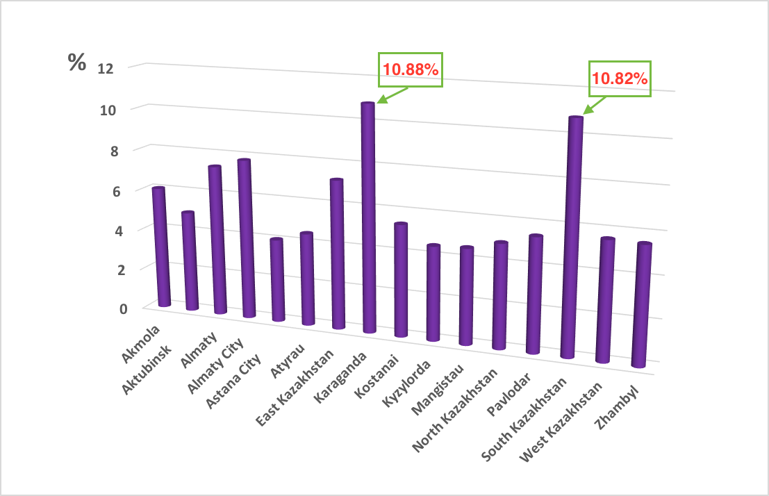

Figure 3.1: Regional distribution of the sample.

The survey includes a question about whether a respondent lives in a rural or urban area, to estimate the interaction with financial literacy. The data show that 59% of the sample lives in urban areas, and 41% in rural areas.

3.2 Financial Inclusion

Participation in financial markets is determined by holding and using financial products. In my case, they are a bank account, a deposit, a debit card, a credit card, stocks and trading stocks, foreign currency, and mutual funds.
From the summary statistics in Table 2 of Appendix 8.3, one can easily see that the debit card is the most popular financial product in Kazakhstan, while mutual funds are not so well-known. Figures 3.2 and 3.3 summarize reasons that an average Kazakhstani does not use several financial products. Most respondents don't open deposits and bank accounts, because they don't have enough money or don’t need financial services. People don't use stocks and mutual funds, because they lack financial knowledge or can't afford them. Kazakhstanis will be better off if they make the most of financial educational programs.

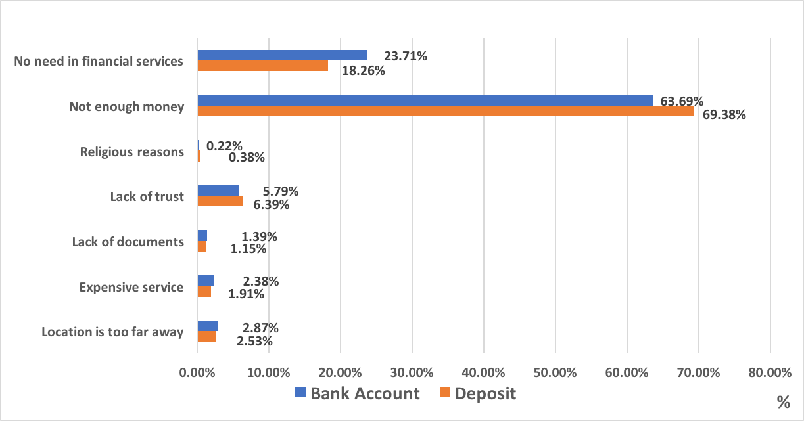

Figure 3.2: Reasons for financial exclusion (deposits and bank accounts).

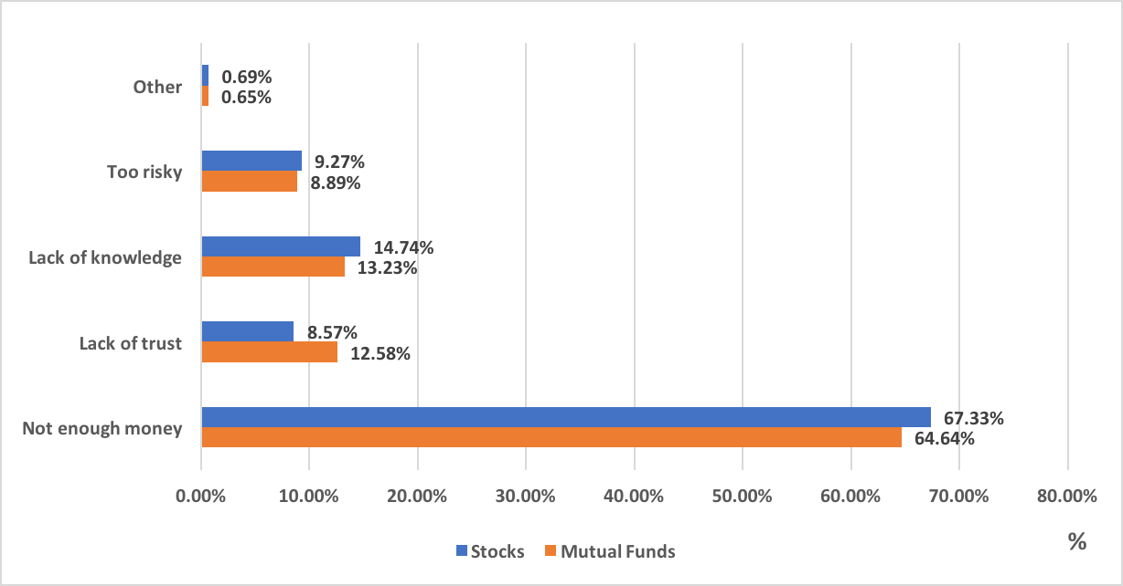

Figure 3.3: Reasons for financial exclusion (stocks and mutual funds).

3.3 Measuring Financial Literacy

Consumers who don't understand interest compounding face higher transaction costs and bigger debts (Lusardi & Tufano, 2015). Meanwhile, those who are financially well-informed are good at planning and saving for retirement (Behrman, Mitchell, Soo, & Bravo, 2010; Lusardi & Mitchell, 2014).
I measure financial literacy through the following three questions, which were combined from two surveys.

1. Suppose you have some money. Is it safer to put your money into one business or investment, or to put your money into multiple businesses or investments?
a. One;
b. Multiple;
c. I don't know.

2. Suppose you need to borrow 100,000 KZT. Which is the lower amount to pay back?
a. 105,000 KZT;
b. 100,000 KZT + 3%;
c. I don't know.

3. Imagine that the interest rate on your savings account was 1% per year and inflation was 2% per year. After one year, how much would you be able to buy with the money in this account?
a. More than today;
b. Exactly the same;
c. Less than today;
d. I don't know.

The first and the second questions were taken from Standard & Poor's Rating Services' Global Financial Literacy Survey (Klapper, Lusardi, & Van Oudheusden, 2015), and the third question is from an experimental financial literacy module designed by Lusardi and Mitchell (2005) for the 2004 Health and Retirement Study. Their questions became a benchmark for a wide variety of researchers who study financial literacy around the world. The three questions test basic knowledge of risk diversification, interest compounding, and inflation in Kazakhstan.
Figure 3.4 displays the distribution of the answers to these questions by the respondents. An individual is considered as financially literate if he answers two of three questions correctly. Based on this definition, 46.26% of the adults are financially literate in Kazakhstan.
Knowledge of risk diversification and inflation rate is low in Kazakhstan. More than 56% of all respondents (1,865 and 1,861) gave wrong answers. This is consistent with the results of the S&P worldwide survey mentioned above. Interest compounding is better understood.
According to Figure 3.5, even those who use financial services in Kazakhstan don't fully understand the basic financial and numerical concepts. Less than 60% of the clients of financial services answered correctly two or three questions on financial literacy.

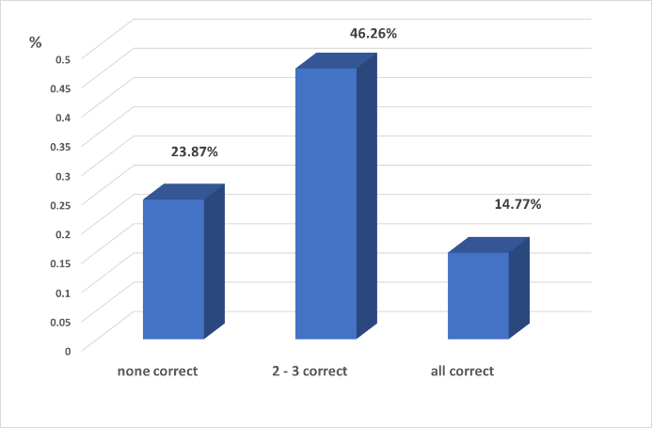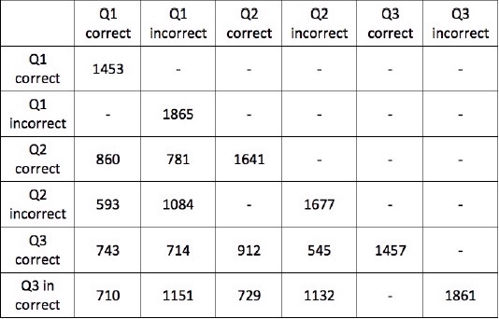

Figure 3.4: Distribution of the answers to financial literacy questions.

Figure 3.5: Financial literacy level of financial market participants.

3.4 Methodology

This paper studies the effects of financial literacy and internal migration on financial inclusion. Two questions are discussed separately with two econometric models.
First, I check how financial literacy might increase financial inclusion. For that I use a probit model based on this specification of the independent variables:

α + β FL_{i} + δ FLR_{i} + θ X_{i} + ε (1)

where the dependent variable fininc_{i} is a dummy variable that indicates financial inclusion (1 if one holds a financial product, 0 if one does not). I have eight products, hence I run eight regressions. I use a probit model, since my dependent variable can take one of only two values: 0 and 1. Probit applies a standard cumulative normal probability distribution to the dependent variable. It estimates the probability of financial inclusion for person i (that is, where the dependent variable fininc_{i} equals 1) as a nonlinear function of (1).
X_{i} is a vector of dummy variables for observed demographic characteristics (age, gender, education, nationality, marital status, and whether the living area is rural or urban).
FL_{i} is a dummy variable for financial literacy. I have created three dummies―FL₁, FL₂ and FL₃―in accordance with the three questions (FL₁=1 if a respondent answers correctly the first question, 0 if the answer is wrong; FL₂, for the second question; FL₃, for the third question).
FLR_{i} is an interactive term of financial literacy and living in a rural area (also a dummy variable). I include this term to check whether rural residence affects the response to financial literacy.
Regressions results of Model (1) are in Table 3 (Appendix 8.3).
Interaction effects were tested after the probit regressions. Interaction between financial literacy and living in rural areas was statistically significant, but other interactive effects were not.
Next, I check how migration from rural to urban areas affects financial inclusion. From Table 1, 717 people have moved in the last 10 years. According to Figure 3.6, of these 717 migrants, over 35% moved from rural to urban areas. These people are expected to be unusually active in financial markets.

 | Frequency | Percentage
Permanently residing here | 1,577 | 47.53
More than 10 years | 1,024 | 30.86
5 - 10 years | 304 | 9.16
Less than 5 years | 413 | 12.45
Total | 3,318 | 100

Table 1. Living duration in this residential area.

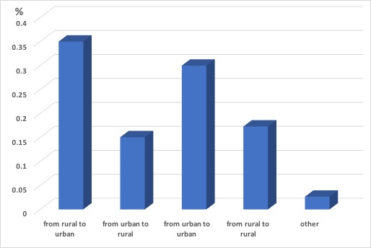

Figure 3.6: Migration in the last 10 years.

My second model includes a dummy variable for migration from rural to urban areas (M_{i}) and an interactive term for financial literacy and migration (FLM_{i}). The specification of the independent variables is now

α + β FL_{i} + γ M_{i} + δ FLM_{i} + θ X_{i} + ε (2)

In this model, I reduce the sample to urban residents only. According to the data, 1,965 respondents (59% of all respondents) live in cities.

4. Empirical Evidence

Tables 3 and 4 present the regression results of Models 1 and 2. (See Appendix 8.3.)
Looking at Model 1, the variables of interest are FinLit₁, Rural, FinLit₁ * Rural, FinLit₂, FinLit₃, FinLit₂ * Rural and FinLit₃ * Rural. The reference age is over 57/62.
The results show that an individual with a good understanding of risk diversification is more likely to hold a deposit, a debit card, and foreign currency than other people. A basic knowledge of risks affects one's decision to hold foreign currency more than other financial products, perhaps because those who understand tenge devaluation diversify their risks by buying and keeping different foreign currencies. A positive effect of financial literacy on holding a deposit can be explained similarly.
Also, it's more common for Kazakhstanis to use debit cards than it was five to ten years ago. Perhaps they understand financial risk: it is more prudent to carry less cash.
Basic numerical skills significantly increase the probability of holding almost all popular financial products in Kazakhstan. The biggest positive impacts are on having mutual fund shares and debit cards. An average person with knowledge of interest compounding can easily calculate his return from saving money on deposits or investing in mutual funds, and gauge expenses from using a credit card, a debit card, and foreign currency.
The third question, which tests one's knowledge of inflation, turns out to be one of the most difficult to answer. Only 44% gave the correct response. Previous studies had similar results. Understanding inflation encourages one to use a debit card more often and to trade stocks less often.
Table 3 suggests that living in a rural area decreases the probability of financial inclusion. But this is not because a rural individual is less literate: interactive terms FinLit₁ * Rural, FinLit₂ * Rural, and FinLit₃ * Rural don't show significant effects on financial inclusion, except one on trading stocks. The decrease in financial inclusion may be explained by limited access to financial institutions for households in villages and suburbs. Usually, there are no banks or post offices in a rural area in Kazakhstan. However, we can observe the positive effect of FinLit₂ * Rural on trading. The intuition behind this result is that knowledge of interest compounding makes it more likely that rural residents will trade stocks. That is, FinLit₂ increases the response of trading to the Rural variable.
Even when one can diversify investment risks, living in a rural area still decreases the probability of trading, by more than four fifths and with statistical significance. At the same time, the interaction between basic skills of interest compounding and living in a rural area has a significantly positive effect on trading. Being able to calculate your return from different investments might increase your interest in trading stocks even if you don't live in a city.
This model didn't show a statistically significant effect of financial literacy and living in a rural area on financial products other than on trading. This can imply that Kazakhstanis suffer from limited access to financial institutions while living in rural areas. Being financially well-informed cannot increase one's inclusion in financial markets if he is constrained by location.
Looking at the demographic characteristics, it can be concluded that women hold fewer stocks and less foreign currency than men. Kazakhs are likely to hold more debit cards and credit cards and less foreign currency than other nationalities on average. Individuals who are married or live with a partner use fewer credit cards and less foreign currency. This might be because married people want to carry less risk and to avoid unnecessary expenditures on a credit card or a currency devaluation, since they need to provide for their families.
From the regression results, I conclude that credit cards are popular for all ages, especially ages 25 to 45. But these people don't like to trade stocks.
College education significantly increases the probability of participation in financial markets. This is consistent with previous research. But from Table 3 we see that getting a college education decreases the probability of trading by almost half, perhaps because people who graduate from a college usually try to work in a full-time job related to their major. However, trading in Kazakhstan is becoming popular among those who can’t find full-time work, very often due to the lack of higher education. They can make extra money while trading in the short run.
Now let's turn to probit model (3.2). My variables of interest here are FinLit₁, Migration, FinLit₁ * Migration, FinLit₂, FinLit₃, FinLit₂ * Migration and FinLit₃ * Migration. Migration indicates only the move from a rural to an urban area.
The effects of financial literacy on financial inclusion are consistent with Model (3.1). Financially educated individuals are more likely to hold basic financial products like bank accounts, deposits, debit cards, credit cards, and foreign currencies. Understanding risk diversification has a strong positive effect on trading. This is because people invest in stocks and actively trade them in order to mitigate their risks. However, respondents with knowledge of inflation are less likely to trade. They might prefer to spend their money rather than invest it for a long time.
A person who understands risk diversification and has numerical skills is more likely to hold foreign currency, perhaps because of big fluctuations in the tenge exchange rate since 2015. Knowledge of interest compounding increases the probability of holding a debit card.
From Model (1), I concluded that a rural individual's financial behavior is little affected by his understanding of financial concepts. To check if migration changes this situation, I introduced a new variable―migration from rural to urban areas.
Table 4 shows that such migration significantly decreases the probability of investing in stocks and mutual funds. Of 251 respondents who migrated to urban areas, only two bought stocks and only seven had shares in mutual funds. Initially many of them may not have been familiar with stocks and mutual funds.
Omission of results on trading is explained by the small number of respondents. Out of 47 respondents who were trading, only 33 lived in urban areas, and only two of them had migrated there.
In Model 2, I also test interaction effects. In this case, FinLit₁ * Migration, FinLit₂, FinLit₃, FinLit₂ * Migration and FinLit₃ * Migration don't show much significance.

5. Conclusion

In a nationwide survey, I measure financial literacy by using three questions that test basic knowledge of risk diversification, interest compounding, and inflation. An individual is considered as financially literate if he answers two of three questions correctly. Based on this definition, 46% of adults of the surveyed group are financially literate. They know less about risk diversification than about interest compounding and inflation. This is consistent with the results of the S&P worldwide survey.
Consequences for financial literacy differ when it comes to gender, age, and education. A total of 48.6% of Kazakhstani men provide correct answers. Financial literacy increases with educational attainment: 46.26% of adults with a college education are financially literate, while only 42% of those with a secondary education answered correctly the given questions.
Overall, financial literacy is important for a user of financial markets in Kazakhstan. But financial literacy is not the only determinant of financial inclusion. As the survey shows, many people don't have enough money to buy stocks or to maintain saving accounts.
The area of residence can also affect financial inclusion. Rural residents use fewer financial products, even if they possess numerical skills and knowledge about risks and inflation, because they have limited access to financial institutions.
Migration does not determine financial behavior. On average, people don't consume more banking products when they move elsewhere. The main reasons for financial exclusion are a lack of money and information. Policy makers should consider training the population in financial literacy.
This paper can be extended in several ways. First, one can estimate the effect of financial literacy on insurance and pension funds. Second, one can include expenses of food or electricity as an instrumental variable for income―taking care to avoid endogeneity, since those with higher income might use more financial services despite their illiteracy. Income may affect financial literacy as well. Third, new explanatory variables might include bank locations and access to the Internet.

Akerke Nurgaliyeva is a Research Coordinator at the China and Central Asia Studies Center, KIMEP University. She received a master’s degree in economics from Nazarbayev University, Nur-Sultan, Kazakhstan, and a bachelor’s degree in international finance from Beihang University, Beijing, China. Her research area of interest is financial economics.

6. Summary

English: Based on an original nationwide survey, this study shows that financial literacy is low in Kazakhstan. Rural residents use fewer financial products because they have limited access to financial institutions. However, moving to urban areas doesn’t significantly improve financial inclusion. Policy makers should consider training the population in financial literacy.

Russian: Основываясь на оригинальном общенациональном опросе, данное исследование показывает, что финансовая грамотность в Казахстане достаточно низкая. Сельские жители используют меньше финансовых продуктов, в связи с ограниченным доступом к финансовым учреждениям. Однако переезд в город не повышает финансовую вовлеченность. Политикам необходимо рассмотреть вопрос обучения населения финансовой грамотностью.

Kazakh: Жалпыұлттық сауалнамаға сүйене отырып, бұл зерттеу Қазақстанда қаржылық сауаттылықтың төмендігін көрсетеді. Ауыл тұрғындары аз қаржылық өнімдерді пайдаланады, өйткені олардың қаржы институттарына қол жетімділігі шектеулі. Алайда, қалаға көшу қаржылық кірісті айтарлықтай жақсартпайды. Саясат жасаушылар халықты қаржылық сауаттылыққа үйретуді қарастыруы керек.

7. References

Agnew, J.R., Bateman, H., & Thorp, S. (2013). Financial literacy and retirement planning in Australia. Numeracy, 6, 1-25.

Behrman, J., Mitchell, O.S., Soo, C., & Bravo, D. (2010). Financial literacy, schooling, and wealth accumulation (No. 16452). Cambridge, MA: National Bureau of Economic Research Working Paper Series (October).

Boisclair, D., Lusardi. A., & Michaud, P. (2014). Financial literacy and retirement planning in Germany (No. 20297). Cambridge, MA: National Bureau of Economic Research Working Paper Series (July).

Bucher-Koenen, T., & Lusardi, A. (2011). Financial literacy and retirement planning in Germany. Journal of Pension Economics and Finance, 10, 565-584.

Gibson, J., McKenzie, D., & Zia, B. (2012). The impact of financial literacy training for migrants. The World Bank Economic Review, 28, 130-161.

Gustman, A.L., Steinmeier, T.L., & Tabatabai, N. (2010). Financial knowledge and financial literacy at the household level (No. 16500). Cambridge, MA: National Bureau of Economic Research Working Paper Series (October).

Kish, L. (1965). Survey sampling. New York: John Wiley & Sons, Inc.

Klapper, L., Lusardi, A., & Van Oudheusden, P. (2015). Financial literacy around the world: insights from Standard & Poor's Ratings Services’ global financial literacy level. Washington, D.C.: World Bank.

Klapper, L., & Panos, G.A. (2011). Financial literacy and retirement planning in view of a growing youth demographic: the Russian case. Turin, Italy: Center for Research on Pensions and Welfare Policies.

Lee, S.H., & Kuttyzholova, A. (2016). Financial literacy and retirement planning in Kazakhstan. Journal of Insurance and Financial Management, 1, 77-96.

Lusardi, A., & Mitchell, O.S. (2005). Financial literacy and planning implications for retirement well-being (No. WP 2005-108). Michigan Retirement Research Center Research Paper (December).

Lusardi, A., & Mitchell, O.S. (2011). Financial literacy around the world: an overview. Journal of Pension Economics and Finance, 10, 497-508.

Lusardi, A., & Mitchell, O.S. (2014). The economic importance of financial literacy: theory and evidence. Journal of Economic Literature, 52, 5-44.

Lusardi, A., & Tufano, P. (2015). Debt literacy, financial experiences, and over-indebtedness. Journal of Pension, Economics and Finance, 14, 332-328.

Norton, E.C., Wang, H., & Ai, C. (2004). Computing interaction effects and standard errors in logit and probit models. The Stata Journal, 4, 154-167.

President's Advisory Council on Financial Literacy. (2008). Annual report to the President. Washington, D.C.: President's Advisory Council on Financial Literacy. https://www.treasury.gov/about/organizational-structure/offices/domestic-finance/documents/exec_sum.pdf

Rooji, M.V, Lusardi, A., & Alessie, R. (2009). Financial literacy and retirement planning in the Netherlands. Amsterdam: Netherlands Central Bank, Research Department.

World Bank (2017). Retrieved from www.worldbank.org/en/topic/financialinclusion/overview

8. Appendix

8.1 Survey Questions

- How long have you been living in this inhabited locality?
- Always.
- More than 10 years.
- 5-10 years.
- Less than 5 years.

- In the past 10 years you (please choose your last move)
- Migrated from a village to a city.
- Migrated from a city to a village.
- Migrated from a city to a city.
- Migrated from a village to a village.
- Other.

- Do you have a bank account?
- Yes.
- No.

- If no, the reason is (please choose one).
- Too far away.
- Too expensive.
- Lack of documentation.
- Lack of trust.
- Religious reasons.
- Lack of money.
- No need for financial services.
- Other.

- If you have an account, have you made any deposit/withdrawal into/from your account in the past six months?
- Yes.
- No.

- If you have an account, have you made any payments using mobile phone or the Internet in the past six months?
- Yes.
- No.
- Do you have a fixed deposit account?
- Yes.
- No.

- If no, the reason is:
- Too far away.
- Too expensive.
- Lack of documentation.
- Lack of trust.
- Religious reasons.
- Lack of money.
- No need for financial services.
- Other.

- If you have a deposit account, have you made any deposit/withdrawal into/from your account in the past six months?
- Yes.
- No.

- If you have a deposit account, have you made any payments using mobile phone or the Internet in the past six months?
- Yes.
- No.

- Do you have a debit card in your own name?
- Yes.
- No.

- If yes, have you used it in the past six months?
- Yes.
- No.

- Have you made any payments on your debit card using a mobile phone or the Internet in the past month?
- Yes.
- No.

- Do you have a credit card in your own name?
- Yes.
- No.
- If yes, have you used it in the past six months?
- Yes.
- No.

- Have you made any payments through your credit card using a mobile phone or the Internet in the past month?
- Yes.
- No.

- Do you hold dollars?
- Yes.
- No.

- Do you buy stocks?
- Yes.
- No.

- If no, the reason is
- Lack of money.
- Lack of trust.
- Lack of knowledge.
- Too risky.
- Other.

- If yes, how often do you trade?
- Every month.
- Every six months.
- Every year.

- Do you know what a mutual fund is?
- Yes.
- No.

- Do you have shares in any mutual fund?
- Yes.
- No.

- If no, the reason is
- Lack of money.
- Lack of trust.
- Lack of knowledge.
- Too risky.
- Other.

- Suppose you have some money. Is it safer to put your money into one business or investment, or to put your money into multiple businesses or investments?
- One.
- Multiple.
- I don't know.

- Suppose you need to borrow 100,000 KZT. Which is the lower amount to pay back?
  - 105,000 KZT.
  - 100,000 KZT + 3%.
  - I don't know.

- Imagine that the interest rate on your savings account was 1% per year and inflation was 2% per year. After one year, how much would you be able to buy with the money in this account?
- More than today.
- Exactly the same.
- Less than today.
- I don't know.

8.2 Demographic Information

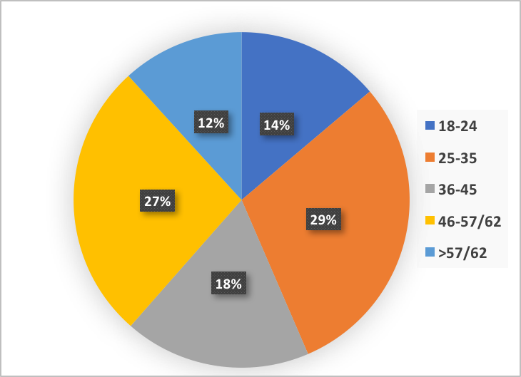

Figure 8.1: Sample male distribution.

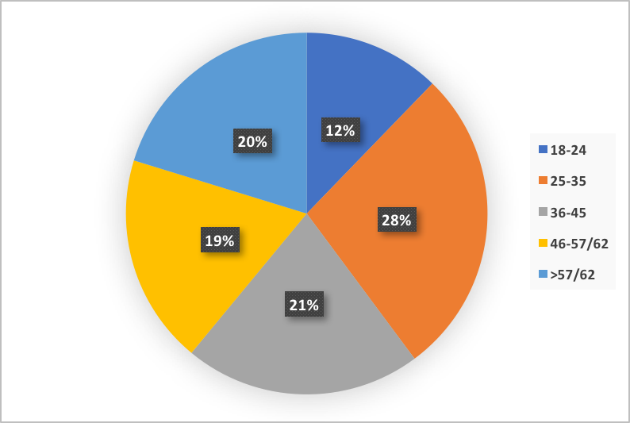

Figure 8.2: Sample female distribution.

8.3 Regression Results

Variable | Mean | Std. Dev. | Min. | Max. | N
Bank Account | 0.328 | 0.469 | 0 | 1 | 3318
Deposit | 0.132 | 0.339 | 0 | 1 | 3318
Debit Card | 0.467 | 0.499 | 0 | 1 | 3318
Credit Card | 0.158 | 0.365 | 0 | 1 | 3318
Stocks | 0.015 | 0.121 | 0 | 1 | 3318
Trading | 0.347 | 0.481 | 0 | 1 | 49
Foreign Currency | 0.083 | 0.277 | 0 | 1 | 3318
Mutual Fund | 0.02 | 0.141 | 0 | 1 | 3318
Fin Lit 1 | 0.438 | 0.496 | 0 | 1 | 3318
Fin Lit 2 | 0.495 | 0.5 | 0 | 1 | 3318
Fin Lit 3 | 0.439 | 0.496 | 0 | 1 | 3318
Rural | 0.408 | 0.491 | 0 | 1 | 3318
Migration from rural to urban area | 0.076 | 0.264 | 0 | 1 | 3318
College education | 0.331 | 0.471 | 0 | 1 | 3318
Female | 0.621 | 0.485 | 0 | 1 | 3318
Age 18-24 | 0.128 | 0.335 | 0 | 1 | 3318
Age 25-35 | 0.284 | 0.451 | 0 | 1 | 3318
Age 36-45 | 0.2 | 0.4 | 0 | 1 | 3318
Age 46-57/62 | 0.218 | 0.413 | 0 | 1 | 3318
Age 57/62 | 0.17 | 0.376 | 0 | 1 | 3318
Kazakh | 0.673 | 0.469 | 0 | 1 | 3318
Married or w/partner | 0.637 | 0.481 | 0 | 1 | 3318
Divorced or widow | 0.192 | 0.394 | 0 | 1 | 3318

Table 2. Summary statistics.

 | Bank Account | Deposit | Debit Card | Credit Card | Stocks | Trading | Foreign Currency | Mutual Fund
FinLit₁ | 0.073 | 0.156** | 0.160*** | 0.027 | 0.134 | 0.579 | 0.204*** | 0.092
 | (0.060) | (0.070 | (0.059) | (0.069) | (0.148) | (0.495) | (0.078) | (0.143)
FinLit₂ | 0.138** | 0.130* | 0.272*** | 0.180** | 0.056 | 0.224 | 0.160** | 0.282*
 | (0.062) | (0.072) | (0.061) | (0.072) | (0.152) | (0.614) | (0.078) | (0.158)
FinLit₃ | 0.051 | 0.071 | 0.179*** | 0.043 | -0.058 | - 2.317*** | - 0.048 | - 0.078
 | (0.061) | (0.071) | (0.060) | (0.072) | (0.135) | (0.623) | (0.078) | (0.139)
Rural | - 0.155* | - 0.284*** | - 0.039 | - 0.053 | - 0.084 | - 1.748* | - 0.406*** | 0.259
 | (0.080) | (0.109) | (0.077) | (0.097) | (0.204) | (1.052) | (0.132) | (0.183)
FinLit₁ * Rural | - 0.014 | 0.049 | - 0.140 | 0.088 | - 0.036 | - 5.590*** | - 0.036 | - 0.039
 | (0.097) | (0.125) | (0.093) | (0.112) | (0.251) | (1.311) | (0.148) | (0.209)
FinLit₂ * Rural | - 0.088 | - 0.039 | - 0.024 | - 0.090 | - 0.217 | 5.890*** | - 0.123 | - 0.266
 | (0.097) | (0.125) | (0.093) | (0.113) | (0.255) | (0.868) | (0.148) | (0.216)
FinLit₃ * Rural | 0.071 | - 0.115 | - 0.074 | - 0.068 | 0.144 | 0.000 | 0.193 | 0.204
 | (0.098) | (0.127) | (0.094) | (0.116) | (0.245) | (.) | (0.148) | (0.206)
College | 0.372*** | 0.458*** | 0.330*** | 0.216*** | 0.322*** | - 1.753*** | 0.374*** | 0.141
 | (0.050) | (0.060) | (0.049) | (0.058) | (0.119) | (0.603) | (0.067) | (0.107)
Female | 0.079 | - 0.032 | 0.001 | - 0.036 | - 0.312*** | 0.716 | - 0.128* | - 0.044
 | (0.049) | (0.060) | (0.047) | (0.056) | (0.119) | (0.718) | (0.068) | (0.106)
Kazakh | 0.074 | - 0.053 | 0.108** | 0.128** | 0.158 | 0.823 | - 0.135* | - 0.100
 | (0.051) | (0.062) | (0.049) | (0.062) | (0.138) | (0.531) | (0.072) | (0.111)
Married or w/partner | 0.114 | 0.004 | - 0.043 | - 0.154** | 0.047 | 0.728 | - 0.178* | 0.210
 | (0.071) | (0.088) | (0.069) | (0.078) | (0.208) | (0.814) | (0.094) | (0.183)
Divorced or widow | 0.070 | - 0.099 | - 0.076 | - 0.158 | 0.176 | - 0.010 | - 0.190 | 0.160
 | (0.092) | (0.116) | (0.089) | (0.106) | (0.240) | (1.182) | (0.126) | (0.224)
Age  (18-24) | 0.130 | - 0.153 | - 0.067 | 0.335*** | - 0.499 | 0.655 | 0.279* | - 0.358
 | (0.101) | (0.126) | (0.097) | (0.129) | (0.313) | (1.278) | (0.150) | (0.273)
Age  (25-35) | 0.153* | - 0.018 | - 0.055 | 0.641*** | - 0.314* | 1.009 | 0.321*** | 0.024
 | (0.079) | (0.093) | (0.075) | (0.105) | (0.181) | (0.750) | (0.122) | (0.165)
Age  (36-45) | 0.114 | - 0.032 | 0.023 | 0.559*** | - 0.343* | 1.184 | 0.373*** | - 0.354*
 | (0.080) | (0.097) | (0.077) | (0.107) | (0.189) | (0.775) | (0.123) | (0.191)
Age  (46-57/62) | 0.087 | - 0.277*** | - 0.066 | 0.393*** | - 0.242 | 0.487 | 0.217* | 0.025
 | (0.078) | (0.099) | (0.075) | (0.106) | (0.179) | (0.974) | (0.124) | (0.157)
Constant | - 0.921*** | - 1.205*** | - 0.421*** | - 1.563*** | -2.076*** | - 0.343 | - 1.514*** | - 2.356***
 | (0.110) | (0.137) | (0.106) | (0.134) | (0.290) | (1.045) | (0.157) | (0.251)
N | 3318 | 3318 | 3318 | 3318 | 3318 | 43 | 3318 | 3318
Standard errors in parentheses
* p<0.1, ** p<0.05, *** p<0.01

Table 3: Regression results of Model 1.

 | Bank Account | Deposit | Debit Card | Credit Card | Stocks | Trading | Foreign Currency | Mutual Fund
FinLit₁ | 0.085 | 0.156*** | 0.133** | 0.013 | 0.081 | 21.121*** | 0.201** | 0.039
 | (0.064) | (0.075) | (0.063) | (0.074) | (0.161) | (2.311) | (0.083) | (0.156)
FinLit₂ | 0.138** | 0.126 | 0.276*** | 0.167** | - 0.005 | 7.989 | 0.156* | 0.123
 | (0.065) | (0.077) | (0.064) | (0.077) | (0.163) | (.) | (0.085) | (0.165)
FinLit₃ | 0.017 | 0.057 | 0.152** | 0.052 | - 0.059 | - 30.609*** | - 0.064 | 0.023
 | (0.065) | (0.076) | (0.064) | (0.077) | (0.139) | (2.180) | (0.083) | (0.142)
Migration | - 0.256 | - 0.028 | - 0.156 | 0.021 | - 7.723*** | 0.000 | - 0.019 | - 3.552***
 | (0.163) | (0.196) | (0.155) | (0.182) | (0.408) | (.) | (0.221) | (0.333)
FinLit₁ * Migration | - 0.125 | - 0.027 | 0.265 | 0.094 | 4.060*** | 0.000 | 0.020 | 0.253
 | (0.194) | (0.212) | (0.185) | (0.208) | (0.402) | (.) | (0.240) | (0.444)
FinLit₂ * Migration | - 0.018 | 0.096 | - 0.063 | 0.137 | 4.161*** | 0.000 | 0.005 | 4.274**
 | (0.197) | (0.219) | (0.191) | (0.213) | (0.488) | (.) | (0.238) | (0.322)
FinLit₃ * Migration | 0.224 | 0.129 | 0.169 | - 0.027 | - 0.343 | 0.000 | - 0.036 | - 0.572
 | (0.202) | (0.226) | (0.196) | (0.222) | (0.660) | (.) | (0.234) | (0.434)
College | 0.316*** | 0.427*** | 0.302*** | 0.219*** | 0.493*** | - 32.790*** | 0.456*** | 0.214
 | (0.062) | (0.072) | (0.062) | (0.073) | (0.157) | (3.324) | (0.079) | (0.144)
Female | 0.032 | - 0.015 | - 0.048 | - 0.061 | -0.475*** | 21.360*** | - 0.133* | - 0.037
 | (0.062) | (0.073) | (0.061) | (0.072) | (0.151) | (2.313) | (0.080) | (0.151)
Kazakh | - 0.050 | - 0.104 | 0.036 | 0.071 | 0.099 | 29.653*** | - 0.179** | - 0.111
 | (0.064) | (0.074) | (0.062) | (0.077) | (0.168) | (3.142) | (0.084) | (0.153)
Married or w/partner | 0.116 | - 0.002 | - 0.125 | - 0.069 | - 0.029 | 32.551*** | - 0.217** | 0.328
 | (0.089) | (0.105) | (0.088) | (0.099) | (0.275) | (3.926) | (0.110) | (0.264)
Divorced or widow | 0.108 | - 0.159 | - 0.185* | - 0.067 | 0.139 | - 4.965* | - 0.203 | 0.331
 | (0.112) | (0.137) | (0.111) | (0.131) | (0.296) | (2.827) | (0.146) | (0.316)
Age  (18-24) | 0.157 | - 0.179 | - 0.341*** | 0.544*** | - 0.608 | 27.075*** | 0.162 | - 0.294
 | (0.127) | (0.150) | (0.124) | (0.163) | (0.443) | (3.062) | (0.176) | (0.492)
Age  (25-35) | 0.199** | - 0.045 | - 0.247*** | 0.751*** | - 0.377* | 0.956 | 0.241* | 0.358
 | (0.099) | (0.112) | (0.097) | (0.136) | (0.218) | (1.234) | (0.140) | (0.258)
Age  (36-45) | 0.060 | - 0.179 | - 0.139 | 0.750*** | - 0.356 | 0.478 | 0.381*** | - 0.043
 | (0.104) | (0.121) | (0.102) | (0.139) | (0.227) | (1.187) | (0.144) | (0.279)
Age  (46-57/62) | - 0.018 | - 0.314*** | - 0.293 | 0.588*** | - 0.312 | 0.065 | 0.122 | 0.259
 | (0.101) | (0.121) | (0.098) | (0.138) | (0.218) | (1.749) | (0.145) | (0.252)
Constant | - 0.751*** | - 1.106*** | - 0.068 | - 1.731*** | - 1.878*** | - 29.142*** | - 1.428*** | - 2.722***
 | (0.131) | (0.158) | (0.127) | (0.166) | (0.345) | (2.817) | (0.176) | (0.372)
N | 1965 | 1965 | 1965 | 1965 | 1965 | 33 | 1965 | 1965
Standard errors in parentheses
* p<0.1, ** p<0.05, *** p<0.01

Table 4: Regression results of Model 2.

President's Advisory Council on Financial Literacy.
The reader can request the data via email.
The National Analytical Center JSC was established in September 2007 at the initiative of the Government of the Republic of Kazakhstan and the National Bank. The NAC provides consultation services in such fields as public administration as well as strategic and economic development. In 2017 it was renamed the NAC Analytica Corporate Fund. www.nacanalytica.com
A bank account is a current account that doesn’t imply interest earnings―what in American English is called a “demand deposit account.” A deposit is a savings account.
Graphs of interactive effects were produced using a new command in STATA, inteff, which computes the marginal effect of a change in two combined variables. This method was introduced and discussed by Norton, Wang, and Ai (2004). In nonlinear models like logit and probit, inteff gives the correct marginal effects and standard errors. The total number of graphs derived is 96 (one graph for each interactive effect for each product), including the second model. Graphs are available on request.
The interactive effect between knowledge of inflation and living in a village on trading was omitted in the results for Model (3.1). This is because only two people out of 1,457 who answered correctly the third question, actually trade stocks.
The graphs can be provided upon request.

