Multidimensional poverty: An application to Kazakhstan

Alma Kudebayeva,
College of Social Sciences, KIMEP University, Kazakhstan
almak@kimep.kz
and
Ainur Janbauova
ajanbauova@gmail.com
Central Asia Business Journal 8(1): 5-25
Summer 2017

Multidimensional poverty: An application to Kazakhstan

Alma Kudebayeva,
College of Social Sciences, KIMEP University, Kazakhstan
almak@kimep.kz
and
Ainur Janbauova
ajanbauova@gmail.com

Abstract: This study estimates multidimensional poverty in Kazakhstan by applying a method developed by Alkire and Foster (2011) and by using data from the 2005 and 2009 versions of the Kazakhstan Household Budget Survey. Income, education, and drinking water supply were selected as dimensions for poverty estimations. The study finds that 18% in 2005 and 8% in 2009 of the population is multidimensionally poor, of which more than 70% live in rural areas. The income and education dimensions contribute the most to overall multidimensional poverty. The Kyzylorda, Atyrau, South-Kazakhstan and Mangistau oblasts have the highest levels of multidimensional poverty. Female headed households, older or unmarried household heads, household heads with good or satisfactory health, and household heads of ethnicities other than Kazakh and Uighur were less likely to be multidimensionally poor in 2005. Household heads with poor health, widowed household heads, households with four or more members, and household heads who were unemployed or rural were most likely to be multidimensionally poor.

Keywords: Multidimensional poverty, determinants of poverty, Kazakhstan, household surveys

1. Introduction
Poverty, as defined by Clark and Hulme (2010), has three dimensions: Depth (or severity), breadth (multidimensionality over various capabilities, rights or deprivations) and time (duration).
The main approaches for evaluating well-being in poverty are welfarist and non-welfarist (Duclos and Araar, 2006). The welfarist perspective roots in utilitarianism (Bentham, 1789; Edgeworth, 1881; Marshall, 1890; Mill, 1961; Pigou, 1920) and uses income or consumption as a proxy for welfare (Atkinson, 1987; Kakwani, 1980; Ravallion, 1996). Sen (1979, p. 554) criticized this approach: “The poor cannot be distinguished for this purpose from the rich – neither in terms of utility, nor in terms of income or other non-utility information.”
While scholars agree that poverty is multidimensional, they debate whether indicators of deprivation should form a composite index. On the other hand, such a measure seems unavoidable when the purpose is to gauge the incidence of deprivations in the same individuals. One way to measure multidimensional poverty is to count the number of dimensions in which people are deprived. The counting approach is popular in the Alkire-Foster (2011) family of poverty studies and in other works (Anand and Sen, 1997; Bourguignon and Chakravarty, 2003; Chakravarty and Silber, 2008; Ray and Sinha, 2015).
The government of Kazakhstan has achieved three of its Millennium Development Goals – reducing poverty, providing general primary education, and promoting women’s rights (UN, 2010). Poverty headcount indexes using the official poverty line declined from 46.7% in 2001 to 2.8% in 2014 (Appendix, Table A1). But the United Nations Development Programme notes that poverty is a “multidimensional phenomenon that has deep socio-economic, cultural and psychological roots. It is conditioned by time and location. Historical developments within individual countries must be taken into account when measuring poverty” (UNDP Kazakhstan, 2004).
One example of the multidimensional approach is the Programme’s Human Development Index, which it introduced in its 1997 Human Development Report. The Index uses such indicators as life expectancy, unemployment, infant mortality and maternal mortality to measure poverty in addition to such traditional measures as income, consumption and purchasing power (UNDP Kazakhstan, 2004). But to our knowledge, ours is the first paper to estimate multidimensional poverty in Kazakhstan.
In the paper, Section 2 reviews the literature. Section 3 discusses our methods and data, and Section 4 gives our results. The last section summarizes and interprets conclusions.

2. Literature review
“Monetary poverty” is an approach focusing on income or consumption, emphasizing the cost of a subsistence basket of goods (Ravallion, 1994). It limits the range and depth of human needs, and its rationale for the threshold below which a household is considered poor is fuzzy.
According to Townsend (1979, p.31): “Individuals, families and groups in the population can be said to be in poverty when they lack the resources to obtain the types of diet, participate in the activities, and have the living conditions and amenities which are customary, or are at least widely encouraged or approved, in the societies to which they belong. Their resources are so seriously below those commanded by the average individual or family that they are, in effect, excluded from ordinary living patterns, customs and activities.”
This definition of poverty is multidimensional. Anyone who lacks certain goods and services is poor (Bellido et al., 1998). Thus the measurement of poverty should consider living conditions, health, education, and other vital characteristics. Papers on multidimensional poverty measures include Alkire and Foster (2011) and Bourguignon and Chakravarty (2003). Anand and Sen (1997), Atkinson (2003) and Thorbecke (2008) define cross-cutting problems. Chakravarty and Silber (2008), Tsui (2002), and Bourguignon (2003) proposed axiomatic approaches to multidimensional poverty measures. With an axiomatic approach, one can construct individual and aggregate measures of deprivation and social exclusion (Bossert and Peragine, 2007).
Research on multidimensional poverty has grown substantially during recent years. For example, Laderchi et al. (2003) found evidence that monetary poverty does not always mirror deprivations that occur in several dimensions. In Peru, about 30% of the children and adults who were deprived of education were not monetarily poor. That was also true of around 20% of the children and more than half of the adults who were deprived of health or nutrition. Thus monetary poverty may misidentify deprivation in other dimensions (Alkire and Foster, 2011).
However, the method of multidimensional poverty has disadvantages. One problem is to select essential goods and services, since populations differ in their needs and demands. Secondly, the researcher must make sure that deprivation in a given dimension is unwanted and can occur only through a lack of resources (Bellido et al., 1998). In any case, the researcher’s selection of dimensions depends on her own understanding of poverty (Hayati et al., 2006).
In multidimensional settings, identification is complex. With given dimensions, one can identify for each person whether she is deprived in each dimension by using related thresholds or poverty lines. But the problem is to aggregate each person’s deprivations in each dimension and to decide who is to be considered multidimensionally poor (Bourguignon and Chakravarty, 2003).
In this perspective, recent studies have developed two ways to identify poverty: Union and intersection.
The union is the most common approach. It considers the person to be poor if deprived in at least one dimension. However, as the number of dimensions increases, most of the population may be identified as poor, which some observers may regard as an exaggeration. Consequently, the union method cannot be useful in distinguishing the most extensively deprived persons (Alkire and Foster, 2011).
The other identification approach is the intersection: To be considered poor, a person must be deprived in all dimensions. Thus those considered poor are few. This approach is most helpful in distinguishing the poorest of the poor. But those who are deprived in many but not all dimensions are considered non-poor. Furthermore, as the number of dimensions increases, the poor share of the population decreases (Alkire and Foster, 2011).
In a good comparison of the two methods, Alkire and Seth (2015) use ten dimensions to identify the poor in rural India. Of the population, the union approach identified 97.1% as poor, and the intersection approach, 0.1%. These methods cannot be applied in all circumstances.
The majority of poverty studies in Kazakhstan have long been conventional, based on cross-sectional data (Anderson and Pomfret, 2002; Pomfret, 2006; Rhoe et al., 2008). Conventional static analysis focuses on the poverty headcount ratio, which measures the proportion of the population that has fallen below an income or expenditure threshold at a particular time, without considering deprivation in other dimensions.

3. Methodology and data

3.1 Multidimensional poverty index
Before considering Alkire and Foster’s (2011) model in detail, let’s clarify notation. Let $n$ denote the number of persons, and $d≥2$ (since the measure is multidimensional) be the number of dimensions. Let $x=\left[x_{ij}\right]$ represent the $n×d$ matrix of achievements, and $x_{ij}≥0$ be an achievement of any person $i$ $=1,…,n$ in any dimension $j=1,…,d$. Each row vector $x_{i}$ contains person $i$’s achievements in different dimensions, whereas each column vector $x_{*j}$ represents the distribution of dimension $j$ achievements across persons. Let $z_{j}>0$ be the deprivation cutoff or poverty line in dimension $j$. We use the expression $\left|v\right|$ to represent the sum of all elements of any vector or matrix $v$, and $μ(v)$ to denote the mean of $v$ (or $\left|v\right|$ divided by the total number of elements of vector or matrix $v$) (Alkire and Foster, 2011).
For any given $x$, $g^{0}=\left[g_{ij}^{0}\right]$ represents the matrix of deprivations, whose typical element $g_{ij}^{0}$ is defined by $g_{ij}^{0}=1$ in case $x_{ij}<z_{j}$, and $g_{ij}^{0}=0$ in case $x_{ij}≥z_{j}$. Thus $g^{0}$ is a matrix such that its ${ij}^{}$ element is 1 when person $i$ is deprived in dimension $j$, and 0 when the person is not deprived. From $g^{0}$ we build a column vector $c$ of deprivation counts such that the $i^{th}$ element $c_{i}=\left|g_{i}^{0}\right|$ denotes the number of deprivations suffered by person $i$.
The approach of Alkire and Foster (2011) identifies the multidimensionally poor using a cutoff level $c_{i}$ lying between the two extremes of 1 and $d$. For $k=1,…d$, let $P_{k}$ be the identification measure defined by $P_{k}\left(x_{i};z\right)=1$ when $c_{i}≥k$, and $P_{k}\left(x_{i};z\right)=0$ when $c_{i}<k$. That is, $P_{k}$ identifies person $i$ as multidimensionally poor if the number of dimensions in which she is deprived is at least as large as $k$. If the number of deprived dimensions is less than the cutoff $k$, she is not considered as multidimensionally poor. Since $P_{k}$ uses both the within dimension cutoffs $z_{j}$ and the across dimensions cutoff $k$, the authors call it the dual cutoff method of identification. $P_{k}$ includes the union and the intersection methods in the special cases of $k=1$ and $k=d$.
Let $Z_{k}=\left\{ i :P_{k}\left(x_{i};z\right)=1\right\}$ denote the set of multidimensionally poor people identified by using the dual cutoff approach. The percentage of the population that is poor will be estimated by the multidimensional Headcount Ratio$H=H(x;z)$, which is defined by $H=q/n$, where $q=q\left(x;z\right)=\sum_{i=1}^{n}{P_{k}(x_{i};z)}$ is the number of persons in the set $Z_{k}$. This measure is easy to compute and understand, and it can be calculated with ordinal data (Santos and Ura, 2008). But it violates the dimensional monotonicity axiom. In other words, if a poor person becomes deprived in a new dimension, $H$ won’t change. Furthermore, $H$ cannot be decomposed to show how much each dimension contributes to poverty (Alkire and Foster, 2011).
In this connection, the authors suggest a class of poverty measures that adjusts for dimensions, the Foster-Greer-Thorbecke (FGT) approach. This is given by $M_{α}\left(x;z\right)=μ\left(g^{α}\left(k\right)\right)$ when $α≥0$. When $α=0$, they propose the Adjusted Headcount Ratio, given by $M_{0}=μ\left(g^{0}\left(k\right)\right)=HA$, which is the total number of deprivations experienced by the poor (or $\left|c(k)\right|=\left|g^{0}(k)\right|$) divided by the maximum number of deprivations that could be experienced by all people (or $nd$). The measure $M_{0}$ is also the product of the percentage of the population that is multidimensionally poor ($H$) and the average deprivation share across the poor A, which is given by $A={\left|c(k)\right|}/{(qd)}$. It contains information about the incidence of poverty and the average extent of a poor person’s deprivation (Santos and Ura, 2008). The advantage of this measure is its sensitivity to the frequency and breadth of multidimensional poverty. In the method ($P_{k};M_{0}$), if a poor person becomes deprived in a new dimension, then $A$ and $M_{0}$ increase, satisfying the dimensional monotonicity axiom. The measure $M_{0}$ can be calculated with ordinal data (Alkire and Foster, 2011).
When $α=1$, the authors propose the measure Adjusted Poverty Gap, which is $M_{1}=μ\left(g^{1}\left(k\right)\right)=HAG$. This is the sum of the normalized gaps of the poor (or $\left|g^{1}(k))\right|$ divided by the highest possible sum of normalized gaps (or $nd$) (Santos and Ura, 2008). $M_{1}$ is a product of the Adjusted Headcount Ratio $M_{0}$ and the average poverty gap given by $G={\left|g^{1}(k)\right|}/{\left|g^{0}(k)\right|}$. It tells us about the incidence of multidimensional poverty, the average range of deprivations, and the average depth across deprived dimensions. The method ($P_{k};M_{1}$) fulfills the monotonicity axiom, so if the deprivation of a poor person deepens in any dimension, $g_{ij }^{1}(k)$ and $M_{1}$ will increase (Alkire and Foster, 2011).
A key property for all $M_{α}(x;z)$ class members is decomposability: The overall poverty level equals the weighted average of subgroup poverty levels, where the weights are subgroup population shares. This property is useful for generating profiles of poverty and determining the population that is unusually poor (Alkire and Foster, 2011).

3.2 Dimensions, deprivation cutoffs and weighting
Kazakhstan signed the Millennium Declaration and tried to implement eight of its goals (MDGs). This paper bases the selection of dimensions for measuring multidimensional poverty on the MDGs, but data are available for only three.
The dimension income relates to the first MDG: Eradicate extreme poverty and hunger. For the income cutoff, we used the official Kazakhstani levels of minimum subsistence for 2005 and 2009, computed by the Agency (now Committee) of Statistics of the Republic of Kazakhstan (ASRK) for each oblast depending on price differences. If the household’s monthly income for consumption is less than the corresponding level of the subsistence minimum, the household is income-deprived.
The dimension education relates to the second MDG: Achieve universal primary education. Kazakhstan achieved this goal, leading to the next MDG, which is for general secondary education. Since Kazakhstan provides this to children everywhere, we assume that all children attend school, so we consider only adults. A household is education-deprived if the share of post-secondary educated adults is less than half of all adults in the household.
The third dimension, the supply of drinking water, relates to the seventh MDG: Ensure environmental sustainability. Kazakhstan is increasing access to safe drinking water, but some areas are still lacking. To satisfy this dimension, a household must have access to a drinking water pipe in its dwelling, or a water supply must be within 200 meters of the residence. Otherwise, the household is water-deprived.
We assign the same weight to each of the three dimensions.

3.3 Multivariate logistic regression analysis
We used the logit model to estimate determinants of multidimensional poverty. The dependent variable is binary, representing a household’s status as multidimensionally poor (1) or non-poor (0). The model is
$$\operatorname{Pr}\left(Y=1\right| X_{1}, X_{2},…X_{i})=\frac{1}{1+\left(\frac{1}{e^{\left(β_{0}+β_{1}X_{1}+β_{2}X_{2}+…+β_{i}X_{i}\right)}}\right)}$$
where $X_{1}, X_{2},…X_{i}$ are the control variables; and $β_{0}, β_{1},β_{2}…β_{i}$ are the coefficients of the i independent variables.

3.4 Data
Our data come from the Kazakhstan Household Budget Surveys (KHBS) for 2005 and 2009. These surveys collect comprehensive information about living standards from 12,000 households. They are representative at the level of the oblast (region). In the first stage of sampling, we divided areas in each oblast (excluding the major cities Almaty and Astana) into four strata: Large cities, medium-sized cities, small towns and rural settlements. In the second stage, we took within each stratum primary sampling units, each with at least 150 households. Within each primary sampling unit, we sampled households with a probability proportional to household size, listing 30 households (10 more were listed as replacements). We constructed survey weights as reciprocals of population quantities, which were provided by the ASRK.
The questionnaires contain four modules. The first concerns daily expenditures on food and household necessities. The second includes quarterly expenditures for clothes, durables, utilities, education, healthcare, transportation and other expenses; the module also includes household incomes. The third module gathered data on housing conditions, livestock, equipment and machinery, education and employment. The last module covers the structure of the households. For 2005 two additional modules surveyed the health and education of household members.
Due to missing information, we used only 11,345 households in 2005 and 11,684 households in 2009. Tables A2 and A3 in the appendix present the regional composition of the samples. The unit of identification is a household.

4. Estimation results

4.1 Estimation of multidimensional poverty
The estimates indicate that the incidence of deprivation is higher in income and education than in water access for 2005. The statistical means of each dimension are in the Appendix (Tables A4 and A5). According to Figure 1, 32% of the population had income used for consumption that was below the subsistence minimum, whereas 30% lived in a household where more than half of the adults did not have post-secondary education in 2005. About 12% of the population lacked access to drinking water, three fourths of which were rural. In fact, the greater part of the population deprived in all three dimensions lived in rural areas. Estimates for 2009 indicate that the incidence of deprivation was higher in education than in consumption income and water access, due to improvements in the latter. Nevertheless, fewer deprivations occurred in all dimensions in 2009.

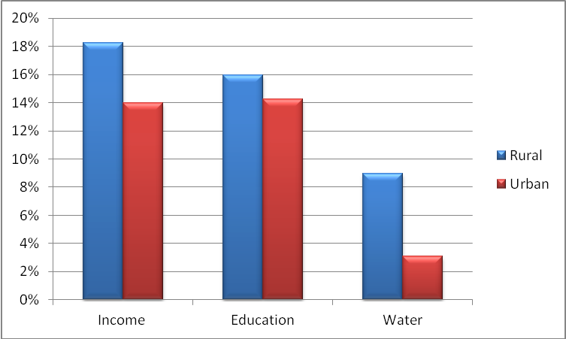
Figure 1: Headcount ratios in each dimension for rural and urban areas in 2005. Source: Authors’ calculations based on HBS 2005.

As seen in Figure 2, 24% of the population in Kazakhstan lived in households where more than half of the adults lacked post-secondary education in 2009. About 11% of the population consumed less than the subsistence minimum, whereas 10% of the population had no access to safe drinking water, 90% of which were rural. In 2009, the majority of the population that was deprived in all three dimensions lived in rural areas.

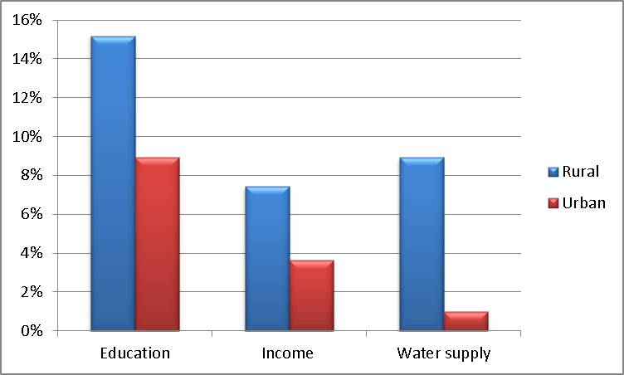
Figure 2: Headcount ratios in each dimension for rural and urban areas in 2009. Source: Authors’ calculations based on HBS 2009.

To measure multidimensional poverty, this study uses the intermediate cutoff $k=2$, since it considers a set of people that is narrow enough to be evaluated as multidimensionally deprived and broad enough to include people who, even if not deprived in all dimensions, experience deprivation in at least two thirds of them.
Table 1 presents the estimated multidimensional Headcount Ratio ($H$) and the Adjusted Headcount Ratio ($M_{0}$) based on different cutoffs ($k$) for 2005. When$k=1$, 53% of the population is deprived in one dimension or more; the average resident is deprived in 1.4 dimensions. The intensity of poverty rises when $k$ increases, meaning that the share of dimensions in which the household is deprived grows with $k$ (Adeoti, 2014). When$k=2$, 18% of the population is deprived in two or more dimensions; the average is 2.2 dimensions. A measure of the intensity of poverty, $M_{0},$ is 0.13. The headcount ratio decreases when $k$ increases, since this reduces the number of households that are poor (Adeoti, 2014). Finally, when$k=3$, only 3% of the population was poor in 2005.

K | H | A | M0 | Bootstrapped  95 percent confidence interval for M0
1 | 0.531 | 0.467 | 0.247 | [0.243 0.252]
2 | 0.183 | 0.723 | 0.132 | [0.127 0.138]
3 | 0.030 | 1 | 0.030 | [0.028 0.033]

Table 1: Multidimensional Headcount Ratio ($H$) and Adjusted Headcount Ratio ($M_{0}$) in 2005. The table considers three dimensions with different $k$ values. Source: Authors’ calculations based on KHBS 2005.

K | H | A | M0 | Bootstrapped  95% confidence interval for M0
1 | 0.363 | 0.413 | 0.150 | [0.146 0.153]
2 | 0.079 | 0.698 | 0.055 | [0.052 0.059]
3 | 0.007 | 1 | 0.007 | [0.006 0.009]

Table 2: Multidimensional Headcount Ratio ($H$) and Adjusted Headcount Ratio ($M_{0}$) in 2009. The table considers three dimensions with different $k$ values. Source: Authors’ calculations based on KHBS 2009.

The situation improved in 2009 compared to 2005 (Table 2). When $k=1$, 36% of the population was deprived in one or more dimensions, on average in 1.2 dimensions. When $k=2$, 8% of the population was deprived in two or more dimensions, on average in 2.1 dimensions. The Adjusted Headcount Ratio was 0.06. The share of households deprived in all three dimensions was 1%. So, all measures of multidimensional poverty declined in 2009 compared to 2005.
Figure 3 shows estimates of multidimensional poverty in 2005. The overall multidimensional poverty rate is 18%. The overlap of different dimensions represents the household’s deprivation in two dimensions, since the cutoff is$k=2$; that is, we do not consider households deprived in only one dimension. The largest overlap is for education and income; 10 percent of Kazakhstan’s population live in a household where more than half of the adults do not have a post-secondary education and have a consumption income below the subsistence minimum. Hence, household adults without post-secondary degrees earn lower income and are more likely to be poor.
Eight percent of the population is deprived of water supply -- basically a rural phenomenon, since the dispersion of the rural population makes drinking water expensive. The share of households deprived in two dimensions, such as education and access to water, is the same in both years, 2 percent. The overlap in the center, which is covered by all dimensions, represents the share of households deprived in income, education and water supply. The share is small, meaning that extreme poverty is not widespread.
Figure 4 shows estimates of multidimensional poverty for 2009 using Alkire and Foster’s model. The multidimensional poverty rate is 8%. The largest overlap is for education and income, indicating that 4% of Kazakhstan’s population lives in a household where more than half of the adults lack post-secondary education and consumption income is less than the subsistence minimum. As in 2005, the household with adults lacking post-secondary degrees has lower consumption than other households and is more likely to be poor. Overall, multidimensional poverty decreased from 2005 to 2009, which is consistent with conventional poverty measures (Table A1).

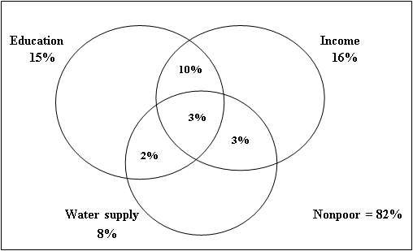
Figure 3: Multidimensional poverty in 2005 ($k=2$). Source: Authors’ calculations based on KHBS 2005.

We calculated multidimensional poverty measures for each oblast. Figures 5a and 5b present estimates for each oblast, and for rural and urban areas of each oblast, for 2005 and 2009. Poverty rates across oblasts vary significantly, from 1% to 80% in 2005 and from 1% to 69% in 2009 of the rural poor. Mangistau and Kyzylorda have the highest levels of rural poverty in both years. The variation in poverty rates among oblasts is large; but almost half of the oblasts have an incidence of poverty above 20% in 2005 and above 10% in 2009. The dynamics illustrate the decline of poverty in all regions in 2009 compared to 2005. However, in 2009 poverty was still rural.

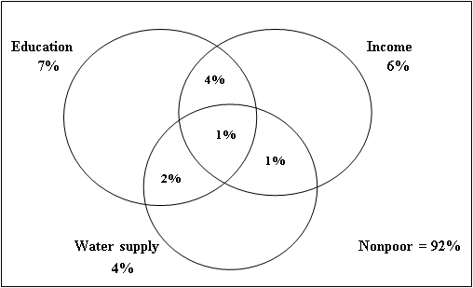
Figure 4: Multidimensional poverty in 2009 ($k=2$). Source: Authors’ calculations based on KHBS 2009.

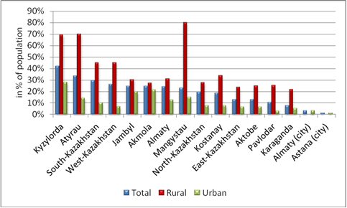
Figure 5a: Oblast multidimensional poverty rates in rural and urban areas in 2005 ($k=2$). Source: Authors’ calculations, based on KHBS 2005. Total, rural and urban rates are calculated as shares of the oblast population living in all areas, rural areas and urban areas.

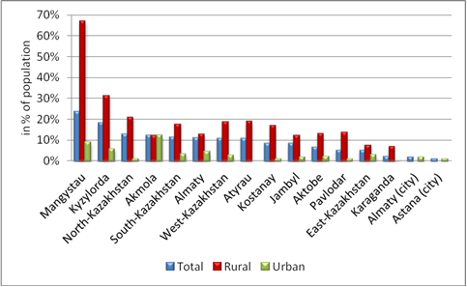

Figure 5b: Oblast multidimensional poverty rates in rural and urban areas in 2009 ($k=2$). Source: Authors’ calculations based on KHBS 2009. Total, rural and urban rates are calculated as shares of the oblast population living in all areas, rural areas and urban areas.

However, because some oblasts have larger populations than others, poverty is concentrated in them. About 30% of multidimensionally poor individuals lived in South Kazakhstan and Almaty oblasts in 2005 and around 27% in 2009 (Figures 6a and 6b).

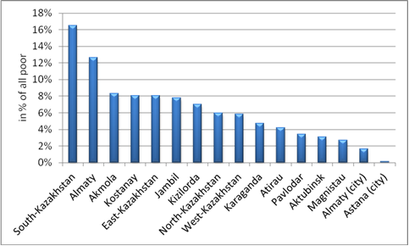
Figure 6a: Distribution of the multidimensionally poor by oblast ($k=2$). Source: Authors’ calculations based on KHBS 2005.

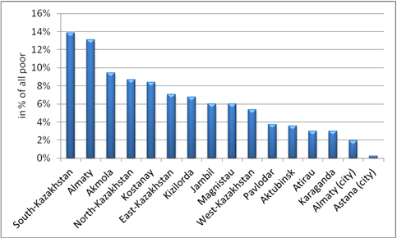
Figure 6b: Distribution of the multidimensionally poor by oblasts in 2009 ($k=2$). Source: Authors’ calculations based on KHBS 2009.

These results reinforce World Bank (2004) research on poverty in Kazakhstan in 2001-2002. The World Bank study concluded that poverty in Kazakhstan has a strong regional character, with most of the poor living in rural areas. The estimates in this study also suggest that multidimensional poverty in Kazakhstan is rural. Furthermore, almost the same oblasts as in the World Bank report have a high incidence of multidimensional poverty.

4.2 Identification of factors of multidimensional poverty
Based on a cross-sectional LSMS survey in Kazakhstan, Anderson and Pomfret (2002) study the determinants of household expenditures in 1996. They find that education, household location, ethnicity and household size were important determinants. We cannot include education as a predictor in our model due to an endogeneity problem – we included education as a deprivation measure in the multidimensional poverty index. We do control for age and gender as well as for marital, health and employment status of the head of household. The data on the head of household’s health was not available for 2009.

 | 2005 |  | 2009
Predictor variables | dy/dx | means | dy/dx | means
Gender of household head
Male | measuring reference | 0.440 | measuring reference | 0.435
Female | -0.038* (0.008) | 0.559 | 0.0004 (0.004) | 0.564
Age of household head (years) | -0.001*(0.0003) | 50.26 | -0.001*(0.0001) | 49.66
Ethnicity of household head
Kazakh | measuring reference | 0.477 | measuring reference | 0.525
Russian | -0.023* (0.008) | 0.375 | 0.007 (0.004) | 0.343
Ukrainian | -0.047* (0.014) | 0.052 | 0.004 (0.008) | 0.045
Uzbek | -0.033 (0.021) | 0.013 | 0.048* (0.022) | 0.012
Tartarian | -0.046* (0.022) | 0.022 | -0.009 (0.012) | 0.020
Uighur | 0.037 (0.035) | 0.009 | -0.011 (0.012) | 0.009
German | -0.021 (0.025) | 0.016 | 0.027 (0.017) | 0.015
Other ethnicities | -0.003 (0.019) | 0.035 | 0.014 (0.012) | 0.029
Marital status
Married | measuring reference | 0.638 | measuring reference | 0.641
Not married | -0.005 (0.020) | 0.041 | 0.015 (0.009) | 0.057
Divorced | 0.045* (0.015) | 0.112 | 0.015* (0.008) | 0.118
Widowed | 0.075* (0.013) | 0.208 | 0.036* (0.007) | 0.185
Household size | 0.050* (0.002) | 3.547 | 0.018* (0.001) | 3.501
Employment (dummy variable)
Employed household head | measuring reference | 0.687 | measuring reference | 0.743
Unemployed household head | 0.086* (0.010) | 0.312 | 0.029* (0.006) | 0.256
Health status of household head
Very good | measuring reference | 0.022
Good | -0.052* (0.024) | 0.294
Satisfactory | -0.063* (0.024) | 0.568
Poor | -0.039* (0.027) | 0.110
Very poor | 0.084 (0.073) | 0.005
Type of the settlement (dummy variable)
Urban | measuring reference | 0.624 | measuring reference | 0.555
Rural | 0.157* (0.008) | 0.375 | 0.086* (0.005) | 0.444
Constant | -3.078* (0.219) |  | -4.85* (0.230)
Number of observations | 11,342 |  | 11,684
LR chi²(23) | 2146.49 |  | 1,145.29
Log likelihood | -4,340.099 |  | -2,680.294
Prob > chi² | 0.0000 |  | 0.0000
Pseudo R² | 0.1983 |  | 0.176

Table 3: The marginal effects from logit model regressions for 2005 and 2009. Source: Authors’ calculations based on KHBS 2005 and 2009. Note: *Indicates statistical significance at the 5% level of significance. Standard errors are in parentheses. “Measuring reference” refers to the background variable.

In the logit models (Table 3), marginal effects indicate that for the female head of household (aged 50.26 years), and with a household size of 3.55, compared to the male head of household, the probability of being multidimensionally poor decreased by 3.8% in 2005, but it did not differ from zero with statistical significance in 2009. (In these estimates, other predictor variables are set to their mean values, a convention that we will follow for the rest of this section.) This conclusion is inconsistent with the findings that, on average, male wages in Kazakhstan are 31% higher than female wages; moreover, that females have lower chances of finding jobs. The contradiction can be explained by demographic and location factors. Female heads of households are older and less likely to have young children than are other women. Also, their households are usually smaller and more prevalent in large cities, where poverty rates are lower (World Bank, 2004).
The age of the household head relates negatively to the probability of being multidimensionally poor. In the marginal effects, a one-year increase in the age of the head of household relates to a decrease in the probability of being multidimensionally poor of 0.1% in both years and is statistically significant (Table 3). The average age of the head of household declined from 50.26 years in 2005 to 49.66 years in 2009.
Ethnicity of the household head also affects multidimensional poverty. Being Russian, Ukrainian, Uzbek, Tartarian, German or other ethnicities decreases the probability of being poor relative to the base category of being Kazakh, whereas being Uighur increases it in 2005 at the means of predictor variables. The largest decrease in the probability of being poor relative to the base category is being Ukrainian and Tartarian with the marginal effects of 0.047 and 0.046 respectively; both values are statistically significant at the 5% level (Table 3). However, ethnicity becomes less significant in 2009. Only being Uzbek increases with statistical significance the probability of being multidimensional poor relative to the base category of being Kazakh, by 4.8%.
The marital status of the household head also affects poverty. If this status changes from married to not married, the probability of being poor decreases. If the status changes from married to divorced or widowed, the probability of being poor increases. Widowed household heads are more likely to be multidimensionally poor relative to a married household head; in fact, they have the largest marginal effect, a rise in probability of 7.5% in 2005. The situation is the same in 2009 but with a smaller marginal effect. An unmarried head of household is more likely to be poor than a married one (Table 3).
Household size relates positively to poverty. The mean size is 3.55; if it had increased by one member, its probability of poverty rose 5% in 2005 (Table 3). Results were similar in 2009. These findings were consistent with those obtained by Adeoti (2014) for multidimensional poverty as well as by Anderson and Pomfret (2002) and the World Bank (2004) for conventional poverty measures.
Unemployment of the household head significantly raised the probability of being multidimensional poor relative to the base category. Losing a job raised the likelihood of being poor by 8.6% in 2005 and by 2.9% in 2009 (Table 3). The World Bank (2004) reported that according to statistics in Kazakhstan, wages provided over 60% of total income for all rich and poor. Thus an unemployed household head is more likely to be poor.
The influence of the health of the household head varies with its intensity. A change in health from very good to very poor increases the probability of being poor by 8.4%, while a change in health from very good to satisfactory reduces the probability by 6.3%. However, the respondents themselves evaluated their health. Since each person evaluates in her own way, it is hard to draw general conclusions about the link of health to poverty when the perceived change in health is small. Also, wealthier households pay more attention to their health, since they can afford medical examinations.
Location of the household plays an important role in poverty. The estimates confirm that poverty in Kazakhstan is rural. Living in rural areas increased the probability of being poor by 15.7% in 2005 and by 8.6% in 2009 (Table 3).
In summary, gender, age, ethnicity, marital status, employment, health, household size and location (rural or urban) are statistically significant and important predictors of multidimensional poverty. Households headed by females, by older people, by the unmarried, or by people with very good health (as compared to very poor health) are less likely to be impoverished. But households headed by the widowed, by the unemployed, or by people with very poor health are more likely than others to be poor. Large or rural households are also relatively likely to be poor.

5. Conclusions
This study has estimated multidimensional poverty in Kazakhstan by applying the method developed by Alkire and Foster (2011). The dimensions were selected based on MDGs: Income (minimum level of subsistence), education (50% or more of the adults in the household have post-secondary educations), and water supply (a water pipe in the dwelling or a supply within 200 meters of the home). The KHBS for 2005 and 2009 provided data for the measurements.
Estimates suggest that 18% (cutoff$k=2$) of the population in 2005 and 8% in 2009 were deprived in at least two of the three dimensions. Moreover, 70% in 2005 and more than 80% in 2009 of the deprived persons lived in rural areas. The level of poverty, and the deprivations in separate dimensions, declined from 2005 to 2009. But the same 2% of households were deprived in two dimensions, such as education and water supply, in both years. Decomposition of multidimensional poverty by oblast indicates that Kyzylorda, Atyrau, South Kazakhstan and Mangystau had the highest levels of poverty in 2005. In 2009, the counterparts were Mangystau, Kyzylorda and North Kazakhstan. Poverty is mainly rural.
Logistic regression identified factors that influence poverty (given the cutoff level k = 2). We selected as predictor variables gender, age, ethnicity, marital status, employment and health of the household head, the household size, and the type of settlement (rural or urban). It turns out that household heads who are female, advanced in years, unmarried, or healthy are less likely than others to be poor, whereas household heads who are ill, widowed or unemployed are more likely to be poor. Households having four or more members, or living in rural areas, are relatively likely to be poor.
These results partially reinforce World Bank research on poverty in Kazakhstan in 2001-2002, which found that the majority of the poor lived in rural areas. Our study identified almost the same oblasts as being poor that the World Bank did, although the latter used conventional poverty measures. Like the World Bank, we conclude that a lack of education or jobs is a condition of poverty, as is a large household size.
This study provides a flexible methodology for measuring multidimensional poverty. The main decisions -- selecting dimensions and the poverty cutoff as well as determining dimensional cutoffs and weights – are left to the researcher.
This study can aid allocation of the budget among oblasts, particularly in poverty reduction programs, since it identifies the poorest oblasts and the reasons for their poverty. It can also help target households that are the poorest of the poor – i.e., those deprived in multiple dimensions.

Alma Kudebayeva is an assistant professor of economics at KIMEP University. She has a PhD in Mathematics from Al Farabi Kazakh National University and a PhD in Development Economics from the University of Manchester.
Ainur Janbauova has a Master’s of Arts in Economics from KIMEP University.

6. References
Adeoti, A.I. (2014), “Trend and determinants of multidimensional poverty in rural Nigeria,” Journal of Development and Agricultural Economics, Vol. 6, pp. 220–231
Alkire, S., and Foster, J. (2011), “Counting and multidimensional poverty measurement,” Journal of Public Economics, Vol. 95, pp. 476–487
Alkire, S. and Seth, S. (2015), “Multidimensional poverty reduction in India between 1999 and 2006: Where and how?”, World Development, Vol. 72, pp. 93-108
Anand, S. and Sen, A. (1997), "Concepts of human development and poverty: A multidimensional perspective," United Nations Development Programme
Anderson, K. and Pomfret, R. (2002), “Relative living standards in new market economies: Evidence from Central Asian Household Surveys,” Journal of Comparative Economics, Vol. 30, pp. 683–708
Atkinson, A. (1987), “On the measurement of poverty,” Econometrica, Vol. 55, pp. 749–764
Atkinson, A. (2003), “Multidimensional deprivation: Contrasting social welfare and counting approaches,” Journal of Economic Inequality, Vol. 1, pp. 51–65
Bellido, N.P., Jano, M.D., Ortega, F.J.L., Martín-Guzmán, M.P., and Toledo, M.I. (1998), “The measurement and analysis of poverty and inequality: An application to Spanish conurbations,” International Statistical Review, Vol. 66, pp. 115–131
Bentham, J. (1789), "An introduction to the principles of morals and legislation," Clarendon Press
Bossert, W., D'Ambrosio, C., and Peragine V. (2007), “Deprivation and social exclusion,” Economica, Vol. 74, pp. 777–803
Bourguignon, F., and Chakravarty, S. (2003), “The measurement of multidimensional poverty,” The Journal of Economic Inequality, Vol. 1, pp. 25–49
Chakravarty, S. and Silber, J. (2008), “Measuring multidimensional poverty: The axiomatic approach,” in N. Kakwani and J. Silber (eds.), "Quantitative approaches to multidimensional poverty measurement," Palgrave Macmillan
Clark, D., and Hulme, D. (2010), “Poverty, time and vagueness: Integrating the core poverty and chronic poverty frameworks,” Cambridge Journal of Economics, Vol. 34, pp. 347–366
Duclos, J., and Araar, A. (2006), "Poverty and equity: Measurement, policy and estimation with DAAD," Springer
Edgeworth, F.Y. (1881), "Mathematical psychics," Kegan Paul
Hayati, D., Karami, E., and Slee, B. (2006), “Combining qualitative and quantitative methods in the measurement of rural poverty: The case of Iran,” Social Indicators Research, Vol. 75, pp. 361–394
Kakwani, N. (1980), “On a class of poverty measures,” Econometrica, Vol. 48, pp. 437–446
Laderchi, C.R., Saith, R., and Stewart, F. (2003), “Does it matter that we do not agree on the definition of poverty? A comparison of four approaches,” Oxford Development Studies, Vol. 31, pp. 243–274
Marshall, A. (1890), "Principles of economics," Macmillan
Mill, J.S. (1998), "Utilitarianism," Oxford University Press
Pigou, A.C. (1920), "The economics of welfare," Macmillan
Pomfret, R. (2006), "The Central Asian economies since independence," Princeton University Press
Ravallion, M. (1994), “Measuring social welfare with and without poverty lines,” American Economic Review, Vol. 84, pp. 359–364
Ravallion, M. (1996), “Issues in measuring and modelling poverty,” Economic Journal, Vol. 106, pp. 1328–1343
Ray, R. and Sinha, K. (2015), “Multidimensional deprivation in China, India and Vietnam: A comparative study on micro data,” Journal of Human Development and Capabilities, Vol. 16, pp. 69–93
Rhoe, V., Babu, S. and Reidhead, W. (2008), “An analysis of food security and poverty in Central Asia -- case study from Kazakhstan,” Journal of International Development, Vol. 20, pp. 452–465
Santos, M.E., and Ura, K. (2008), "Multidimensional poverty in Bhutan: Estimates and policy implications," OPHI Working Paper No 14, University of Oxford
Sen, A. (1979), “Utilitarianism and welfarism,” Journal of Philosophy, Vol. 76, pp. 463–489
Thorbecke, E. (2008), “Multidimensional poverty: Conceptual and measurement issues,” in N. Kakwani and J.Silber (eds.), "Many dimensions of poverty," Palgrave MacMillan
Townsend, P. (1979), "Poverty in the United Kingdom," Penguin
Tsui, K. (2002). "Multidimensional Poverty Indices," Social Choice & Welfare, Vol. 19, pp. 69–93
United Nations (2010), “Millennium Development Goals in Kazakhstan,” http://www.undp.org/content/dam/undp/library/MDG/english/MDG Country Reports/Kazakhstan/Kazakhstan_MDGReport_2010.pdf
United Nations Development Programme Kazakhstan (2004), "Poverty in Kazakhstan: Causes and cures," UNDP Kazakhstan
World Bank (2004), "Kazakhstan: Dimensions of poverty in Kazakhstan. Volume I: Policy briefing," Poverty Reduction and Economic Management Unit: Europe and Central Asia Region

7. Appendix

 | 2001 | 2002 | 2003 | 2004 | 2005 | 2006 | 2007 | 2008 | 2009 | 2010 | 2011 | 2012 | 2013 | 2014
Poverty Po Population | 46.7 | 44.5 | 37.5 | 33.9 | 31.6 | 18.2 | 12.7 | 12.1 | 8.2 | 6.5 | 5.5 | 3.8 | 2.9 | 2.8
Rural p Rura Rural | 59.4 | 58.4 | 53.2 | 47.1 | 45.6 | 24.4 | 18.1 | 15.9 | 12.1 | 10.1 | 8.8 | 6.1 | 4.9 | 4.7
Urban Urb Urban | 36 | 33 | 24.7 | 23.4 | 20.2 | 13.6 | 6.9 | 8.1 | 4.1 | 3.7 | 2.4 | 1.9 | 1.3 | 1.3

Table A1: Poverty indicators for 2001-2014 in Kazakhstan. Source: World Bank, Poverty and Equity Database (2016). All three indicators are headcount ratios at the national poverty lines. The first row represents the percentage of the population; the second row, the percentage of the rural population; the third row, the percentage of the urban population.

Oblast | Rural | Urban | Total
Akmola | 364 | 340 | 704
Aktobe | 172 | 316 | 488
Almaty | 684 | 397 | 1081
Atyrau | 90 | 172 | 262
West-Kazakhstan | 235 | 229 | 464
Jambyl | 314 | 338 | 652
Karaganda | 174 | 1095 | 1269
Kostanay | 367 | 537 | 904
Kyzylorda | 117 | 231 | 348
Magnystau | 30 | 210 | 240
South-Kazakhstan | 638 | 523 | 1161
Pavlodar | 223 | 444 | 667
North-Kazakhstan | 370 | 259 | 629
East-Kazakhstan | 484 | 787 | 1271
Astana (city) | 0 | 209 | 209
Almaty (city) | 0 | 996 | 996
Kazakhstan | 4262 | 7083 | 11345

Table A2: Sample size by region and by rural and urban areas in 2005.
Source: Authors’ calculations based on KHBS 2005.

Oblast | Rural | Urban | Total
Akmola | 436 | 292 | 728
Aktobe | 208 | 294 | 502
Almaty | 877 | 234 | 1111
Atyrau | 149 | 117 | 266
West-Kazakhstan | 237 | 234 | 471
Jambyl | 420 | 270 | 690
Karaganda | 321 | 983 | 1304
Kostanay | 439 | 491 | 930
Kyzylorda | 171 | 176 | 347
Magnystau | 60 | 179 | 239
South-Kazakhstan | 652 | 499 | 1151
Pavlodar | 230 | 462 | 692
North-Kazakhstan | 381 | 262 | 643
East-Kazakhstan | 613 | 724 | 1337
Astana (city) | 0 | 231 | 231
Almaty (city) | 0 | 1042 | 1042
Kazakhstan | 5194 | 6490 | 11684

Table A3: Sample size by region and by rural and urban areas in 2009. Source: Authors’ calculations based on KHBS 2009.

 | Mean
Variable | Rural | Urban | National
Income  (household’s per capita monthly income) | 8,975.08 | 13,000.37 | 11,488.35
Education (dummy variable)* | 0.43 | 0.23 | 0.30
Water supply (dummy variable)** | 0.24 | 0.05 | 0.12
Table A4: Statistical means of dimensions used in measurement of multidimensional poverty in 2005. Source: Authors’ calculations based on HBS 2005. Notes: *0 if share of post-secondary educated adults more or equal to 50% of total adult members of household, 1 otherwise; **0 if household has access to drinking water pipe in dwelling or water supply source not far than 200 meters, 1 otherwise.

 | Mean
Variable | Rural | Urban | National
Consumption  (household’s monthly income per capita) | 20,149.590 | 27,502.700 | 24,233.950
Education (dummy variable)* | 0.341 | 0.160 | 0.241
Water supply (dummy variable)** | 0.200 | 0.018 | 0.099
Table A5: Statistical means of dimensions used in measurement of multidimensional poverty in 2009. Source: Authors’ calculations based on HBS 2009. Notes: *0 if share of post-secondary educated adults more or equal to 50% of total adult members of household, 1 otherwise; **0 if household has access to drinking water pipe in dwelling or water supply source not far than 200 meters, 1 otherwise.

The corresponding author is Alma Kudebayeva, almak@kimep.kz .
The corresponding author is Alma Kudebayeva, almak@kimep.kz .
The poverty gap is defined as g_{i}=z-x_{i}, which measures the deprivation shortfall of the ith individual. The gaps are normalized by the poverty line z and the number of the poor.

