The role of context effect in the choice of financial products: An experimental investigation in the Kyrgyz Republic

Kalys Zhumakadyr uulu,
American University of Central Asia, Kyrgyzstan kalys.zh@gmail.com
and
Prof. Dr. Nils Koenig,
American University of Central Asia, Kyrgyzstan koenig_n@mail.auca.kg
Central Asia Business Journal 6(1): 5-20
Fall 2014

The role of context effect in the choice of financial products: An experimental investigation in the Kyrgyz Republic

Kalys Zhumakadyr uulu,
American University of Central Asia, Kyrgyzstan kalys.zh@gmail.com
and
Prof. Dr. Nils Koenig,
American University of Central Asia, Kyrgyzstan koenig_n@mail.auca.kg

Abstract: Academic research in marketing in recent years has slowly moved away from the idea that individuals make choices based on stable, rational preferences. This paper shows how the context effect – a phenomenon from consumer psychology – can influence the perception and choice of financial products. In an experiment with 90 participants, one group stated its preferences for two financial products; a second group chose from a set of three products -- the two previous ones plus a clearly inferior product, i.e. the context product. The choices of both groups were compared using t-tests. The findings suggest that the introduction of the context product to the choice set significantly changed preferences for at least one of the two basic products. We argue that financial companies can influence customer choices by strategically designing their product portfolios.

Keywords: context effect, attraction effect, consumer behavior, cognitive psychology, consumer choice, financial industry

Consumer behavior and context effect – an introduction
Traditional research in marketing and consumer behavior assumes that customer preferences are stable and that customer choices are not influenced by the presence or absence of choice options. Recent research challenges this assumption, indicating that consumer preferences and choices depend on the specific set of alternatives in which an option is considered, i.e. the context effect. The same product may be more desirable in one context and less desirable in another (Busemeyer et al., 2007). The context effect and its variations have significant implications for such marketing practices as pricing policies, product offerings and communication, particularly in the context of competition in the price-quality space (Prelec et al., 1997).
While aspects of the context effect have been researched in such industries as consumer electronics and newspaper publishing, applications to the more complex service context in general, and to the financial industry in particular, are missing. This article reviews the concept of context effect and applies it to the financial industry in the Kyrgyz Republic, proving that banks and other financial players can influence customer choices by changing product offerings and menus. An experiment, involving students of universities in the Kyrgyz Republic, tests for the context effect.

In this article, Section 2 surveys characteristics of the context effect. Section 3 develops the methodology to test whether the effect applies to the financial industry in Kyrgyzstan. Section 4 summarizes the main findings and implications of the experiments. Section 5 discusses limitations of the research and offers recommendations for future research.

Theoretical background
Context effect
Traditional research in consumer behavior builds on decision theory. This assumes that people are rational in their evaluation of products and in their preferences and choices (Busemeyer and Townsend, 1993). In particular, these assumptions rest on the binary independence assumption called the Axiom M of Menu Independence in decision field theory and other social sciences. In brief, its meaning is this: If option x is liked at least as well as option y in a choice set containing both options, then x will also be liked at least as well as y in an expanded choice set containing x, y and z. Thus, if x is chosen in the smaller choice set, then it will also be chosen in the expanded set.
The intuitive meaning of the axiom is that the preference ordering must not be altered by a change in the menu from which the individual chose. Eliminating some unchosen alternatives should not affect the selection of x as the best option. Vice versa, given preferences over an initial pair of choices, addition of a third option should not change either the preference relation or the preference itself. Debunking the idea of internal consistency of choice as “essentially confused,” Sen argues that choice is never independent of circumstances and environmental influences such as objectives, values and norms (Sen, 1993, 1994). He adds that preferences may be sensitive to the choice process itself, including the identity of the chooser, and that choices may have to be made whether or not the judgmental process has been completed (Sen, 1997).
In marketing, consumer behavior researchers challenged the assumption from decision field theory of binary independence based on practical observations, particularly the implication that product choice is always based on rational evaluation. This challenge led to the concept that context affects consumer behavior (Rooderkerk, 2011).
This concept arises from cognitive psychology, which studies mental processes such as attention, thinking and perception. The context effect is “present when a perception of an object changes when its context changes, without […] changes in the object” (Todorovic, 2010). Initial studies of the phenomenon looked, for example, at physical changes of an object’s environment, in particular in the visual sphere (Figure 1).

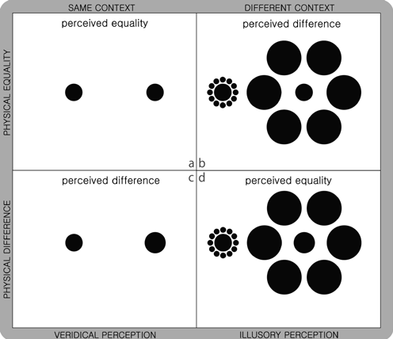

Figure 1. Example of context effect: Perception of object size (Todorovic, 2010).

In addition to the psychological impact of physical changes to an object or its environment, the context effect has implications for business research, especially for marketing. Several studies have found that the choice set greatly contributes to the context effect and not only via physical changes. The perception of objects and the resulting choice can be influenced by the availability (quantity) of options in the choice set and their characteristics. Prelec et al. (1997) refer to the context effect as “the finding that the proportion of subjects choosing a particular product from a set is influenced by set composition in a manner apparently inconsistent with stable preferences.”

Context effect types
Three types of context effect relate to marketing. They have been studied in only the past three decades: The similarity effect (Tversky, 1972), the compromise effect (Tversky, 1972), and the attraction effect (Huber et al., 1982). All three violate the principle from decision field theory of independence of irrelevant alternatives. We will illustrate them with a choice set of two bicycles: Bicycle A has good design and quality but is expensive; bicycle B is affordable but scores low on quality and design.
Similarity effect
This effect occurs when the consumer’s preference relationship over the initial pair of choices changes with the introduction of a third option that resembles one of the initial options (Trueblood et al., 2013). Suppose that we add to the choice set {A, B}

bicycle C that, like A, is expensive but has good quality and design. This can reduce the preference for A compared to B. In simple terms, when a consumer faces three product options out of which two are similar, the brain tends to group the similar options together. If the initial probability of purchasing A was 50% and for B was 50%, the introduction of C decreases A’s probability to 25% while B’s probability is still 50% and C’s is 25%, gained at A’s expense. Figure 2 illustrates the similarity effect.

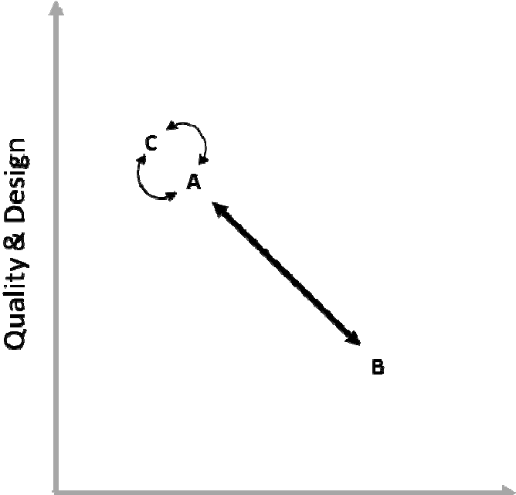

Figure 2. Similarity effect.

Compromise effect
This effect occurs when one option is preferred as a compromise between the two other options (Trueblood et al., 2013). People tend to compromise among extreme options. As Simonson (1989) puts it, they prefer a “middle option” regardless of the real values and characteristics of the choices. Consider a choice set of two bicycles, A and B. The compromise effect occurs when the consumer’s preferences between A and B change because of the addition of an extreme product C that makes product A look like a compromise (Figure 3).

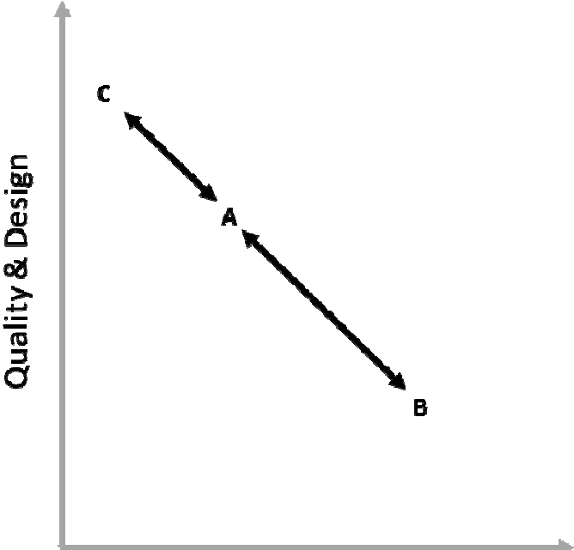

Figure 3. Compromise effect.

Attraction effect
In decision theory, the regularity principle states that the probability of choosing option A from a set containing only A and B should be at least as great as the probability of choosing A from a set also containing B and a new option C. In contrast, the attraction effect occurs if a new option makes an initial option in the choice set “shine out,” increasing the preference for it (Trueblood et al., 2013) (Figure 4).

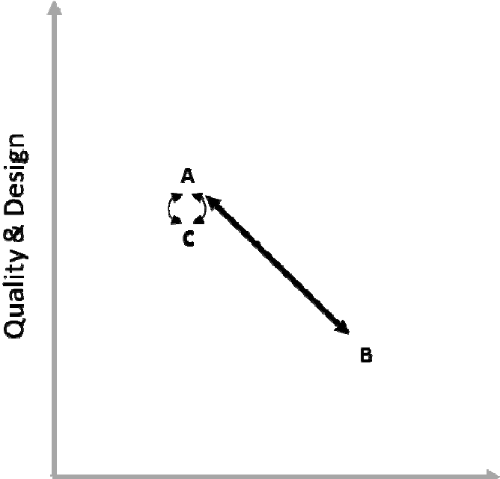

Figure 4. Attraction effect.

Context effect in the financial industry
While researchers have observed the context effect in a range of industries and markets, its applicability to the service sector has received little attention. Ariely (2008) found that the attraction effect influenced choices in tourism. The initial choice set consisted of a “Rome all-inclusive package” and a “Paris all-inclusive package.” Adding a clearly inferior package, “Rome all-inclusive except for coffee,” increased the demand for “Rome all-inclusive.” He concluded that the attraction effect dominated when consumers found it hard to compare very different options and so chose among options that they could easily compare. Referring to this phenomenon as “trade-off aversion,” Hedgcock and Rao (2009) investigated the attraction effect by using a study of functional magnetic resonance imaging. The implication was that the context effect became more significant and relevant when products were harder to compare. Conceivably the attraction effect may prevail more in the service sector than in others, because services are less tangible, more complex, and consequently less comparable than other products. Also, services are closely tied to their providers.
Choosing financial products is an intensive and complex process, since they are manifold. In recent years, they have diversified as banks have expanded their product portfolio and customer base (Finlay, 2012). Choosing financial products is complex because of the special role of money in the economy (Quoidbach et al., 2010). Purchasers of financial products are likely victims of the context effect. They have trouble assessing the differences in such products as savings accounts, time deposits, loans and credits, with respect to interest rates, collateral requirements, terms, etc. Their specific implications for the individual can hardly be predicted by non-experts. Consequently, our research focuses on the application of context effect theory to the financial industry.
Financial customers are particularly vulnerable to the attraction effect; adding an inferior product to the set affects choices of the initial products since these become more attractive in the eyes of the customer. We hypothesize that the attraction effect destabilizes consumer preferences and thus induces irrational changes in them:
H1: The initial preference relation among two given financial products {A, B} changes with the introduction of a context product C to the choice set.

Methodology
Most investigations of the context effect, in cognitive psychology and marketing, use experiments. The researcher can compare the behaviors of two groups, each exposed to its own choice set, in a way that is easy to administer and control. Ariely’s experiment (2008) on the attraction effect used two subscription schemes for the Economist newspaper for two groups of university students (Figure 5). We decided upon an experiment to test Hypothesis H1, stated above.

Figure 5. Choice sets of the Economist attraction effect experiment (Ariely, 2008).

Experimental set-up
The experiment comprised three stages, each leading to the next: Design and pilot a choice set without context; design a context product and add it to the choice set; finally, run the experiment and collect the results.
In the first stage, we developed two loan products that differed in the length of the loan (the period) and the annual interest rate (Table 1). Product A offered a loan for 15 months, with monthly repayments; the interest rate was 22%. Product B offered a loan for 12 months, with monthly repayments; the interest rate was 24%. Most commercial banks in Kyrgyzstan offer annuity plans for consumers to cover their debts. Under such a plan, fixed monthly payments partly cover interest and principal. Table 1 calculates a sample annuity for a loan of 1,000 Kyrgyz som (KGS); differences in the resulting values and payments are negligible.
In a pilot test with 30 internet users, neither product dominated the other in consumer choice. Some people preferred product A for its lower annual interest rate and monthly payments while others preferred B for its lower absolute payments of interest.
Perhaps each product satisfied a different demand. (The test included a qualitative aspect, asking for an explanation of each choice.)

Loan type | Period (months) | Interest rate (% p.a.) | Monthly annuity payments,  KGS | Total repayment amount, KGS
A | 15 | 22% | 77 | 1,152
B | 12 | 24% | 95 | 1,134

Table 1: Choice set of financial products without context.

The next step created a context product. For an attraction effect to occur, this product must be obviously worse than at least one of the others. For comparison to product B, C was created by adding to B a 1% bank commission (Table 2).

Loan type | Period (months) | Interest rate (% p.a.) | Additional condition
A | 15 | 22%
B | 12 | 24%
C | 12 | 24% | 1% bank commission

Table 2: Choice set of financial products with context.

Data collection and sample overview
The experiment was conducted at five universities in Bishkek: The Academy of Management under the President of the Kyrgyz Republic, Kyrgyz Economic University, Kyrgyz National University, Kyrgyz-Russian Slavic University, and Kyrgyz State Technical University. With the support of the university administrations, several classes were selected randomly from science and study programs. These classes were visited in February and March 2014. Randomization was employed to select the 50% of the volunteering class students who would participate in the experiment. The randomization was introduced to avoid or at least reduce adverse selection effects. To these students, the two choice sets were distributed randomly, along with a Russian-language questionnaire to provide demographic information and to identify the preferred loan product from the given set. (The English translation is in Appendix A; the Russian version is available on request.) The two groups were filling out the questionnaires separately and at different times. After finding out (with the first group) the preferred product, the context product was introduced to the choice set and a new set was given to the second group. This enabled us to determine which product to create the context for.
The sample comprised 90 participants from the five universities. Participants took 7 to 15 minutes to complete our questionnaire. Detailed demographic information was collected to ensure comparability of the two sub-samples. Table 3 is an overview of the sub-samples and total sample.

 | Choice set 1 (no context) | Choice set 2 (with context) | Total sample
N | 45 | 45 | 90
Age
18-21 years | 82.2% | 73.3% | 77.8%
22-25 years | 17.8% | 26.4% | 22.2%
Gender
Male | 42.2% | 40.0% | 41.1%
Female | 57.8% | 60.0% | 58.9%
Income (month)
<5,000KGS | 64.4% | 62.2% | 63.3%
5001-10,000KGS | 24.4% | 17.8% | 21.1%
>10,001KGS | 11.2% | 20.0% | 15.6%
Origin
Bishkek | 44.4% | 68.9% | 56.7%
Issyk Kul | 20.0% | 13.3% | 16.7%
Naryn | 17.8% | 8.9% | 13.3%
Djalal Abad | 4.4% | 6.7% | 5.6%
Talas | 6.7% | 0.0% | 3.3%
Other | 6.7% | 2.2% | 4.4%

Table 3: Overview of experiment sample.

Analysis
In the first group of 45 people exposed to the choice set without the context product, 27 participants (60%) preferred product A, while 18 participants (40%) preferred
B. In the second group of 45 people exposed to the choice set with the context product, 18 participants (40%) preferred A, while 24 participants (53.3%) preferred B. Product C was chosen by 3 participants (Figure 6).

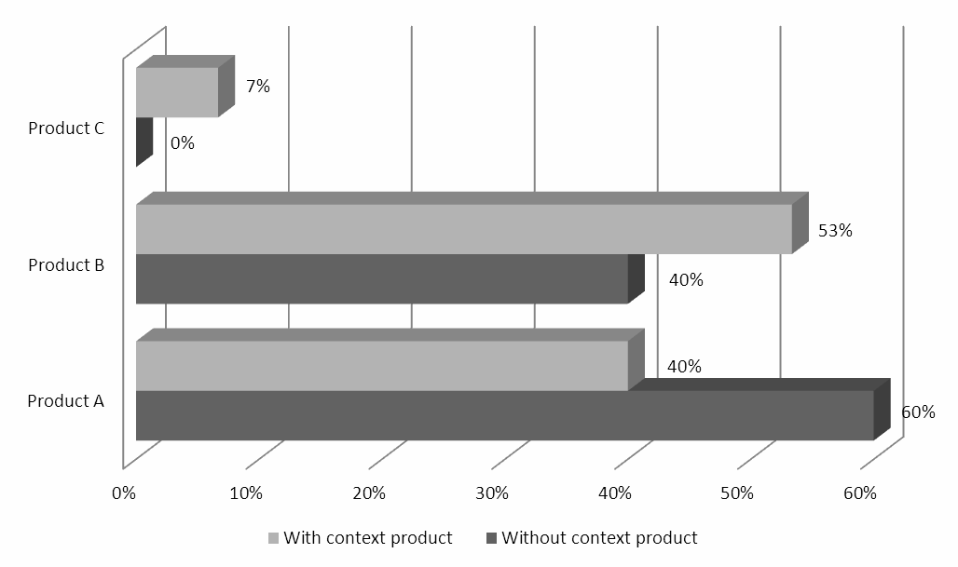

Figure 6. Distribution of choices in context and non-context groups.

Independent t-tests of the differences in the choices of products A and B were conducted for the two groups using SPSS. For product A, the difference in choices between the scenario with and without the context product was statistically significant at the 10% level of significance. Product B was more preferred in the scenario with the context product than in the other (53% versus 40%) although statistical significance in a two-tailed test could not be confirmed due to the small sample size (Table 4). However, since one would expect the context effect to increase preferences for B in this case, a one- tailed test may be appropriate. In that event, the increased preference for B is almost statistically significant at the 10% level.

Product | Group 1 (no context) |  | Group 2 (with context) |  | Mean difference |  | Significance  .
 | Q | µ | Q | µ | Δ | Se | t | P
A | 27 | .60 | 18 | .40 | .200 | .105 | 1.90 | .061
B | 18 | .40 | 24 | .53 | .133 | .105 | 1.23 | .2
C | - | - | 3 | .07 | - | -
Notes: N1= 45, N2=45.
Table 4: Resulting choices of both experiment groups.

We tested for effects of gender, income, origin and field of study on the mean differences, but these were not statistically significant even at 90% significance. These tests included separate mean difference tests for each demographic factor as well as a

joint test. Age was not considered as a demographic factor because of the limited age range of the participants.

Discussion and implications
Our analysis shows that the context product influenced individuals’ relative preferences between the two initial loan options A and B. The introduction of the context loan product C, which is similar to B but inferior to it because of its higher cost, increased the share of participants choosing B while the preference for A decreased.
According to decision theory, given stable and rational preferences, the introduction of C should not change the relative preference for A over B. Due perhaps to the attraction effect, however, B became the most popular choice among participants after the context product was introduced.
The practical explanation for this phenomenon is the challenge of comparing alternatives. In the initial situation, A and B were hard to compare. Each product had a certain advantage over the other, in terms of monthly and total payments. The introduction of the context product resulted in a choice set where one could easily compare two of the three products (B and C). Participants focused on these two, ignoring to some extent the third option A. This increased demand for B and decreased demand for A.
These findings suggest that adjusting the availability of options in a given choice set of financial products can influence the demand for a specific product. This is highly relevant to the competitive financial market, with its diverse and complex products. The Kyrgyz banking landscape is characterized by high liquidity and intense competition for potential loan customers. For example, the National Bank of the Kyrgyz Republic (2013) highlights a major increase in the loan portfolio of the commercial banks, which at the end of 2013 amounted to 54b Kyrgyz som, a yearly increase of 34.5%. At the same time, the industry was quite liquid (National Bank of the Kyrgyz Republic 2014), indicating sufficient money for loans and significant competition for customers.
If a financial institution wishes to stimulate a long-term loan (for example), it can create loans that are similar to it but less attractive, inducing customers to focus on the most comparable ones. Indeed, consumers could compare financial products across several institutions; the offerings of one company could serve as the context for those of another. Also, companies can try to counter the attraction effect by positioning their products in a way that decreases direct comparability.
Exploiting the context effect has an ethical dimension. On one hand, the context effect could stimulate the sales of desired and useful products; on the other hand, exploiting the effect could be interpreted as misleading consumers by manipulating their perception in favor of irrational, maybe even harmful, choices. As our experiment showed, participants exposed to the initial choice set preferred A to B. Once a context product was introduced, people preferred B to A, although the qualitative differences between the two products had not changed. Rational evaluation of both options was weakened by adding the context product to the choice set, favoring otherwise unwanted products. However, the same ethical dimension is in such key marketing decisions as

positioning, pricing and advertising. Before exploiting the context effect, a company must carefully rethink its ethical and socially responsible behavior.

Summary
Following Sen’s reasoning that individual choice is influenced by environmental and personal characteristics that can eliminate binary independence, this research tested whether the context effect in general, and the attraction effect in particular, can be observed in the financial market. To confirm our hypothesis, we conducted an experiment with 90 students from five Kyrgyz universities. The results indicate that the introduction of a context product that is similar but clearly inferior to an initial option may increase the preference for this option (Figure 7). From this finding we derived several implications for marketing practices in the financial industry, which were discussed in detail in Section 4.

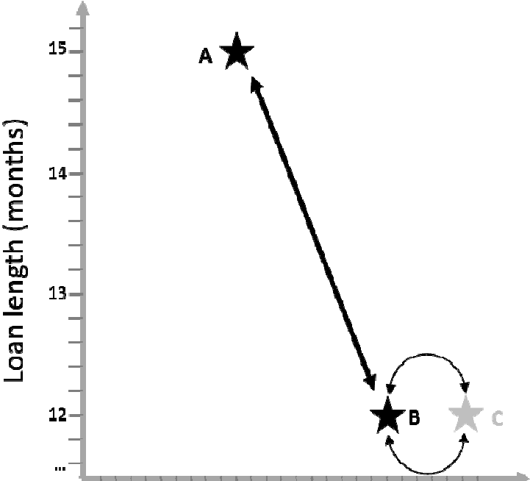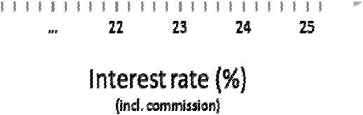

Figure 7. Visualization of attraction effect for financial products A and B with context product C.

Limitations
Our research has several limitations. First, the participants were not in a completely realistic situation for choosing a product. In reality, a person thinking about taking a loan will probably consult family and experts. Extended consultation would likely decrease the context effect, although the customer’s own evaluation and perception would still be essential to the purchase decision.
Second, although we recruited students from several universities and fields of study, the use of only college students yielded a sample that may not fully represent

financial consumers. On the other hand, identifying actual customers without an overall product bias (as they had already made a choice) would be challenging if not impossible. In addition, the choice to compare group means using independent sample t-tests rather than to analyze the absolute choices and their underlying factors should make our findings more transferable, although confirming tests with other samples are recommended.
Thirdly, the lack of statistical significance concerning the choice of product B is unfortunate but due to the small sample size. A similar study with a larger sample could underscore the findings of our work.

Directions for future research
Using our research on the attraction effect in the financial industry as a starting point, two directions of further research seem worthwhile. Firstly, it is reasonable to assume that the similarity and compromise effects also influence individuals’ choices of financial products. This assumption can be investigated through similar experiments.
Second, researchers can investigate differences between types of financial products. Finlay (2012) concludes that decision-making processes differ significantly between types. One can investigate if the extent and impact of the context effect also differ across types. This would enable financial institutions to identify products that require caution when they develop a competitive position.

Nils Koenig is a professor of marketing and corporate communication at the American University of Central Asia in Bishkek, Kyrgyzstan. He has a doctoral degree from Magdeburg University in international management & marketing. His teaching and research focus on international marketing, trends in corporate communication, and social media. He has published in Management Research Review, Corporate Reputation Review and other higher-ranking international business journals. He is an editorial board member for Horizon Research Publishing’s management journals. He is the corresponding author for this article (koenig_n@mail.auca.kg)..
Kalys Zhumakadyr uulu earned a Business Administration degree from American University of Central Asia in Bishkek, Kyrgyzstan in 2014. He became interested in consumer behavior at Koc University in Istanbul. His research focuses on psychological concepts that influence consumer choice and decision processes.

References
- Ariely, D. (2008), “Predictably irrational,” Harper Collins
- Busemeyer, J. R., Barkan, R., Mehta, S., and Chaturvedi, A. (2007), “Context effects and models of preferential choice: implications for consumer behavior,” Marketing Theory, Vol. 7(1), pp. 39-58

- Busemeyer, J. R., Townsend, J. T. (1993), “Decision field theory: A dynamic- cognitive approach to decision making in an uncertain environment,” Psychological Review, Vol. 100(3), pp. 432-459
- Finlay, S. (2012), “Credit scoring, response modeling, and insurance rating: A practical guide to forecasting consumer behavior,” Palgrave Macmillan.
- Hedgcock, W., Rao, A. R. (2009), “Trade-off aversion as an explanation for the attraction effect: A functional magnetic resonance imaging study,” Journal of Marketing Research, Vol. 46(1), pp. 1-13.
- Huber, J., Payne, J. W., and Puto, C. (1982), “Adding asymmetrically dominated alternatives: Violations of regularity and the similarity hypothesis,” Journal of Consumer Research, Vol. 9(1), pp. 90-98
- National Bank of Kyrgyz Republic (2014), “Major indices of the banking sector,” Bishkek, viewed 20 May, 2014,
<http://www.nbkr.kg/index1.jsp?item=1482&lang=ENG>
- National Bank of Kyrgyz Republic (2013), “Trends of the development of the banking system as of December 31, 2013,” Bishkek, viewed 20 May, 2014,
<http://www.nbkr.kg/index1.jsp?item=1481&lang=ENG >
- Prelec, D., Wernerfelt, B., and Zettelmeyer, F. (1997), “The role of inference in context effects: Inferring what you want from what is available,” Journal of Consumer Research, Vol. 24(1), pp. 118-125
- Quoidbach, J., Dunn, E. W., Petrides, K. V., and Mikolajczak, M. (2010), “Money giveth, money taketh away: The dual effect of wealth on happiness,” Psychological Science, Vol. 21(6), pp. 759-763
- Rooderkerk, R. P., Van Heerde, H. J., Tammo, H. A. (2011), “Incorporating context effects into a choice model,” Journal of Marketing Research, Vol. 48(4), pp. 767-780
- Sen, A. (1994), “The formulation of rational choice,” American Economic Review, Vol. 84 (2), pp. 385-90
- Sen, A. (1993), “Internal consistency of choice,” Econometrica, Vol. 61(3), pp. 495- 521
- Sen, A. (1997), “Maximization and the act of choice,” Econometrica, Vol. 65(4), pp. 745-780
- Simonson, I. (1989), “Choice based on reasons: The case of attraction and compromise effects,” Journal of Consumer Research, Vol. 16(2), pp. 158–74
- Todorovic, D. (2010), “Incorporating context effects into a choice model,” Journal of Marketing Research, Vol. 48(4), pp. 767-780
- Trueblood, J. S., Brown, S. D., Heathcote, A., and Busemeyer, J. R. (2013), “Not just for consumers: Context effects are fundamental to decision making,” Psychological Science, Vol. 24(6), pp. 901-908
- Tversky, A. (1972), “Elimination by aspects: A theory of choice,” Psychological Review, Vol. 79(4), pp. 281–99

Appendix A
Questionnaire for choice set without context product

Questionnaire
Hello, thank you for kindly agreeing to take part in this
marketing experiment. The information provided will be used for my senior thesis. Please do not share any personal information (cell phone number, names and etc.) for confidentiality purposes.
1) Sex: M F
2) Age: 18-21
26-29
22-25
>30
3) Area of study:
- Region (where you are coming from):
Bishkek Issyk Kul
Abad
Batken Naryn
- Approximate monthly income:
Osh
Djalal
Talas

0-5000KGS
5001-10000KGS
10001-15000KGS 15001-20000KGS
20001-25000KGS
More than

Questionnaire for choice set with context product

Questionnaire
Hello, thank you for kindly agreeing to take part
in this marketing experiment. The information provided will be used for my senior thesis. Please do not share any personal information (cell phone number, names and etc.) for confidentiality purposes.
1) Sex: M F
2) Age: 18-21
26-29
22-25
>30
3) Area of study:
4) Region (where you are coming from):
Bishkek
Osh
Issyk Kul

