Student Exchange Program
University College of the Fraser Valley, Canada
Up to 4 PLACES are available for KIMEP students for one academic year

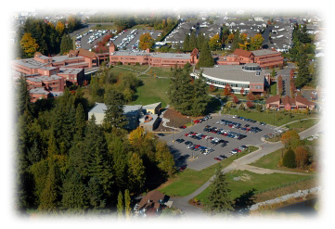
About UCFV
The University College of the Fraser Valley (UCFV) is a fully accredited, public post-secondary institution that enrolls over 10,000 students per year and is larger than half the universities in Canada.

Nestled in the beautiful Fraser Valley just east of Vancouver, British Columbia, UCFV has campuses in Abbotsford, Chilliwack, and Mission, and regional centers in Hope and Agassiz.

The 2007 Globe and Mail’s University Report Card rated UCFV at the top of its category nationwide for having the most satisfied students, highest quality of education, best library, smallest class sizes, and easiest course registration process.

A teaching university with a focus on excellence, UCFV offers 13 bachelor’s degrees, one applied master’s degree, and more than 80 certificate and diploma programs in applied and academic areas, including Trades. Many of the University programs “ladder” into one another, allowing students to keep their options open by earning a one-year certificate and/or a two-year diploma on the way to completing a full degree.
Please visit University’s site for more information:
http://www.ufv.ca/home.htm

National & International Accreditation
AUCC (Association of University and Colleges of Canada)
The Association of Universities and Colleges of Canada is the voice of Canada's universities. We represent 90 Canadian public and private not-for-profit universities and university-degree level colleges.


University Degree Programs - Academic Disciplines

Bachelor of Arts Degree* | Majors in: English, Geography, History, Mathematics, Psychology, Sociology/Anthropology, Sociology.
Bachelor of Arts Degree* | Minors in: Anthropology, Applied Ethics & Political Philosophy, Biology (extended), Business Administration, Criminology/Criminal Justice, Computer Information Systems, Economics, English, French, Geography, History, Kinesiology, Latin American Studies, Mathematics, Mathematics/Statistics, Media and Communications, Psychology (extended), Sociology, Theatre, Visual Arts.
Bachelor of Science Degree | Major in: Biology, Chemistry, Mathematics, Physics.
Bachelor of Science Degree | Minors in: Biology, Chemistry, Computing Science, Mathematics, Mathematics/Statistics, Physics.
Bachelor of Science Degree | Double minors in: Biology/Chemistry, Chemistry/Computing Science, Chemistry/Physics, Mathematics/Computing Science, Physics/Computing Science, Physics/Mathematics.
Bachelor of Arts in Criminal Justice*
Bachelor of Arts in Child & Youth Care*
Bachelor of Arts in Adult Education
Bachelor of Business Administration*
Bachelor of Business Administration in Aviation*
Bachelor of Computer Information Systems*
Bachelor of Fine Arts
Bachelor of General Studies*
Bachelor of Kinesiology*
Bachelor of Social Work*

 Courses in Spring 2009 http://www.ucfv.ca/ar/semesterinfo/200901/200901tenativetimetable.htm
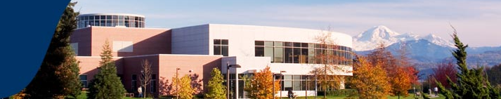

Fees and Costs
KIMEP Exchange Students should pay tuition fee minimum for 4 courses to KIMEP prior to departure according to academic calendar as usually. KIMEP exchange students pay student fee to UCFV.

Accommodation Fee and Estimated Living Costs per semester
(no funding is provided)

• Living expenses: USD 3500 per semester.

This price includes dormitory + meal plan. Meal plan means students are provided with a card ($500) to purchase their food in at the UFV cafeteria

- Homestay: USD 3 000.

Homestay is a great way to become close to a Canadian family. It really depends on student’s preference.

• Books: USD 400 – 700 per semester
• Public transport: USD 100 per month maximum

Other Expenses
- Round ticket: about US 1,800 dollars
- Visa: about US 250
- Insurance: about US 100
Total**: about USD 7, 000 per semester.

Other expenses depend on student’s preferences!

Useful Links
International Students
http://www.ucfv.ca/international/st_prospective/st_inc_admissions.htm

- Academic Calendar http://www.ufv.ca/calendar/2008_09/index.asp

- Canadian Visa Offices
- Document Checklist for Study Permit
- Medical Exam Requirements
- Study Permit Application Information
- Temporary Resident Visa
- Accommodation Options for UCFV International Students http://www.ucfv.ca/international/st_prospective/accommodation.htm



APPLICATION PROCEDURES:

Having been nominated as an exchange student to UCFV, your next step would be to complete the documents listed below and send them to the University in Canada

First send them via email and then by surface mail as well.

We recommend you to send by express mail (EMS Express, Pony Express, Overseas Courier Service, UPS) which guarantees the receiving of them.

Required documents:

- Completed application form at http://www.ucfv.ca/international/st_prospective/st_inc_admissions.htm
- Official transcript
- One passport-size photograph
- A 100 - 200 word letter explaining why you wish to study at the University College of the Fraser Valley
- Support Letter of English language proficiency – ask it at International Office at KIMEP
- Nomination letter from IRO at KIMEP

Application deadlines:
Fall semester: April 1
Spring semester: October 1

Visit the following page for more information:

http://www.ucfv.ca/international/st_prospective/st_inc_admissions.htm

***
Contact person at UCFV

Ms. Sarah Nermo
UFV International
University of the Fraser Valley
Sarah.Nermo@ufv.ca

