Student Exchange Program:
Middle East Technical University (METU), Ankara, Turkey
http://www.metu.edu.tr/

Up to 2 places are available for KIMEP students for one academic year
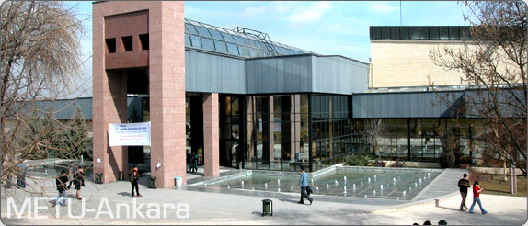

Middle East Technical University (METU), a state university founded in 1956, currently has over 22,000 students of which 4400 are in masters and 2200 are
in doctorate programs.
METU hosts about 1350 international students from nearly 65 different countries studying toward myriad of academic degrees. METU, with 120 Erasmus agreements and 130 bilateral exchange and cooperation agreements with universities in third countries annually sends 250 students and hosts 200 students and 60 teaching staff/researchers.

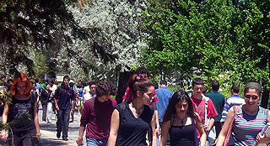
Academic Programs

METU has 47 undergraduate programs within 5 faculties. Additionally, there are 5 Graduate Schools with 97 masters and 55 doctorate programs and a "School of Foreign Languages" which includes the English Preparatory Department. 10 undergraduate programs (including 1 international program) are offered in connection with METU Northern Cyprus Campus.

Please visit the following pages to learn about programs: http://www.metu.edu.tr/academic/undergrad.php and http://www.metu.edu.tr/academic/grad.php

Life at METU

The main part of the campus has dormitory capacity for approximately 6000 students who benefit from a shopping area, banks, post office and many eating places. Also a wide variety of sports facilities, including gymnasiums, tennis courts, basketball and football fields, jogging trails, olympic-size indoor swimming pool, and an outdoor swimming pool are available on METU campus. Among off campus facilities, METU has lodges at Elmadag, 30 kilometers from the METU campus, and a resort at Uludag near Bursa where mountain climbing and various skiing activities are possible.

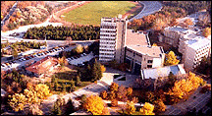

Activities
Throughout the academic year, students can enjoy art exhibitions, concerts, recitals, cinema and theater events as well as a variety of social and academic activities. The Cultural and Convention Center hosts many of these events and many more. One of the most favored social activities is the traditional International Spring Festival held in May.

USEFUL LINKS:

Incoming International Exchange Students:
http://www.issa.metu.edu.tr/Student/Coming_to_Metu.htm
- Offered Courses http://oibs.metu.edu.tr/View_Program_Course_Details_64/
- Catalog Description http://catalog.metu.edu.tr
- Ankara http://www.metu.edu.tr/ankara/
- Visa http://www.issa.metu.edu.tr/Student/Student_Visa.htm



Academic Calendar

Fall semester: early September – early January
Spring semester: mid February – mid June

* Please, check the calendar on http://www.oidb.metu.edu.tr/english/acadcaleng.html

Fees and Costs

KIMEP Exchange Students should pay tuition fee min for 4 courses to KIMEP prior to departure according to academic calendar as usually.

KIMEP exchange students pay student fee to METU.

Other fees are responsibility of the students!

Accommodation Fee and Estimated Living Costs

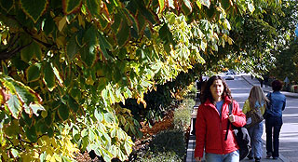
- Accommodation: USD 85 – 120 monthly.
Dormitory is provided.

• Meals: min USD 300 per month
• Books: USD 150 per semester
• Public transport: USD 100 per month maximum

Other Expenses
- Round ticket: about US 800 dollars
- Insurance: about US 100
- Administrative/Orientation fee: US 40

Other expenses depend on student’s personal life-style!

Total**: about USD 3, 000 per semester.

Application Procedure:
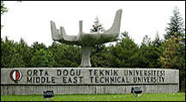
Having been nominated as an exchange student to METU, your next step would be to complete the documents listed below and send them by email to METU:

REQUIRED DOCUMENTS FOR APPLICATION:

- Application Form
- Accommodation Form
- Health Insurance Valid in Turkey
- Copy of Passport
- One Copy of Official Transcript
- A Letter of Intention
- At Least One Recommendation Letter
- One Passport Size Photo

For application form, please click
For accommodation form, please click

Application Deadlines:

The last day of May is for Fall Semester/or Academic Year Applications
November 15 is for Spring Semester Applications

Contact Person
**************************************
Esra AKGUL
Study Abroad Office
Middle East Technical University
Email: esrak@po.metu.edu.tr
intlstud@metu.edu.tr

